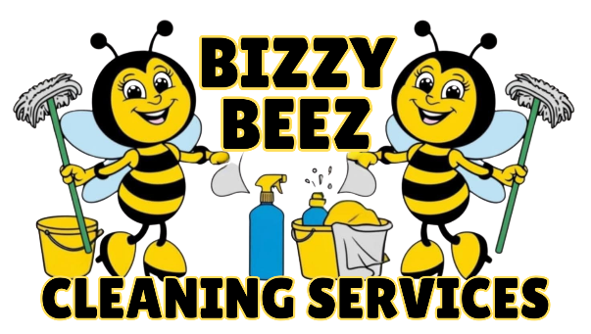
Privacy Policy
Effective Date: 06/01/2025
Company Name: Bizzy Beez Cleaning Services
Location: New Albany, Mississippi, United States
Website: www.bizzybeezcleaningservices.com
Bizzy Beez Cleaning Services ("we," "our," or "us") is committed to protecting your privacy. This Privacy Policy describes how we collect, use, disclose, and safeguard your information when you engage with our services, visit our website, or interact with us in any other way.
1. Information We Collect- We may collect the following types of information:
a. Personal Information:
Name
Address
Phone number
Email address
Payment details (e.g., credit card information, if applicable)
Service location and schedule
b. Non-Personal Information:
Browser type and version
Operating system
IP address
Cookies and usage data (if using a website)
2. How We Use Your Information- We use your information to:
Schedule and deliver cleaning services
Respond to your inquiries and customer service requests
Process payments and invoices
Send appointment reminders and service updates
Improve our services and website
Comply with legal obligations
3. How We Share Your Information- We do not sell or rent your personal information. We may share your information with:
Service providers (e.g., payment processors or contractors working under confidentiality agreements)
Legal or government authorities if required by law
In the event of a business sale or transfer, with the new owners (with notice to you)
4. Data Security- We take reasonable steps to protect your personal information from unauthorized access, use, or disclosure. However, no method of transmission or storage is 100% secure.
5. Your Rights and Choices- As a Mississippi resident, you may:
Request access to the personal data we hold about you
Request correction or deletion of your data
Opt out of marketing communications
To make a request, please contact us at [Insert Contact Email or Phone Number].
6. Cookies and Tracking Technologies- If you visit our website, we may use cookies to enhance your user experience and track usage data. You can disable cookies in your browser settings.
7. Children’s Privacy- Our services are not directed to children under 13. We do not knowingly collect personal information from children.
8. Third-Party Links- Our website may contain links to third-party websites. We are not responsible for the privacy practices of these external sites.
9. Changes to This Policy- We reserve the right to modify this Privacy Policy at any time. We will notify you of any significant changes by updating the effective date and, when appropriate, providing additional notice.
10. Contact Us- If you have any questions about this Privacy Policy or your personal information, please contact us at:
Bizzy Beez Cleaning Services
905 W Bankhead St
New Albany, MS 38652
Email: Bizzybeezservices0@gmail.com
Phone: (662) 539-7343
11. Website Privacy and Online Data Collection- When you visit our website ([Insert Website URL]), we may collect certain information automatically and through user interactions. This section explains how we handle data collected via our website.
a. Information We Collect Automatically- When you access our website, we may collect certain information about your visit, including:
IP address
Browser type and version
Operating system
Referring website (if applicable)
Pages you viewed and time spent on the site
Clickstream data and other usage statistics
We use this information to improve the functionality, performance, and user experience of our website.
b. Cookies and Similar Technologies- We may use cookies, web beacons, and other tracking technologies to:
Remember your preferences
Track website usage and performance
Analyze traffic patterns
Deliver targeted advertisements (if applicable)
You can control or disable cookies through your browser settings. Please note that disabling cookies may affect the functionality of certain website features.
c. Contact Forms and Online Bookings- If you fill out a contact form, request a quote, or schedule a service through our website, we collect the information you submit, which may include:
Name
Email address
Phone number
Service address
Preferred service time/date
Any additional notes or messages
We use this information to respond to your inquiries and fulfill service requests.
d. Third-Party Services- We may use third-party services to operate our website and track usage (such as Google Analytics or scheduling tools). These third parties may collect data in accordance with their own privacy policies. We encourage you to review those policies if you have concerns.
e. Email Marketing and Communications- If you opt-in to receive email communications from us, we may send you updates about our services, promotions, or other content. You can unsubscribe at any time using the link provided in the email or by contacting us directly.
f. Data Retention- We retain website-related personal data only as long as necessary to fulfill the purposes described in this policy, or as required by law.

