**2024 Camp Lavigne Wine Festival**

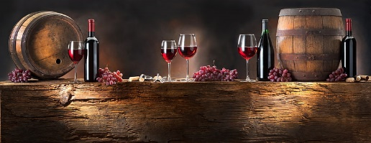

**Application**

Food Vendors

October 19, 2024

11 AM – 5 PM

Business Name: ________________________________________________________________________

Contact Person : ________________________________________________________________________

Staff Names____________________________________________________________________________

Address: ______________________________________________________________________________

City: _________________________________________ State _____________ Zip:___________________

Preferred Phone: ___________________________ Cell Phone:___________________________________

Email Address: _____________________________________________________, for updates to the event.

Food List Description:­­­­­­­­­­­­­___________________________________________________________

***Checklist of items to return to Columbia-Montour Council, BSA in the enclosed envelope or email to*** [***camplavignewinefestival@outlook.com***](mailto:camplavignewinefestival@outlook.com)***:***

_____ List of food for approval (we try not to duplicate food)

_____ Application and fee (after approval)

_____ Booth Information: (ONE) 10 x 20 SPACE ($150.00) # ____________@$150.00 = ___________

_____ The booth fee must be paid when application is accepted to secure your spot.

_____ Certificate of Food Occupancy Certification

_____ Certificate of Liability Insurance policy totaling $1,000,000.00 listing Columbia-Montour Council, BSA Camp Lavigne as additional insurer

_____ Yes, we will be using a generator.

_____ No, we will not be using a generator.

***Important Information to Know***:

* Applications and fees must be received within 10 days of e-mail approval, or the spot will be opened to the next vendor. Festival registration closes September 15, 2024. Email address: [*camplavignewinefestival@outlook.com*](mailto:camplavignewinefestival@outlook.com).
* Once your application has been approved and payment received, there will be no refunds issued.
* This is an outdoor festival, therefore please be prepared for any kind of weather. The festival will be held regardless of snow, rain, or sunshine.
* You are responsible to pay all sales tax to the state and must have a current food/business license on display.
* No one under 21 may attend the festival.

***(ADDITIONAL INFORMATION ON REVERSE)***

* All materials must be received no later than September 15, 2024.
* If not received, the spot will be opened to the next food vendor.
* Your stand must be self-contained with water, power, etc. NO EXCEPTIONS
* QUIET generators allowed. Must be noted on the registration form that you will be using a generator.
* Verizon is the cell phone provider at Camp Lavigne.
* Staff - Besides yourself, the number of staff, who must be over the age of 21, that will be assisting you: __________
* Everyone needs to check in and get a wristband.
* Set up will be on Friday from 2 PM to 4:30 PM and on Saturday from 7 AM to 8:45 AM. No one will be allowed in the event area after 9 AM to set up and no one will be permitted to leave the event until after 6 PM.
* We request that you come set up on Friday to make the day run smoothly. Please notify us when you are coming.
* *To be accepted payments should be made payable to* Columbia Montour BSA *and returned in the enclosed envelope.*
* *The envelope must be clearly marked with the return business name and address.*

Check Number __________ Total ________________________

Signature: _________________________________________________________

**By signing this document, you agree to the terms and conditions as mentioned above, and you will supply Camp Lavigne with the information requested no later than September 15, 2024.**

@@<

=@=4I#

@@<

=@=4I#