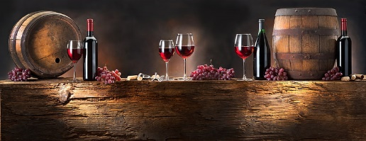

**Camp Lavigne Wine Festival**

Winery/Spirits/Brewery Application

October 19, 2024

11:00 am - 5:00 pm

Business Name:_________________________________________________________________________

Contact Person:_________________________________________________________________________

Names of Additional Staff: ________________________________________________________________

Address:_______________________________________________________________________________

City:________________________________________________State:__________Zip:_________________

Preferred Phone: _________________________Cell Phone:______________________________________

Email Address:_____________________________________________________, for updates on the event.

(Circle one) *Returning* -Winery –Brewpub- Spirits *New* –Winery - Brewpub - Spirits

***Checklist of items to return to Columbia-Montour Council, BSA in the enclosed envelope or email to camplavignewinefestival@outlook.com:***

_____ Application and fee

_____ Off-site Permit

_____ PLCB Event Certificate

_____ Certificate of Liability Insurance policy totaling $1,000,000.00 to the Columbia-Montour Council, BSA Camp Lavigne Wine Festival

***Important Information to Know***:

* The application deadline is September 15, 2024 to ensure that your name and location will be included in the program.
* Once your application has been approved and payment received, there will be no refunds issued.
* This is an outdoor festival, therefore please be prepared for any kind of weather. The festival will be held regardless of snow, rain, or sunshine.
* Each winery/brewpub/spirits will be provided a 10 X 20 space at the designated area at a cost of $100, and a request for a donation of a two bottle wine/brew/spirits basket for the event raffle.
* Once accepted as a winery/brewpub/spirits you agree that you will not attend any other festivals that are on the same date as the Camp Lavigne Wine Festival within a 30-mile radius of the event. Once accepted and you choose to attend another event within a 30-mile radius you will forfeit the location and fees paid, and the event coordinator has the right to replace you with another winery.
* You must have servers and staff members to cover all areas of your booth to make the day run efficiently. Two people at a booth is not acceptable. In the past, each winery/brewpub/spirits has had four to six people assisting to help the day run efficiently.

***(ADDITIONAL INFORMATION ON REVERSE)***

* If you have questions or concerns, please e-mail *camplavingwinefestival@outlook.com*.
* Quiet generators are allowed for electricity.
* Verizon is the cell phone provider at Camp Lavigne.
* Everyone needs to check in and get a wristband. No one under the age of 21 will be permitted at the event. No exceptions.
* Set up will be on Friday from 2 PM to 4:30 PM and on Saturday from 7 AM to 8:45 AM. No one will be allowed in the event area after 9 AM to set up and no one will be permitted to leave the event until after 6 PM.
* The booth fee of $100 includes admission to the event and a 10 X 20 spot*.*
* Please mail your check, made payable to ***Columbia Montour BSA***, along with your application, certificate of insurance, and off site event permit in the enclosed envelope or email to *camplavignewinefestival@outlook.com*:

Check Number __________ Total ________________________

Signature: _________________________________________________________By signing this document, you agree to the terms and conditions as mentioned above. All required current documents for the event must be received by ***October 1, 2024***.