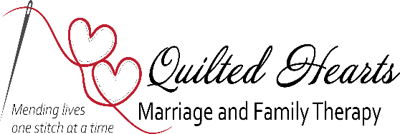

**FEE AGREEMENT**

**Client: _______________________________________________ Client #: ________________________________**

Quilted Hearts Marriage & Family Therapy, PLLC charges a self-pay fee of $100 per session per 45 minute session. If using insurance, copay will be based on insurance company agreement.

Fees are due at the time services are rendered. You will be responsible for payment of appointment cancelled with less than 24-hour notice except in case of emergency. The charge for missed appointments will be $55 unless previous arrangements are made with provider.

Quilted Hearts Marriage & Family Therapy, PLLC accepts several forms of payment as a way to help best suit our clients’ banking choices.

__________________________________________________ _______________________________

Client Signature Date

__________________________________________________ ________________________________

Therapist Signature Date