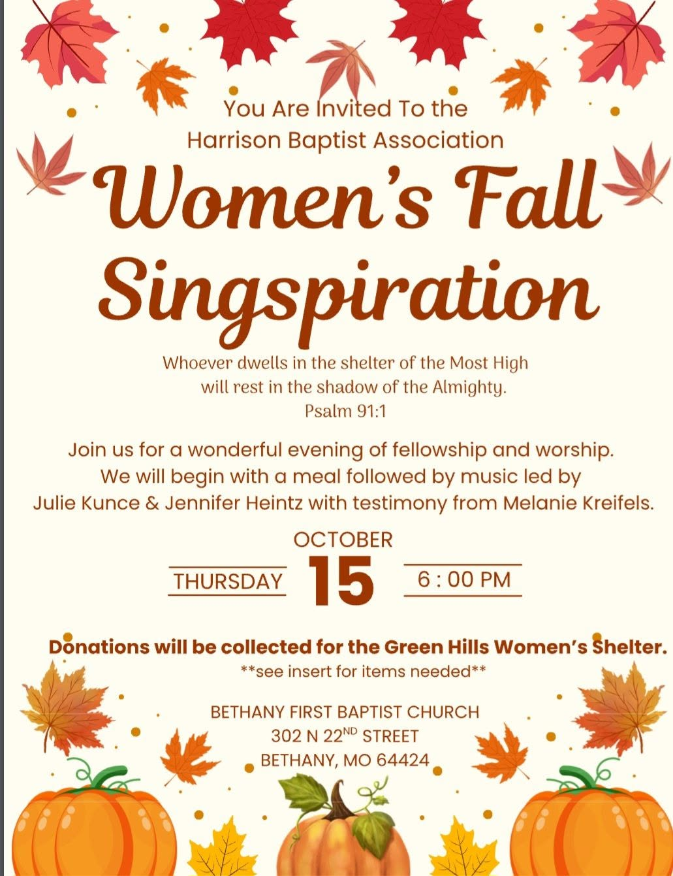 | Baptist Beacon  A Newsletter of the Harrison Baptist Association  An association of 17 praying Churches serving the Lord  904 N 12th St., Bethany, Missouri 64424  Office: 660-425-3889  John’s Cell:660-232-2174  Email: hba@grm.net  Web page: harrisonbaptist.com
  Vol. XL Oct/Nov No. 2
  James 4:7 Submit yourselves therefore to God. Resist the devil, and he will flee from you. 8 Draw near to God, and He will draw near to you. Cleanse your hands, you sinners, and purify your hearts, you double-minded. 9 Be wretched and mourn and weep. Let your laughter be turned to mourning and your joy to gloom. 10 Humble yourselves before the Lord, and He will exalt you.
  October is Pastor Appreciation Month: Let's show our pastor and his family the love they deserve.
  Thank you pastors for your willingness to serve, to sacrifice, to give, and to love us even when we're unlovable.

Greeting from FBC Pattonsburg  We are looking forward to fall and (hopefully) some cooler temperatures. Our church has been buzzing with activity throughout the summer, and it is certainly not slowing down.  Our ice cream social had an amazing turnout. We joined the school district on their back to school night to hand out goodies and invite kids to participate in our children's ministry programs. We hosted another toddler Tuesday, and our men's ministries hosted a father/son fishing day. Our church enjoyed a guest speaker from Samaritans Purse/Operation Christmas Child and received a 20 year service award as a drop off location, afterwards we celebrated with a wonderful fellowship meal.  We are looking forward to more baptisms (praise the Lord) and See you at the pole, where we will share prayer and breakfast with area students. We will also be participating in the homecoming parade where our homeschool co-op group "little rascals" will be our official candy throwers. We will be passing out water and other items at our big community event, the car show.  We are about to start team KID and our youth are exploring Bible drill. Youth will also be hosting a monthly fun night. We look forward to a hotdog/s'mores night and trunk or treat.  Operation Christmas Child collection week is Nov 16th-23, our hours of operation will be 11-16-26 Monday 9am-5pm,11-17-26 Tuesday 2-4pm, 11-18-26 Wednesday 9am-2:30pm, 11-19-26 Thursday 2-4pm, 11-20-26 Friday 2-4pm, 11-21-26 Saturday 2-5pm, 11-22-26 Sunday 12:30-5:30pm, 11-23-26 Monday 7-9am  Please remember you may schedule a time more convenient for your drop off by contacting Sandy @ 660-605-2593.  We will finish out our fall activities with holiday trays being delivered to area shut-ins and nursing homes, and assisting with holiday meal groceries being distributed to some local families.  God bless, Sandy Booth | Greetings from Faith Bible Church. Hope everyone is enjoying the change in the weather.We have continued working on the church and will soon be putting on siding. We have had 1 join the church recently and have enjoyed her presence. We also helped the BSU with the start of the semester events.in Sept we also enjoyed a BBQ that was enjoyed by all. Hope everyone enjoys the cooler weather and worship this fall.  Wanda Gastineau  Greetings from Mount Pleasant #1  On September 26th we had a free dinner and movie night. It was a great time. We have also been praying through Luke 10:2 As part of the Southern Baptist 10 2 project we pray this verse every day till after Christmas. On October 24th we will be participating in the Great Day of Evangelism Another project from the Southern Baptist Convention We are praying and seeking the Lord through this time. We will also be attending the Missouri Convention. and we are very much looking forward to the Midwest Leadership Summit in January 2027.  JC Davis  Melbourne Baptist Church  We are excited about what God is doing here at Melbourne. God is Good and I am proud to be a Christian and serve in our area. We are about to finish our study of Mark on Wednesdays. I’m looking forward to our next study. October 30th 6:00 P.M. We will have our hayride and bond fire. This is always a fun time.God is alive and doing great things. I’m thankful He allows us to be a part of it.  Pastor, Brian Rhodes

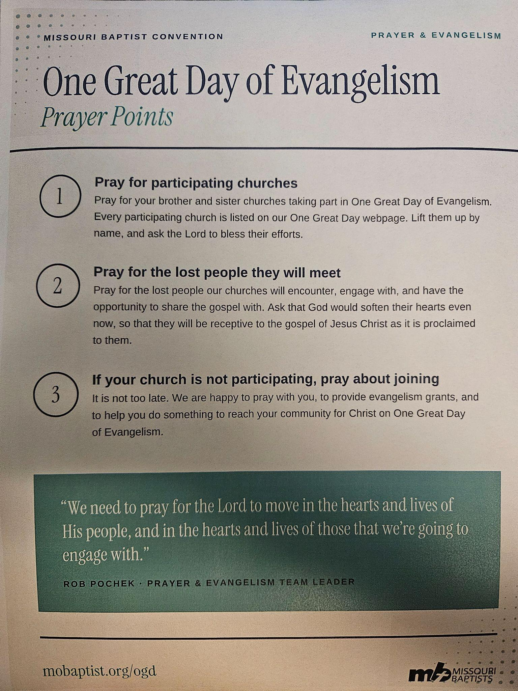 | Hello from all of us at Coffey Baptist Church:  We missed the last newsletter, so I pray this one isn't too long. Pastor Tim and Wendy took a van full of kids to Grand Oaks for youth camp and served as cabin leaders. It was a good week. During children's camp week Pastor Tim and Wendy were at the Fur Takers of America along with two granddaughters serving ice cream, handing out scripture tags, giving a mink demo and Tim preached on Sunday to a big crowd of trappers. It was a blessing to be there! Roger Barker brought the music for the Sunday service. Troy Missouri was the next opportunity to share with the trappers at the Missouri Trappers association  Fall Rendezvous where Tim gave a demo and preached on Sunday. You've heard the song "People need the Lord" well Pastor Tim's version is "trappers need the Lord".  If you are looking to learn about Trapping and Jesus the 1st week in December our church has a camp out and you're all welcome. We are starting our Operation Christmas Child shoeboxes hoping to send many.  The Lord has been good to us as we have had 3 more baptisms, and good attendance on Sunday morning. Since school has started we are having our Wednesday night fellowship suppers at 6 followed by Adult Bible study, Bible Drill and youth, we are very thankful for those who have stepped up to teach. So far we have 5 Bible Drillers. Pastor Tim has been asked to do revival at Ridgeway Baptist and Kirkley Chapel. Pray for God to lead in both revivals.  We pray all of the HBA churches are doing well and would appreciate your prayers as well as we try to do the will of our Lord and Savior Jesus Christ.  In Christ's love,  Wendy

HBA Churches,  Just a few updates from FBC Winston. We had a wonderful VBS with over 30 children each evening. Plus, we had a lot of adults serving to make it joyful for everyone. We have been going verse by verse through the book of James on Sunday mornings except for one Sunday we looked at Psalm 91 and one Sunday we had Walter Plant as our guest. We have a lot of KC Chiefs fans in our church family so, September 27th we had a carry in dinner after worship. We called that our tailgate party. Then we all watched the game together. We praise God for His grace & new mercies each morning.  God bless,  Brad Walker  Prayer for a pastor  O Almighty God, who by your Son Jesus Christ Gave to your Holy Apostles mighty and excellent gifts and commanded them faithfully to feed your flock, We ask you to bless our pastor that he may diligently preach your holy word, and grant us grace to believe your saving Gospel and obediently follow the teaching of your Word, That we may receive the crown of everlasting glory, through Jesus Christ, our Lord.  Amen | Birthday & Anniversary  Oct Nov.  4th Sheila Mohler 16 Annette Rhodes  14 Sarah Williamson 20 Tim & Wendy Wilson  State of the association  Membership Total membership: 21017 - 2026 -25.6% But we also lost a church from our association.  Evangelism/ Additions Total baptisms: We are at a 10 year high with 53 baptisms this year. Praise the Lord  Other editions: We are also at a 10 year high with 58 Additions. Praise the Lord! Worship attendance: Sunday AM worship: We're at a 6 year high going back to 2020, With average attendance of 855 . Praise the Lord! Sunday school average: We're at a four year high with 413. Finances Total receipts: we're at a 10 year high 1,947,943 Praise the Lord! Undesignated: we are also at a 10 year high 1,506,753 Again praise the Lord! Total mission expenses are at a 10 year high at 370,667 Praise the Lord! Overall the trends are positive. These numbers are exciting and encouraging. Thank you for being diligent about the Lord's business. We must move forward and carry on what has been laid before us. I am so thankful for your faithfulness and your diligence in advancing the gospel.  Remember our purpose as an association: The association exists to help churches transform lives and communities with the gospel, by working together in unity and harmony. We are better together.

