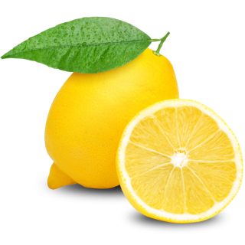  Ice Cold Lemonade  Riley & Stella's |  | Ice Cold Lemonade  Riley & Stella's |  | Ice Cold Lemonade  Riley & Stella's
Ice Cold Lemonade  Riley & Stella's |  | Ice Cold Lemonade  Riley & Stella's |  | Ice Cold Lemonade  Riley & Stella's
Ice Cold Lemonade  Riley & Stella's |  | Ice Cold Lemonade  Riley & Stella's |  | Ice Cold Lemonade  Riley & Stella's
Ice Cold Lemonade  Riley & Stella's |  | Ice Cold Lemonade  Riley & Stella's |  | Ice Cold Lemonade  Riley & Stella's

