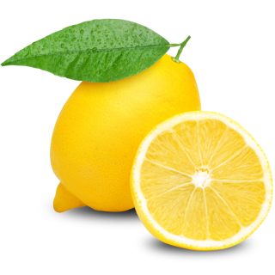  Ice Cold Lemonade  Sophia & Olivia's |  | Ice Cold Lemonade  Sophia & Olivia's |  | Ice Cold Lemonade  Sophia & Olivia's
Ice Cold Lemonade  Sophia & Olivia's |  | Ice Cold Lemonade  Sophia & Olivia's |  | Ice Cold Lemonade  Sophia & Olivia's
Ice Cold Lemonade  Sophia & Olivia's |  | Ice Cold Lemonade  Sophia & Olivia's |  | Ice Cold Lemonade  Sophia & Olivia's
Ice Cold Lemonade  Sophia & Olivia's |  | Ice Cold Lemonade  Sophia & Olivia's |  | Ice Cold Lemonade  Sophia & Olivia's

