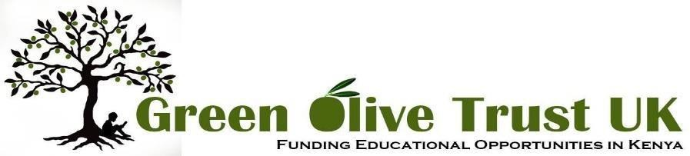

ANNUAL REPORT 2024

Throughout 2024 **Green Olive Trust UK (GOT)** continued to work closely with **Green Olive Foundation (GOF)** our partner organisation in Kakamega, Western Kenya. Our mission is to help relieve poverty in the Kakamega area of Western Kenya by funding education and training. Our focus this year has been on educational bursaries. We funded 15 students throughout the year, some starting their studies during the year, others continuing or completing their courses in 2024. These bursaries have enabled some of the poorest young people in the region to reach their educational potential and thrive. We have also been kept updated by GOF on two projects; the primary school in Kakamega and the Greenhouse Project.

Dr Oscar Shamalla, has worked with us on behalf ofthe Board of Green Olive Foundation in Kenya. We communicated using email, WhatsApp and Zoom. GOF identifies and recommends students who are potentially suitable to receive Green Olive Trust educational bursaries, they administer the payment of the bursaries to schools and universities and provide regular reports and updates to UK trustees. These reports keep UK trustees updated on students' progress and enable us to monitor how funds raised in the UK are spent in Kenya.

**Special Projects: The Musingu Quaker Education Centre** (the primary school) was partially rebuilt and refurbished with funds from Kitchen Table Charities Trust bid for by GOT continued to thrive and serve the community well. The **Greenhouse Project,** which had been funded through a grant from Quaker Peace and Social Witness continued to focus on training young people in greenhouse agricultural technology, as well as providing much needed jobs and produce for the local community. The bore holethat was dug as part of the project continues to provide drinking water for the local community.

**Funding and Fundraising:** From its beginning in 2014 through to 2024 Green Olive Trust UK has received generous funding from its regular and occasional donors, supplemented by various fundraising activities. Grateful thanks go to Jane McIntosh and Kim Ashcroft for their efforts in raising £980 through the sale of festive greeting cards in 2024.

**10th Anniversary Celebration, Lewes Quaker Meeting House:** In July 2024 we celebrated the 10th Anniversary of Green Olive Trust at a special event. Trustees were pleased to meet up with donors and friends of the Trust over tea and cakes. Trustees gave up to date information about our partnership with Green Olive Kenya, showed the impact of our work through a photographic display, talked about the Greenhouse Project and the rebuilding of the primary school, and explained how the charity’s finances worked. We had hoped to welcome Dr Shamalla from GOF Kenya to join us for this celebration. Unfortunately, for the third time, he was unsuccessful in his application for a visa to visit the UK, so he was not able to join us in person. However, Dr Shamalla joined the public meeting via video link and was able to talk to attendees about the work of Green Olive in Kenya, thank our donors and answer questions from attendees.

**Closure of Green Olive Trust, UK.** In August our founder members, Bronwyn and Bob Harwood, gave notice that they wished to retire from active involvement in the work of the Trust**.** At a trustee meeting in November 2024 other trustees sadly reached the conclusion that GOT UK would close and a closure plan should be drawn up in 2025. All six trustees agreed to continue their service during 2025 in order to see through the closure process in a timely and organised way to ensure that current students would be supported financially through to the completion of their courses.

**FINANCIAL UPDATE 2024**

|  |  |  |  |
| --- | --- | --- | --- |
| **RECEIPTS 2024** | **Amount (£)** | **PAYMENTS 2024** | **Amount (£)** |
| Donations | 16,292.45 | Grants | 11,337.66 |
| Collections | 0.00 | Bank fees | 160.00 |
| Fundraising | 980.00 | Fundraising costs | 426.00 |
| Gift Aid refund | 1,042.50 | GOF Admin | 710.47 |
| Bank interest | 14.55 | Travel costs |  |
| **Total Receipts** | **18,329.50** | **Total Payments** | **12,643.13** |
| **FUNDS BALANCE 2024 (£)** | | | |
| Initial balance | | 5,757.91 | |
| Receipts | | 18,329.50 | |
| Payments | | -12,634.13 | |
| Uncleared CAF voucher | | -25.00 | |
| **CLOSING BALANCE 2024** | | **11,428.28** | |

**GREEN OLIVE TRUST UK BOARD OF TRUSTEES 2024**

|  |  |
| --- | --- |
| **Board of Trustees in 2024 Bronwyn Harwood:** Co-convenor  **Fiona Roberts:** Co-Convenor  **Robert Harwood:** Treasurer  **Gina Hutchins:** Publicity and Website  **Tessa Brown:** Trustee  **Ken Bartlett:** Trustee | **Dates of Trustee Meetings in 2024**  18th January 8th April  20th July  27th November  *Minutes of these meetings are available on request* |

**Green Olive Trust UK** was registered by the Charity Commission in March 2016. The charity is governed by a Trust Deed, it is registered with HMRC and receives tax refunds on eligible donations.

**Charity number** 1165906 **Registered address:** 37 Ferrers Road, Lewes, BN7 1PY

**Website:** [www.greenolivetrust.co.uk](http://www.greenolivetrust.co.uk/) **Email:** [admin@greenolivetrust.co.uk](mailto:admin@greenolivetrust.co.uk) **Facebook:** Green Olive Trust

**Bank:** CAF Bank Ltd Account: Green Olive Trust UK

Sort code: 40-52-40

Account no: 00024724