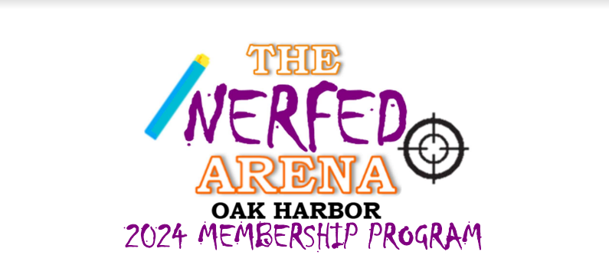

Thank you for helping us maintain our small business by advertising with us! We typically get 100+ people in The Nerf Arena Oak Harbor each weekend during the rainy season.

Please bring us your vinyl banner to The Nerf Arena Oak Harbor, along with this form and method of payment. We recommend at least a 3’ x 6’ size and remember, we have black lights, so make it glow!

* The cost will be $15 per sq. ft. for one year from display date.
* Or, take advantage of savings at $45 per sq. ft. and your promotional banner will be displayed until March of 2027.

**Company _________________________________________________**

**Point of Contact ____________________________________________**

**Address___________________________________________________**

**Phone Number**_____________________________________________

Please bring us your banners to our facility! Your date will start once it’s displayed.

We’ve used 48-hour print for our signs, but you can use your own if you’d like. https://www.48hourprint.com/

**Questions?**

Please contact Gabby Schiller at:

1751 NE Goldie Road, Unit #A3, Oak Harbor, WA 98277

(360) 441-3924 [thenerfarenaoakharbor@gmail.com](mailto:thenerfarenaoakharbor@gmail.com)

For office use only:

DATE DELIVERED __________________DATE DISPLAYED ____________________

SIZE____________ TOTAL $____________ INVOICE SENT/PAID_______________