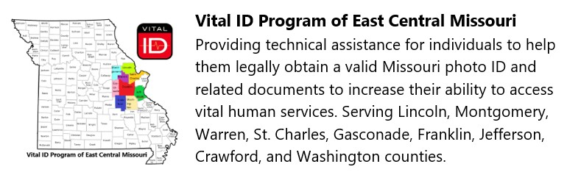

Health Department Montgomery County, Missouri
Montgomery County Health Department – Missouri birth certificates
Address: 400 Salisbury St, Montgomery City, MO 63361
Phone : 573-564-2495
Hours: Monday through Friday from 8:30 AM to 4:30 PM
Department of Motor Vehicles, Montgomery County, Missouri
Address: 723 N. Sturgeon, Montgomery City, MO
Phone: (573) 735-2330
Hours: Monday - Friday 9:00 AM – 4:00 PM

Social Security Offices near Montgomery County, Missouri
St Charles 2000 Boone's Lick Road, St. Charles, MO 63301
Jefferson City SSA office: 129 Scott Station Rd, Jefferson City, MO 65109.
Phone 800-772-1213
Hours Monday – Friday 8:00 Am – 400 PM

For assistance with out-of-state birth certificates or proof of residency, please contact our home office for an appointment: 636-234-7133 Danielle

We believe that access to health care, mental health care, housing, employment, and voting are basis human rights. We try to help all individuals maintain their dignity while legally accessing these essential human services.

