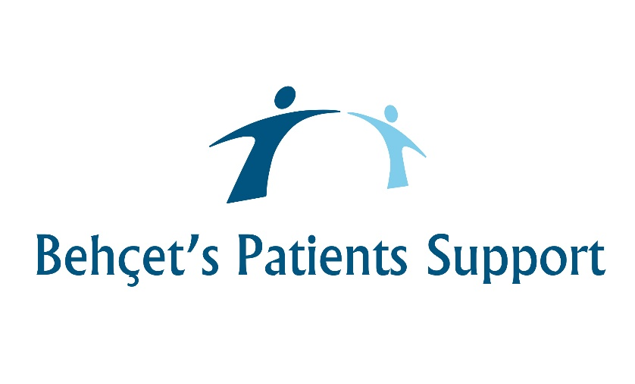

In partnership with the NHS and Behçet’s UK
Helping people with Behçet’s live well.
February 2021
Dear Patient,
Behçet’s Patients Centres (BPC) are committed to protecting your personal information, keeping it safe and being clear about what we do with it.
Your personal data is unique to you, and we have always been careful to protect your information. But it makes sense that you should have control over it too.
That is why a new law, effective from 25th May 2018, gives you more clarity over how your personal information is managed. Its called the General Data Protection Regulation (GDPR) and it replaces the existing Data Protection Act.
The new rules mean we, like other businesses and charities in the UK, will make sure that we’re even clearer about how we handle your data.
We have created a new and clearer Fair Processing Notice which explains how we use your personal information. Details of the new notice are available at https://behcetspatients.org.uk/privacy-policy.
You do not need to do anything, if you have got any questions about these changes or would like a printed copy of the Fair Processing Notice, please email john@behcetspatients.org.uk
Yours sincerely,
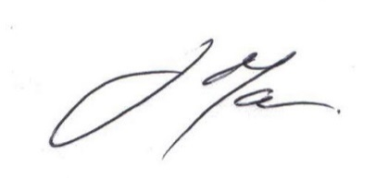
John Mather
Operations Manager
Behçet’s Patients Support
https://behcetspatients.org.uk/

