**Ron Ross Cohen: Creates Masterpieces out of Leather; Unearthing Beauty in Simplicity**

It’s hard to pass by Ron Ross Cohen’s gallery in Stockton’s Noyes Art Museum. There is an authentic sense of true artistry that pulls you in like a magnetic field. Even Cohen’s sign, posted above his store, which reads, Ron Ross Cohen, has artistic flare and depth.

Cohen, a native of Flint, Michigan, first felt sand in his shoes in 1971, when he first came to the Jersey shore. During the 1970s leather was considered a “hot” commodity. Cohen became infatuated with the abundance and beauty of creating artwork from leather.

“I like to define gravity in my work,” said Cohen. “I was dealing with an unknown medium. No one else was doing it.”

In 1977, Cohen created “American Breakfast.” American Breakfast a piece created out of leather, and the piece that brought accolades from critics and art enthusiasts alike.

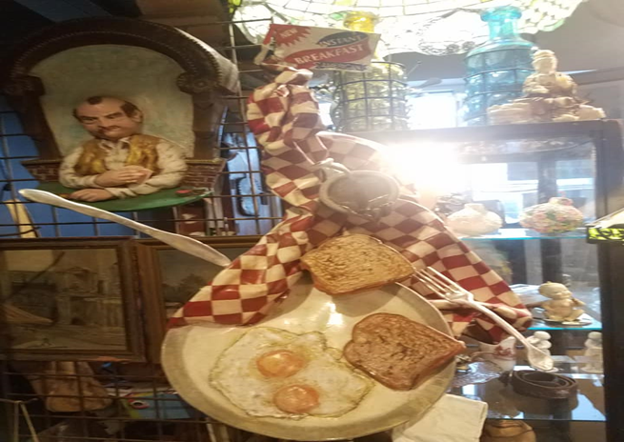

““American Breakfast” was seeking to control the medium,” says Cohen. It’s a natural thing. Everyone can relate to it. I would like to do a whole food series.”

By 1978, Cohen was asked to do a show for Coach’s premiere art show in Paris. The show was entitled: **First Exposition in Paris, "Objects en Cuir."**

“I’m more of a mechanic than an artist.” Cohen says. I would like to be inspired to create the vehicle (ride). I would like to be up against the clock (deadline) to produce art and put it out there.”

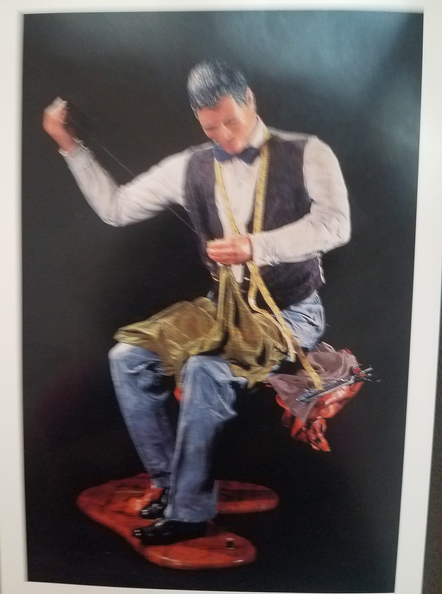

“Sculpture In Leather” by Ron Ross Cohen

In 1998-1994, Cohen was commissioned and featured in Atlantic City’s Claridge Hotel. The piece, titled, “The Winner,” was created entirely out of leather. Every fine detail---the blackjack dealers face, hands, clothes, blackjack table—is delicately constructed from leather. Even the $20,000 worth of chips the dealer is pushing forward—is completely leather.

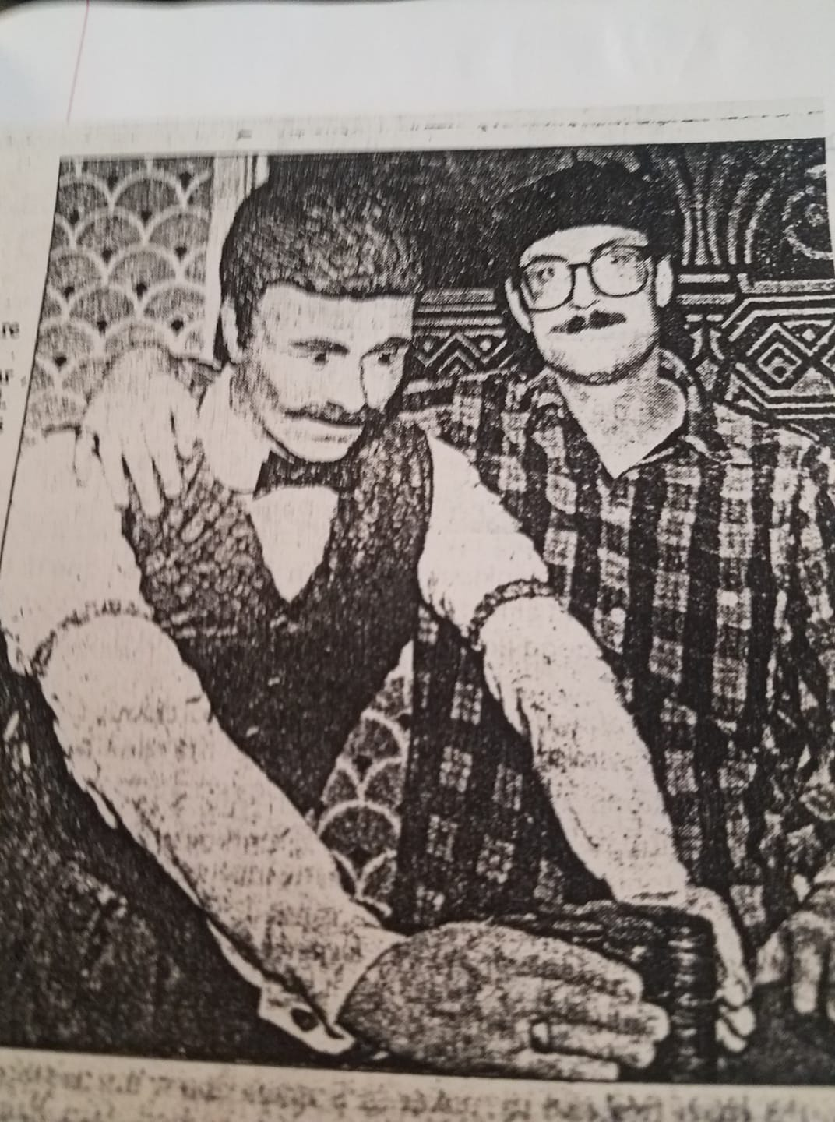

Another influence evident in Ron Ross Cohen’s work is the environment. Cohen is currently creating pieces reflective on saving the environment. “I just try start drawing attention to mother nature. A lot of my messages are, you don’t know what you have until its gone.”

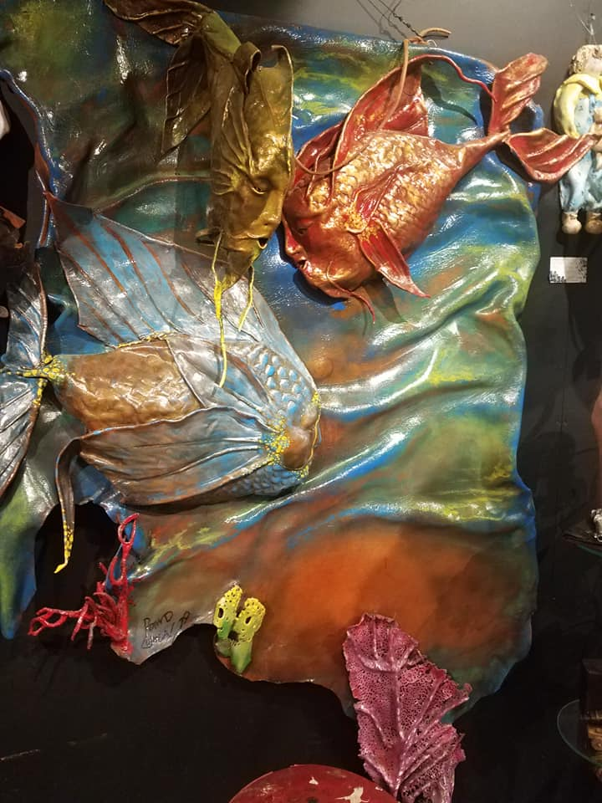

Ron Ross Cohen is currently featured in Stockton’s Noyes Art museum. For further information on Cohen visit: <http://ronrosscohenart.com/>.