Jennifer Wentworth – AKC Golden Retrievers

Health Guarantee

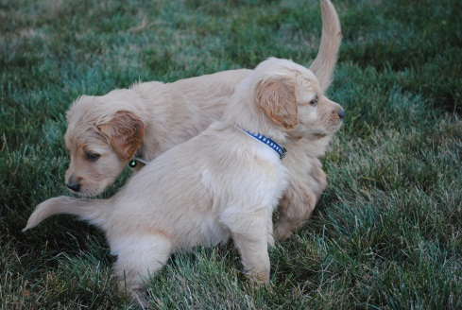

This agreement is made on _______________, by and between Jennifer Wentworth (breeder) and ____________________________________________ (purchaser) and verifies the sale of ownership of the following Golden Retriever puppy:

Golden Retriever Puppy – AKC Litter Registration #_______________

Whelping Date:

Male / Female Price ________

AKC #_____________________

Sire Name: Albert Einstein Wentworth Sire AKC #: SR74650101

Dam Name: Dam AKC #:

I, Jennifer Wentworth, have made every effort to provide a healthy puppy and is guaranteed to be in good health at the time purchaser takes ownership. Since the puppy is at six weeks of age puppy has not yet had eight week shots and de-wormer. Purchaser agrees to provide puppy with shots and send verification to breeder when complete in order to honor health guarantee. Puppies have been vet check prior to leaving our home.

For the protection of both parties, puppy should be examined by a licensed veterinarian within three business days of taking ownership of the puppy. If this puppy if found to have a major health problem at that time, a replacement puppy of equal value will be offered (within 12 months) or a complete refund. A signed letter from the veterinarian stating the exact defect or health problem will be required. If the purchaser does not take the puppy to the veterinarian within 3 business days, this guarantee becomes void.

This guarantee does not include viral illnesses, infections, improper bites, hernias, Guardia or Coccidosis. It also does not include any illness due to the ingestion of foreign objects, food, chemicals or physical injury. I, the breeder, will not be responsible for Parvo, Distemper or Cornona Virus after 24 hours of the sale, as these are highly contagious diseases and they can be contracted immediately after leaving our home.

Your puppy is guaranteed for 1 year from the date of birth against life threatening congenital defects. If within that time a life threatening defect is determined by two non-associated veterinarians, the breeder with replace the puppy with another puppy of the same breed, quality and price (within 12 months). The breeder must be notified at the onset of the problem, in writing, with report from the two veterinarians.

You, the purchaser, agree to insure your puppy’s good health and to keep our guarantee in effect by taking good care of your puppy, providing premium quality food, housing and medical care.

Seller: ______________________________________ Date: _____________

Purchaser: ___________________________________ Date: _____________

Address: _______________________________________________________________

Phone #: _______________________________________

UNCONDITIONAL GUARANTEE: You may return the puppy in the same condition it was when acquired within 10 days of purchase and full price will be refunded.

*****This contract is valid only for the original purchaser.

Jennifer Wentworth

706 Grove Lane SE

Rainier WA 98576

360-901-2988