
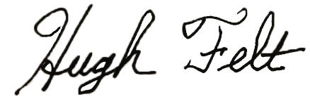

Presented To
~ Name~
Fall 2026
Academic All-State Girls
Honorable Mention

All State Director

Coach

