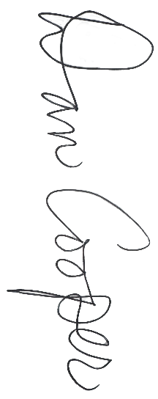
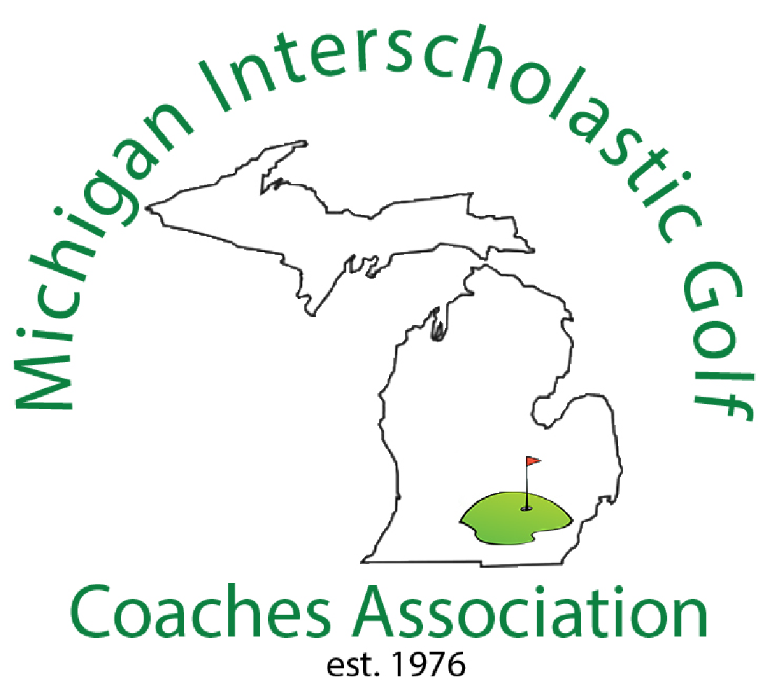


All-State Girls
Honorable Mention
Division 1

~ Name ~
Fall 2025

MIGCA President

Coach

