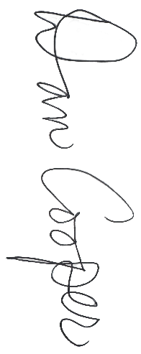
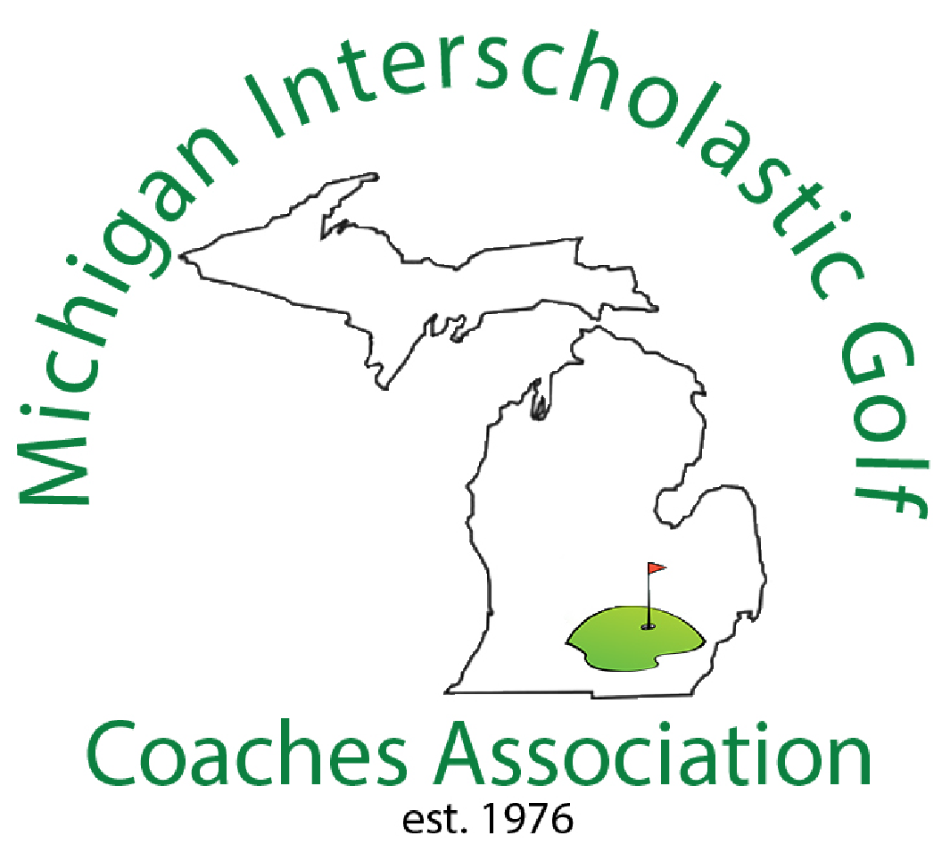

Division 4
~ Name ~
All-State Girls
Honorable Mention
Division 4

Fall 2025

MIGCA President

Coach

