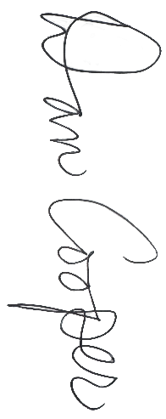


All-State Girls
Division 3
1st Team All-State
Division 3
Presented to
~ Name ~
Fall 2025

MIGCA President

Coach

