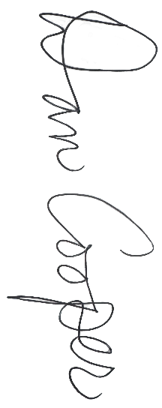


~ Name ~

All-State Girls
Honorable Mention
Division 1

Fall 2026

MIGCA President

Coach

