


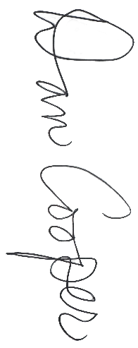
Division 2
~Name~
All-State Girls
Honorable Mention
Division 2
Fall 2025

MIGCA President

Coach

