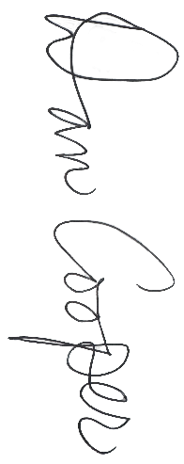



Division 4
~ Name ~
All-State Girls
Honorable Mention

Fall 2026

MIGCA President

Coach

