

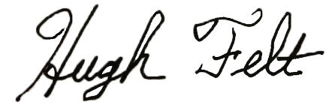
Girls Academic All-State Team

Presented To
~ Name~
~ Name~
~ Name~
~ Name~
~ Name~

Fall 2026
_____________________________
All State Director
_____________________________
Coach

