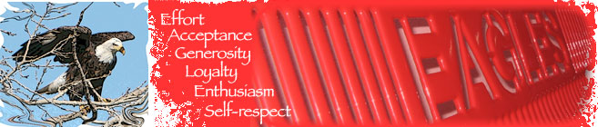

DATES TO REMEMBER
- May 5 8th Grade Visit LRHS
- May 3-5 & 9-11 Smile Mobile
- May 17 Vision Screening
- May 30 No School Memorial Day
- June 1 8th Grade Promotion
- June 9 Last day of School
- June 13-July 1 Summer School

Dear Families:

This June will mark the end of my second year here in Nespelem School District. I grew up in a small town outside of Spokane with my father. He was a teacher and the first one in his family to go to college. He was born in Antlers, Oklahoma, located on the Choctaw Reservation, were he lived with his mother until he was ten, when he moved to Spokane. His father’s family was originally from the Cherokee Reservation in Northeast Oklahoma. Currently my father still lives in Spokane and I live here in Nespelem on the school campus. On the weekends, I go to visit my two daughters whom I raised alone. They both attend WSU, one in Pullman at the Veterinary School and the other in Spokane at the School of Pharmacy. When I’m not working here or visiting my daughters, I enjoy camping in the woods or kayaking on the lake. The time I spend in nature revives me so that I can come back to the school and give my full attention to improving the education provided to the students in Nespelem School District. My hope is that your children will leave this school with all of the tools they need to be successful members of the community.

Enjoy the spring weather,

Dr. E. Dean
Effie J. Dean, EdD
Superintendent
Nespelem School District #014
edean@nsdeagles.org

Counselors Corner: Mrs. Desirae Bear Eagle, MSW

Hello, ?ehé, waỳ xast sxlxẛalt,
The 2021-2022 school year was full of learning, changes, and progress. The students have worked on characteristics of Respect, Empathy, Responsibility, Courage, Perseverance, Honesty, Cooperation, Gratitude, and Kindness. K-8 received lessons on Social Emotional Learning (SEL) and how to recognize and self-regulate those feelings. Another key lesson is relationship skills (friendships with other students and teachers). The students have made a lot of progress in their educational learning and social skills. The pandemic created challenges, but it also created a lot of opportunity. The skills each child has learned, is something they need to continue to develop and nurture, especially over the summer.

An important key to social skills is for students to limit their screen time. If your child will be on their devices for long periods of time, please consider adding educational apps. I would suggest ABC Mouse, Prodigy, Moby Max, and Khan Academy.

The student’s social growth is just as important as their educational growth. So what can you do to foster growth over the summer? So over the summer months, please continue to check in with your child, ask them about how they’re feeling and how there day was. The most common answer you will receive is good, but a great follow up is…tell me what was good about the day. Some good social emotional learning books to read for elementary students are: “The Crayons’ Book of Feelings” by Drew Daywalt, “The Way I Feel” by Janan Cain, “Can You Tell How Someone Feels” by Nita Everly, and “Talk and Work It Out” by Cheri Meiners

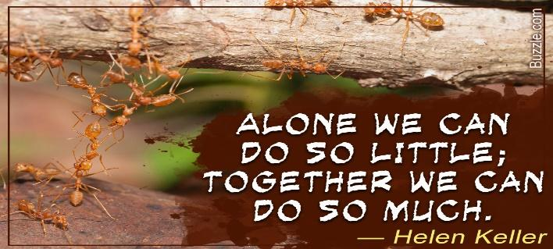
The following books are mature in nature, dealing with things that are real life: drugs, abuse, grief, recovery, kindness, and it shows how they are dealt with. The Seventh Most Important Thing (redemption, the power of kindness, recovery from grief), Fighting Words (about parents drug addiction, foster care, a road to recovery, and The List of Things That Will Not Change (about grief, death, unlikely friendships and coping). These books are ways to have discussions about real life events and topics that are real to our own lives, our community, and in the world. These are suggestions and assist with teens and mental health issues.

Please continue to stay safe, stay healthy, and if I can be of any help please don’t hesitate to send me an email at dbeareagle@nsdeagles.org or call me at Nespelem School 634-4541.
Thank you, Qe ‘ci’yew’yew, nínwiʔs łwikn̓tsn
APRIL’S STAR STUDENT

Kindergarten News:
The kindergarten students have been putting in a lot of work in reading and math this year, and their test scores definitely show it! As of April, all of the kindergarten students are at kindergarten level or higher in both reading and math! Several kindergarten students are at 1st, 2nd, and even 3rd grade reading and math levels! Our current curriculum is Success For All, and I have seen students flourish with this program. Kindergarten students are reading sight words, several short sentences, and completing addition and subtraction problems. Not only have they made strides in their academics, they have also become more confident in the classroom! Many of them had not been in the classroom until this year because of COVID. It took some time to get into the swing of things, but once they did these students soared!
I am so proud of this kindergarten class, as they continue to grow every day!
- Miss Madisyn

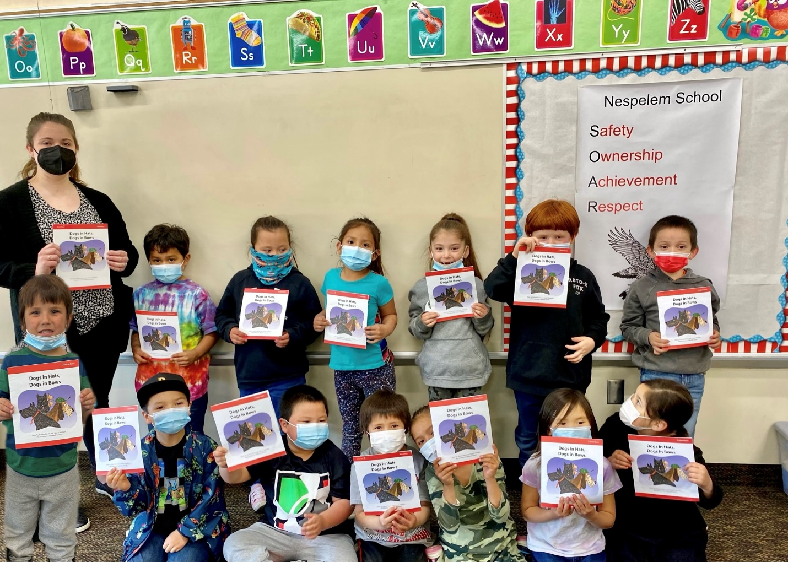

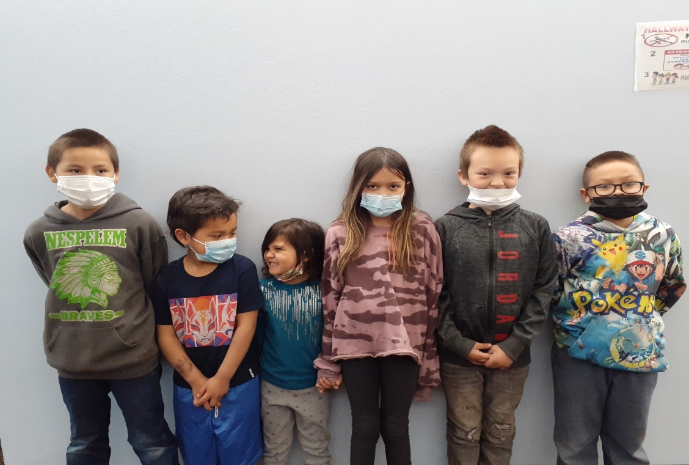
The two pictures show our star students. Each of our star students shine by finishing work on time, following directions, being kind and helpful to their peers and are all around stars.
Introducing our stars: (Left – Right)
3rd grade: Jasyn Vallee
Kindergarten Ezra Marquez-Trevino
Transitional K Lurayah Picard
Second Grade: Jaiyana Marchand
4th Grade; Alec Flett
Jase Thomas

The Middle School Teachers are proud to announce: Anela Somday is our Student of the Quarter. Anela is always here on time, is willing to help her classmates, and never has a negative attitude. She is such a blessing to have in our classrooms each day. She has a GPA of 4.00 which shows how hard she works in the classrooms. CONGRATULATIONS Anela Somday!!! Keep up the good work.
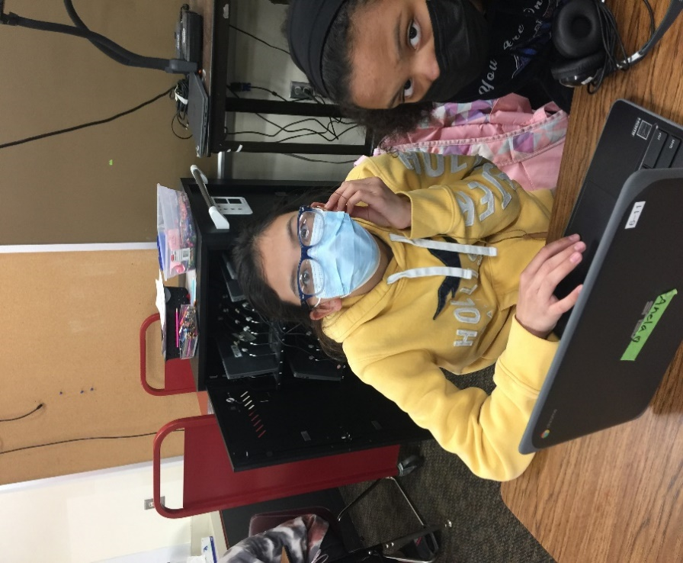
The 8th grade promotion is scheduled for June 1st. We will be doing the parade again this year. A big shout out to all the 8th grade class you made it, (well almost)!!!!!!

