

ALL-STAR TRYOUT PACKET 2026-2027

Welcome to the Storm family!
We are excited to get started on SEASON 10!
Here at Texas Storm Athletics, it is our goal to develop strong competitive teams with well-rounded athletes who understand the true meaning of teamwork. They will have shown compassion and kindness as well as strength and toughness. Above all, they will have learned how to train like the best, to be their best, and to beat the best! The staff members of TSA are here to provide the highest quality coaching as well as a positive environment that will encourage athletes to safely push their limits and learn new skills.

TRYOUT INFORMATION:
Tryout Fee: $125 per Athlete

Step 1: Sign up through our Parent Portal (IClassPro) located on texasstormathletics.com for 26-27 All Star Tryouts and pay the tryout fee.

Step 2: Fill out our Texas Storm Athletics 26-27 Tryout Form located on texasstormathletics.com.

Step 3: (NEW ATHLETES ONLY) Sign up for your pre tryout evaluation on texastormathletics.com to receive your tryout group dates and time.

Our three-week tryout process is designed to give athletes the opportunity to demonstrate their skills and versatility across various positions. During this time, our coaching staff will evaluate each athlete’s performance to ensure they have the chance to showcase their full potential. Tryouts will begin May 18th and end June 4th.

Tryout Schedule May 18th-June 4th:

Athlete Group Assignment:
New athletes will be assigned to their groups following the completion of their pre-tryout evaluation. Returning athletes will receive a band message or email confirming their group assignment once they have submitted their 26-27 all-star tryout form (Step 2).

-BLUE GROUP: MONDAY/WEDNESDAY 5:00-7:00PM
-WHITE GROUP: TUESDAY/THURSDAY 5:00-6:30PM
-RED GROUP: TUESDAY/THURSDAY 6:30-8:30PM

All athletes will be required to wear a black sports bra, black spandex with a high pony and black bow for the duration of the tryout. Tryouts are CLOSED to all spectators. During your tryout process your athlete will be evaluated on their skill level as WELL AS EXCUTITION. Ultimately an athlete’s placement on a team is at the gym’s discretion. Please know that at the end of this process we will create teams that have the best chance to be competitive and successful TOGETHER.

Flyer Tryouts:
If you would like to be considered for a flying position this season, you will be required to attend a flyer evaluation. There is no fee or sign up required beforehand.
Athletes 8 and under will attend on May 19th @ 5-6pm
Athletes ages 9-12 will attend on May 21st @ 5-6pm
Athletes ages 13 and older will attend on May 27th @ 6-7pm
During evaluations, athletes will have the opportunity to demonstrate their flexibility, body control, and a variety of advanced and elite flyer skills within a group setting. This allows our coaches to properly assess technique, confidence, and overall performance as part of a stunt group.
*Team Reveals will take place Friday June 5th via email*

June Payment and Deposit Information:
In the month of June, there will be a single payment due. On June 15th, the All-Star deposit will be required, which covers the cost of uniforms, practice wear, competition bows, practice bows music and choreography.
- Returning members using the same uniform and bow will be required to pay a deposit of $800.
- New members or athletes leveling up will be required to pay a deposit of $1,500.
*If you can purchase a used uniform before June 15^{th,} please see Coach Bri to confirm new deposit amount.

All STAR TUITION PRICING:
(Multiple payment options available)

You will have the opportunity to pay your tuition in 3 ways:
PLEASE NOTE: That there will be 2 required payments per month. 1 payment on the 1st (Tuition) and then another payment on the 15th (Extra Dues). Extra Dues will be released once we have received pricing for the 26-27 season from Varsity in attempt to provide the most accurate pricing for every team.

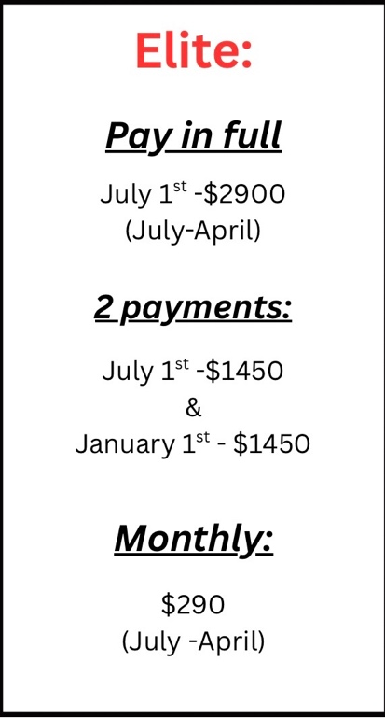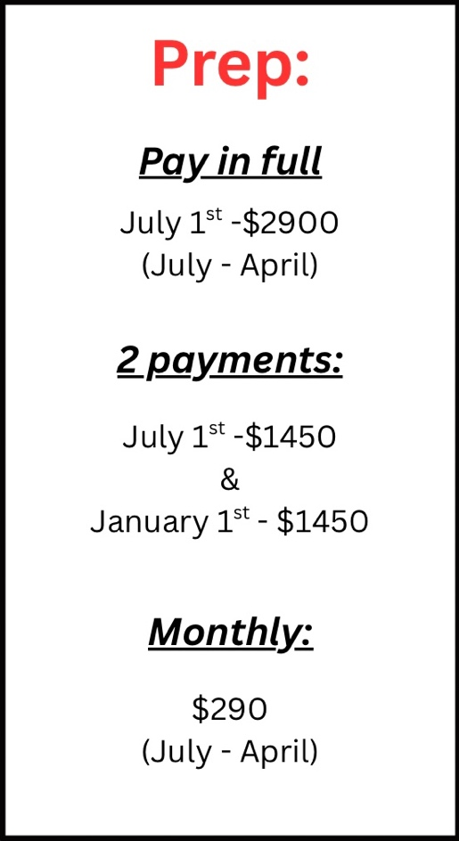

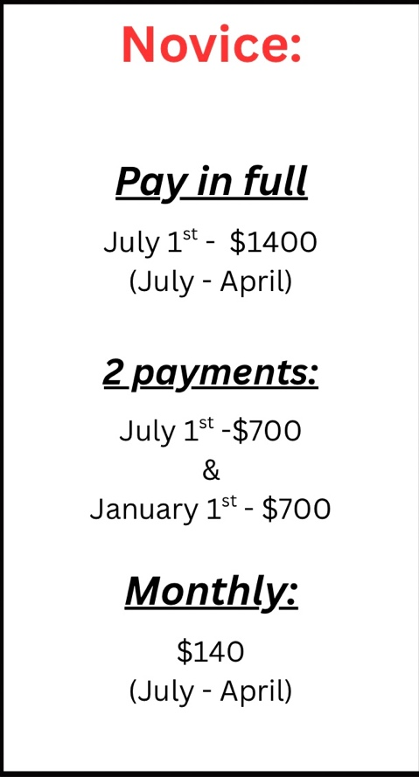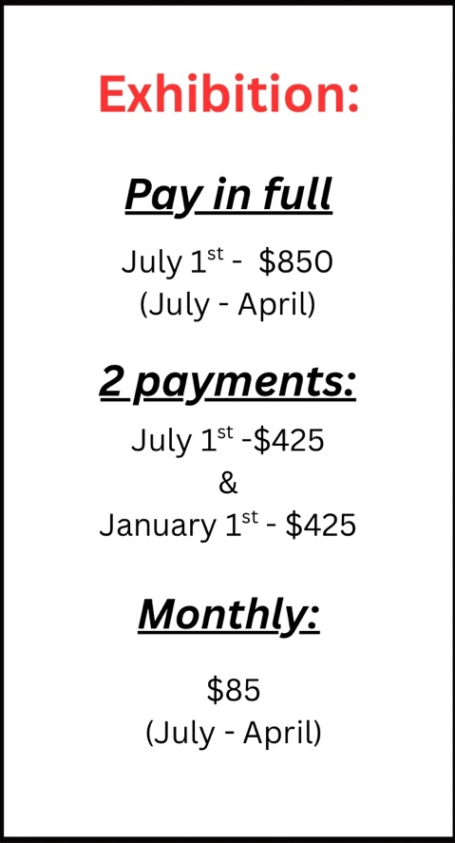

Competition Schedules:
*ELITE*
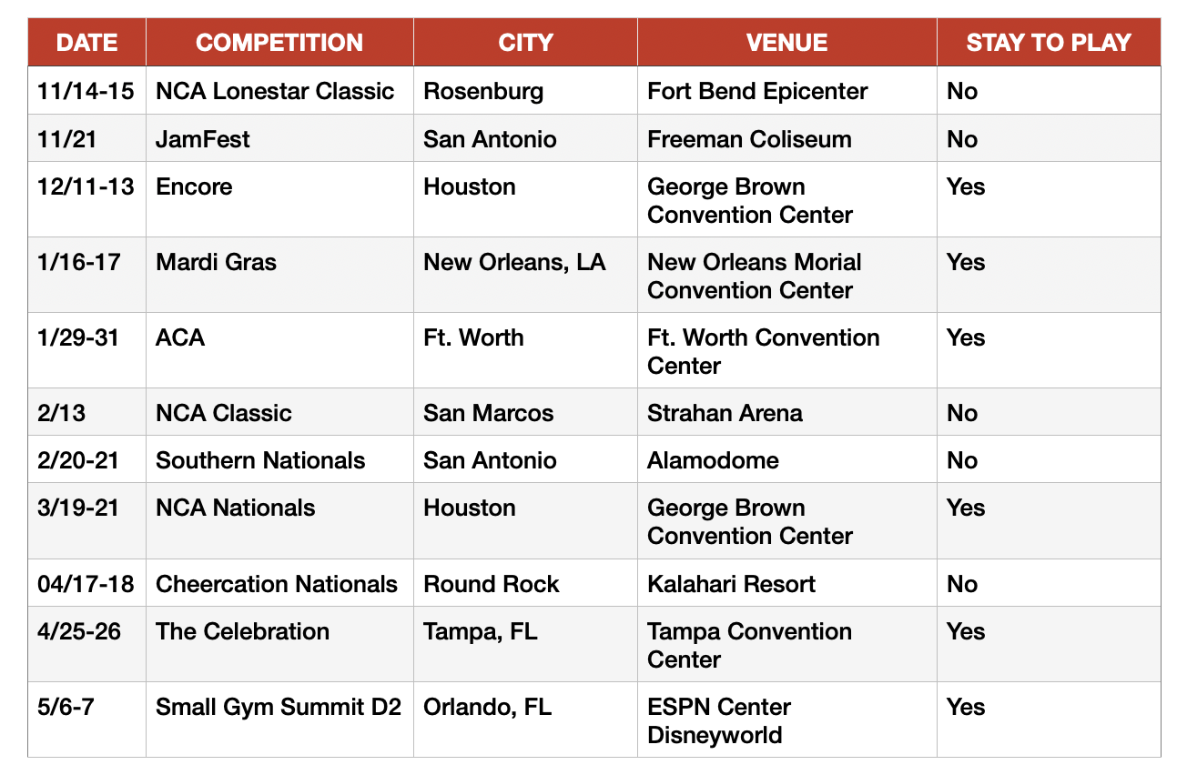

*PREP*
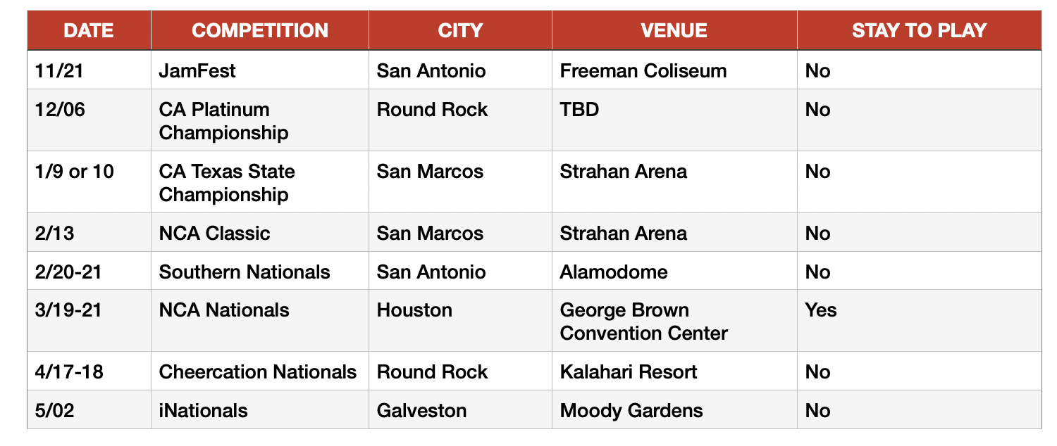

*NOVICE/*EXHIBITION*

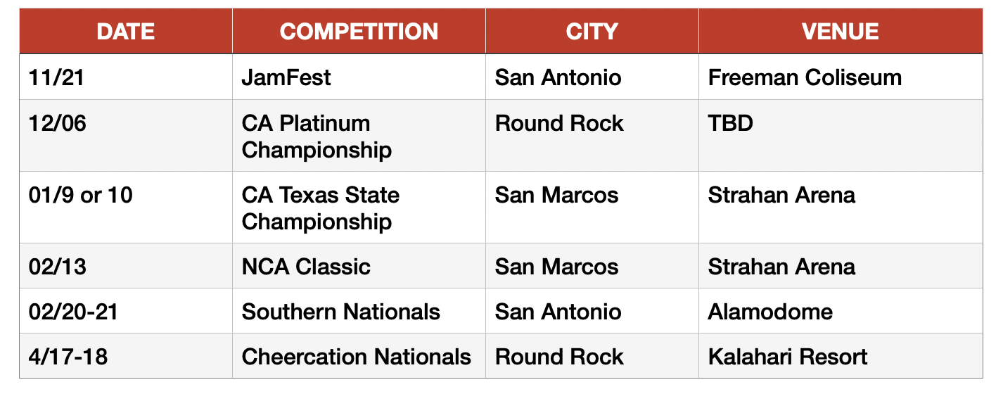

PAYMENT POLICY:

ALL accounts will be auto drafted on the 1st and 15th of each month. The fees will be broken up into 2 payments. Payment on the 1st of each month is your FIXED tuition pricing and all extra dues with be charged on the 15th. Athletes’ delinquent on their tuition/extra dues will be required to attend practices, but sit out, until accounts are brought current. They will not be allowed to participate in competitions, classes, or private lessons when accounts are delinquent. Accounts are delinquent after the 5th/20th of each month. Please note that all payments made are non-refundable. This applies in the event of voluntary withdrawal or if an athlete is removed from the team for any reason, including but not limited to disciplinary action or failure to meet team requirements.

LATE FEE:
A late fee of $50 dollars will be charged to the account if payment is not received by the 5th or 20th of each month. If no payment is made within that month, then the athlete will not be allowed to participate in practice or competition till the balance is paid.

USASF FEES:
Parents are responsible for creating/renewing their USASF membership. There is a $49 fee, and for all new members to upload a copy of your athletes’ birth certificate. You will be required to have your athlete registered online by July 31st ,2026! Anyone who does not register with USASF will NOT be eligible to compete.

TRAVEL FEES:

All travel fees for athletes and families are the parent's responsibility and not included in your team fees. Some of our competitions are “Stay to play”, which means that we are required to stay at the specific locations that are reserved by Team Travel Source. 100% compliance with this policy is required for our teams to be eligible to compete. TTS will provide a variety of hotels that are reserved within the housing block and can accommodate your family’s needs.

LATE SIGNUP:

Athletes signing up after June 2026 will be responsible for the full month’s tuition upon registration regardless of which day of the month they begin training. There will be no proration of tuition.

ATTENDANCE POLICY:

All Star cheerleading is a select team sport requiring full commitment from athletes and parents. All practices and required events are mandatory. Athletes may take summer vacations (June–August),but should not miss more than two consecutive weeks.
All absences (excused or unexcused) must be submitted online for approval in advance. Additional practices may be scheduled as needed and are mandatory. Excessive absences, injuries, or extended illness may result in replacement. Five unexcused absences within the season may result in dismissal.

UNEXCUSED ABSENCES:

School electives such as, but not limited to, athletics, gymnastics, sports, band, theatre, choir, etc. Working, fatigue, personal issues, transportation, birthdays, schoolwork, homework, studying, social occasions, weddings, church occasions, family occasions, family time, etc.

EXCUSED ABSENCES:
Attendance is required at all practices, classes, and events unless excused by a coach for illness, injury, or qualifying circumstances. Excused absences include graded mandatory school functions, a death in the family, or a physician-diagnosed contagious illness with documentation. Proof is required for all excused absences.
Attendance will be recorded at all required activities from the second week of August

through the final competition/event. Parents must notify coaches in advance of absences, tardiness, or illness.
Athletes are responsible for making up missed material, which may require additional practices or private lessons (scheduled with the coach). Absences due to illness or injury within one week of a competition may result in removal from the event at the coaches’ discretion.
No refunds or make-up classes will be provided for missed practices.

MS/HS SCHOOL SPORTS POLICY:

Participation on an All-Star team requires full commitment. We do not accommodate conflicts with school sports or other extracurricular activities during the season. If you decide to take on the additional activity, then a fee of $25 will be charged if an athlete is more than 30 minutes late to practice.

DISMISSAL POLICY:

Texas Storm Athletics reserves the right to remove an athlete from the program at any point during the season at our discretion, based on conduct, performance, or other considerations deemed necessary by the organization.

EXIT FEE:
If an athlete voluntarily withdraws from the program during the season, a non-refundable exit fee of $500 will be required and charged the day of withdrawal. This fee helps cover a replacement for the athlete and ensures a smooth transition for the team and coaches.

ALL STAR FLYER POLICY:
All flyers are REQUIRED to arrive 30 minutes prior to their scheduled practice time for the first practice of each week. All flyers will be working flexibility, stamina, and performance of the flyers required for their routine and/or level.

NOVICE AND PREP TEAM TUMBLE (NEW POLICY):
For the 26-27 season please note that a team tumble will be included in your tuition and will be scheduled after or before your team practice. This is a new policy that is built to help our newer athletes understand the foundation, technique and team synchronization. Any additional classes such as stretch, jump, flyer and/or recreational tumble will be additional fees.

ELITE TUMBLE CLASSES:
For the 26-27 season please note that we have ADDED a tumble class into your fees and will be REQUIRED by every athlete. Please also remember that team practice is not the place for your athlete to learn new skills but to bring their practiced and perfected skills to a routine. It is TSA policy that our all-star athletes do not train or take private lessons with anyone outside of our coaching staff.

END OF SEASON EVENTS
ALL ELITE teams will be competing at an out of state competition therefore, the end of season event and fees will be determined once type of bid is received and will take the place of you May 1st tuition payment.

GYM CLOSURE SCHEDULE:
Memorial Day May 25th
July 4th
Labor Day September 7th
Halloween Oct 31st
Thanksgiving Nov 21st-26th
December 19th-January 3rd
Spring Break March 6th-13th
Easter April 5th

FUNDRASING OPPORTUNITY:
On the next page you will find our beginning of the season fundraising opportunity (Sponsor My Uniform) that will help cover the cost of the deposit. *Please note this is not the uniform for the 26-27 season*
**Second fundraiser will take place beginning of August and cash buy in fee with be required in the month of August**

