**NAPS Completes Briefing of Appeal in Lawsuit Against U.S. Postal Service**

May 13, 2021

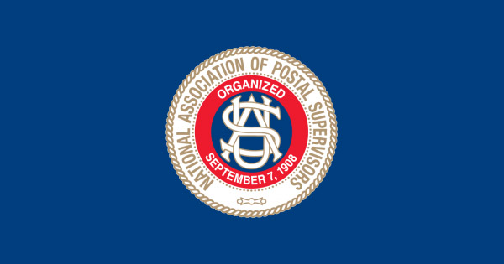

**May 13, 2021**

***NAPS Newsbreak***

**NAPS Completes Briefing of Appeal**

**in Lawsuit Against U.S. Postal Service**

On May 11, 2021, the National Association of Postal Supervisors filed its reply brief in the United States Court of Appeals for the District of Columbia Circuit, responding to arguments made in briefs filed last month by the Postal Service and United Postmasters and Managers of America.

Refuting the Postal Service’s arguments that the requirements of the law are mere “policy guidelines,” NAPS’s brief explains why its members’ rights are enforceable in court. NAPS further explained that, by providing no supervisory differential for thousands of supervisors and by entirely failing to consider private sector-compensation in comparable employment when setting EAS pay, the Postal Service violated enforceable statutory requirements. It also explained how the Postal Service’s refusal to recognize NAPS’s representation of most Headquarters and Area EAS employees and its refusal to recognize NAPS’s representation of its over-4,100 postmaster members violates the law. As NAPS briefed the Court, the law requires that the Postal Service consult with NAPS regarding pay packages and other programs that affect all supervisory and managerial employees, *i.e.*, all EAS employees who are NAPS members.

Oral argument before a three-judge panel of the Court of Appeals is likely to occur sometime in the fall.

NAPS’s reply brief is attached [here.](https://naps.org/files/galleries/NAPS_Reply_Brief.PDF)

NAPS’s initial brief is attached [here.](https://naps.org/files/galleries/NAPS_Opening_Brief.PDF)

The Postal Service’s brief is attached [here.](https://naps.org/files/galleries/USPS_Brief.PDF)

UPMA’s brief is attached [here.](https://naps.org/files/galleries/UPMA_brief.PDF)