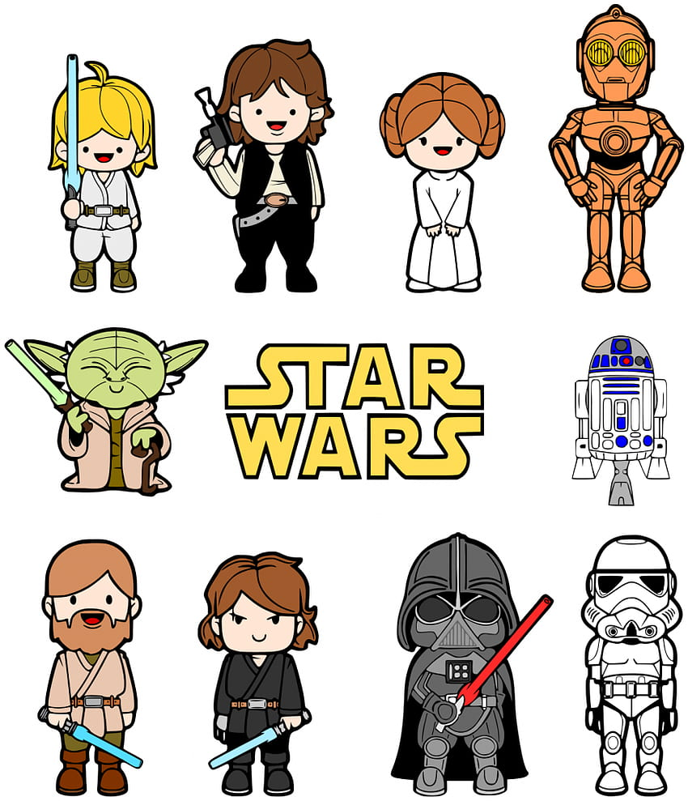  Blue zone | Green zone | 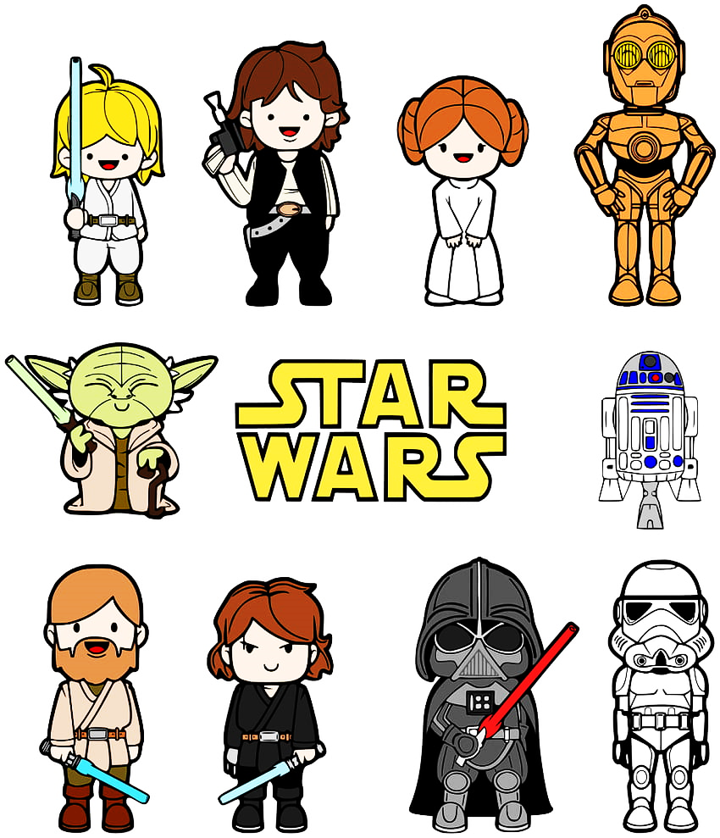  Yellow zone | RED ZONE
Sad  Sick  Tired  Bored | Happy  Calm  Feeling Okay  Good to go  Focused & ready to learn  Chilling | Frustrated  Annoyed  Nervous  Over-excited  Silly/Wiggly  Tired | Angry  Yelling  Out of control  Enraged  I need space & time  Mad or Mean
WHAT ZONE AM I IN?

