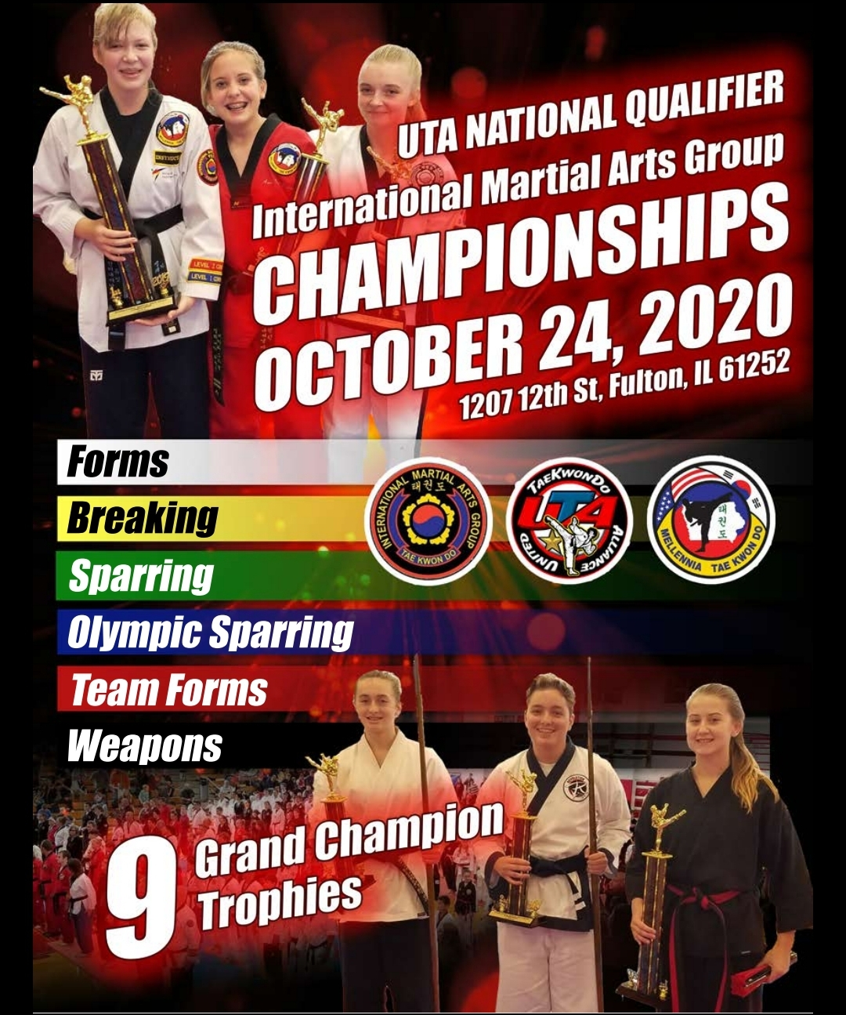

2020 Martial Arts Championships

Date: Saturday, October 24th , 2020

Location: Fulton High School (Riverbend High School)
1207 12th Street, Fulton, IL 61252
Pre-registration: Must be received by October 10th 2020.
Registration: 8:00 – 9:30 a.m.
Entry Fee for one or all events: $45.00 (preregistered) must pre-register by 10-10-2020
$60.00 (at the door)
Spectators: Adults (13yrs & older) $2.00
Children (6-11) $2.00
Children (under age 6) Free
Sorry we do not offer refunds for competition or spectators

Tournament Director: Master S. E. Nixon IMAG Staff

Send Registration to: Mellennia TaeKwonDo
1142 Jefferies Drive
Clinton, IA 52732

Make checks out to Mellennia TKD (please do not staple check to entry)

Schedule of Events

October 24th , 2020 7:00 a.m. Set up of the event

8:00 a.m. Registration Begins
9:30 a.m. Registration Ends
9:00 a.m. Weapons, Team forms BEGIN 9:00 SHARP

10:00 a.m. Competition for under ranks
PLEASE NOTE: WEAPONS AND TEAM FORMS WILL COMPETE AT 9:00
All Times are subject to change. We will move the event as quickly as we can.
Please be sure to listen for your division at the event. Please understand we cannot guess when you or your student will compete. Please be on time to your ring so you are not missed/disqualified.
Message from the Director
I want to personally invite you and your school, friends and family to partake in a day of fun, friendly competition in Fulton, IL. The International Martial Arts Group and Mellennia Martial Arts have put together a great event for you to enjoy. The tournament is one that will be a wonderful starting event for first time students; as well as a great one for more seasoned competitors. All of the judges will follow the International Martial Arts Groups rules on refereeing and there will not be any favoritism or politics. Our goal is for you to come and enjoy your day and have fun. Tournaments are a great way to meet new people, build partnerships, and challenge yourself and your friends. I am very excited for everyone and am looking forward to seeing all of you on the morning of October 24th in Fulton, IL at the High School. Good luck and Pilsung!
Thank you in advance from the members of the International Martial Arts Group also the Black Belts and Students of Mellennia Tae Kwon Do.
You do not need to be a IMAG or UTA member to compete!

UNIFORMS & EQUIPMENT

Uniforms: All competitors can wear their school uniforms and patches, which are allowed at all events. Uniforms are mandatory to include, dobak pants, top and belt. If you are on the competition area you will need to be in uniform. Everyone on the competition floor will need to be in uniform or asked to return to the stands. All officials and judges must be in uniform. No street clothes or suits on the floor.
Mandatory
Equipment: Continuous Point Sparring –All competitors must wear full hand and foot protections (any color foam dipped/vinyl only) Toes and fingers must be covered, head gear (any color dipped foam only), and mouth guard. Male competitors must also wear groin cup and supporters for sparring.
Optional Equipment: Competitors may wear cloth or foam shin and forearm protectors (any color only) at their discretion in addition to required equipment.
Olympic sparring-Hogu, instep, punch and helmet. Cup for males and mouth guard for all. Bring your own Hogu.
Judges: Judges / Black Belts will be assigned to rings. Please understand that to make the event run we need your help. We know that everyone wants to watch their students. We do as well. Please help us help you and your members have a great event!
SPECIAL NOTES
The tournament committee reserves the right to further divide or combine divisions depending on the number of competitors registered to compete in each. Also to disqualify or refuse a student or school due to poor sportsmanship.

Sparring (Continuous Point with clickers)
The sparring event will use the standard Tae Kwon Do point sparring rules. The point areas will be the sides and top of the head. Nothing to the face area! The torso is a target area for striking as well to the sides of the ribs, stomach, chest, but not to the throat or the sides of the throat, and no strikes below the belt. One point will be awarded for any hand or kicking technique to the torso area or a punch to the head. Two points will be awarded for any kick to the helmet area. No kicking to the face or back of the helmet. Three Points will be awarded for any jump kick to the helmet. The competitor scoring the most points at the end of two minutes (adults) or 90 seconds (kids) will be declared the winner. SAFETY IS KEY, if a competitor is injured and blood is drawn the match will stop and the center judge will make a call with the corners to decide on a disqualification or warning on the attacker. Warnings and point loss may occur as well for other infractions such as continuing to kick below the belt or to the back, a kick or punching the face area. Tournament director has full authority and will make final calls if needed.
Olympic Sparring Olympic sparring you will need to bring your Hogu/chest protector. No electronics at this time. This will be scored by proper technique and power to the correct scoring areas. Body kicks will be scored 1 point however a spinning kick will be scored 2 points. A punch to the body is scored as 1 point. NO punches to the head. Head kicks to the sides of the helmet will be scored at 3 points unless they involve a spin then they will be awarded 4 points. Opponents cannot grab their opponent, hold or push. The rounds will be two one minute rounds. THIS IS NEW AND A TRIAL DIVISION. The Gap will the used if a person at the break has a overall 12 point gap over another competitor. If this competition does well we will include full rules in the future. THIS IS NOT USAT, AAU.
One Step/ Sparring Demo This event will be held as a option for those schools who do not spar at White and Yellow belt. This event will be a demonstration of skill with your schools sparring or one step skills. This will be graded similar to forms and will be scored on the technique, balance, proper strike, and students skill level will be taken into consideration.
Forms open hand and Team Forms Competitors will be judged on balance, stances, power, beauty and grace. Judges will have the first 3 competitors perform and then call them back up for scoring before moving on to establish a score. This is your time to shine! You may do any form you choose, however flips and extra techniques will not be given extra consideration. Team forms are limited to a 5 minute time slot. Music for team forms must be appropriate for all ages.
Breaking YOU ARE REQUIRED TO BRING YOUR OWN BOARDS. For Children ages 3-6 you may use 4” wood. Children ages 7-12 may use 6” wood. Children and Adults ages 13 and up may use 12” wood. White to Orange Belts will only break 1 board. Green & Blue Belts will only use 2 boards. Red, Brown & Black Belts will use 3 boards. Bring your own boards. They may be inspected before competition. Wood must be 1x12x12 or 1x12x6 or 1x12x4
Rank # Of boards Stations Age Size of wood
White, Yellow, & Orange 1 1 5 to 6 4''
Green & Blue Up to 2 2 7 to12 5"-6”
Red, Brown, & Black Up to 5 3 13 & up 10”-12”

Grand Champion
Grand champions will be scored as a run off for the forms divisions, The under belts will compete against themselves and Black Belts will be separate.

2020 International Martial Arts Group Championships
INDIVIDUAL ENTRY FORM
DO NOT STAPLE
Make checks payable to:
Mellennia Tae Kwon Do
1142 Jefferies Drive
Clinton, Iowa 52732
Personal Checks Accepted Returned checks will be assessed $20.00 return fee.
TOURNAMENT DATE: Saturday, October 24th 2020

DEADLINE FOR PRE REGISTRATION: October 10th , 2020

ENTRY FEE: 1 Or all Events $45.00 pre-registered
1 Or all Events $60.00 at the door
Spectators $ 2.00

Athlete Name:______________________________________________________________________
Last Name First Name

Address:__________________________________ City:________________ State____Zip__________

Your Phone:________________________________________________________________________

Your Email Address:__________________________________________________________________

Martial Arts School:__________________________________________________________________

Your Instructors name:_______________________________________________________________

Emergency Contact:__________________________________________________________________
Name Cell Number
DIVISIONS*
(Circle the following Events to compete in)

(9:00 a.m. WEAPONS) (9:00 a.m.TEAM FORMS) OLIMPIC SPARRING
FORMS BREAKING CONTINUOUS POINT SPARRING
In consideration of being permitted to participate in any way in the 2020 International Martial Arts Group agree to this waiver. I acknowledge that I am in good health or physical condition to compete in such an event. I fully understand that athletic activities involve risk and serious bodily injury, including permanent disability, paralysis, and death. These risks may be caused by my own actions or inactions of others competing on this said day. There may be other risks and social and economic losses either for losses, cost, and damages I incur as a result of my participation in the activity. I hereby release, discharge, and covenant not to sue the Mellennia Martial Arts, City of Fulton, Fulton School District, International Martial Arts Group or any representatives of martial arts schools or clubs, the volunteer’s, promoters, and judges of the Tournament. I have read and agree to the nature of this agreement fully understand that I have given up substantial rights by signing this and have signed it freely and without any inducement or assurance and intend to be a complete and unconditional release of all liabilities (physical, economical, or any damages incurred) to the greatest extent. Minors Agreement: I as the minors parent or legal guardian, Understand the nature of the competition and that tae kwon do as well as other martial arts are a contact sport, I also agree that the minor in this agreement is in good physical health and in proper condition for competition to compete in such activities. Furthermore I release the 2020 International Martial Arts Group, Mellennia Martial Arts, or any representatives of martial arts schools or clubs, the volunteer’s, promoters, and judges of the Tournament and other competitors from any liability. By signing this agreement, I agree to all of the above, and agree that I am entering this activity well aware of the risks of this event. I furthermore state that I am in good health and able to compete at the level of competition that the event offers. I further state that I and my martial arts school are in good standing of moral turpitude with Mellennia Martial Arts, and the Midwest Martial Arts Group. I agree that I can and will be removed for poor conduct in the event with no refund of costs incurred.

_______________________________________________ ___________________________
Competitor signature Date
_______________________________________________
Co-signer if athlete is under 18

