WILDERNESS ESTATES CABIN RENTALS
OFFERING A DONTION OF A 2 NIGHT STAY
AT A BEAUTIFUL LAKE FRONT OR LAKE VIEW CAMP ON CONROY LAKE IN MONTICELLO
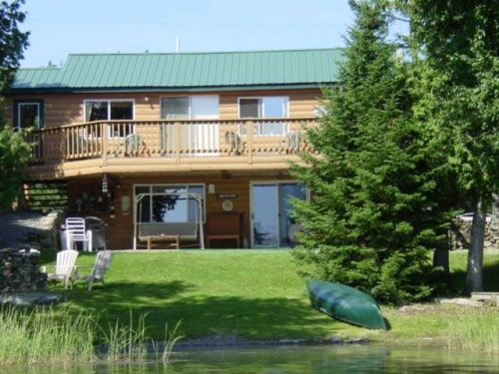
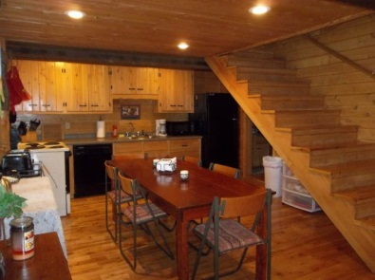
FULL KITCHEN
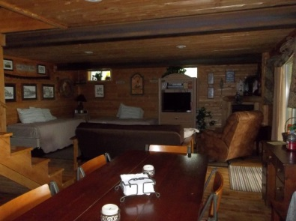
OPEN LIVING AREA
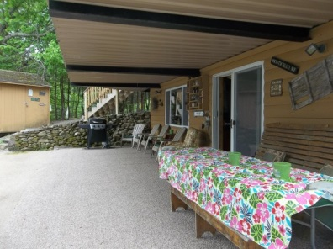
LAKEFRONT COVERED PATIO
- CAMP SLEEPS 7 1 KING 1FULL 3TWIN
- 2 FULL BATHS (LINENS PROVIDED)
- FULLY STOCKED KITCHEN (BRING FOOD)
- DIRECT TV/WIRELESS INTERNET
- DOCK/PADDLE BOATS/ CANOE
- www.vacationhomerentals.com/19646
- for calendar availability and contact ifo
LAKE VIEW CAMP ON CONROY LAKE IN MONTICELLO
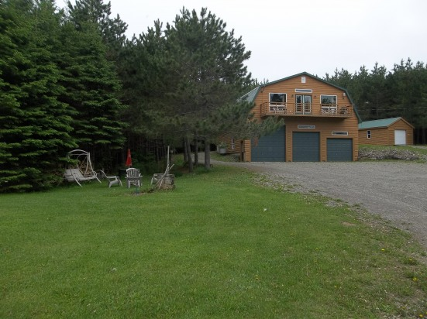
HORSESHOES/FIRE PIT
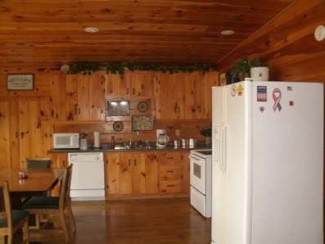
FULL KITCHEN
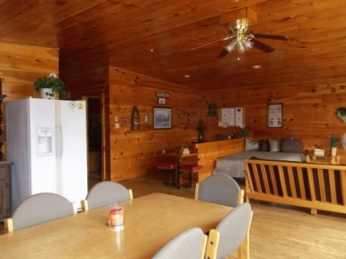
OPEN LIVING AREA
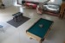
GAME ROOM DOWNSTAIRS
W/POOL PING PONG FOOSEBALL
- CAMP SLEEPS 7 2 KING 1 FULL 1 TWIN
- 1 FULL BATH (LINENS INCLUDED)
- FULLY STOCKED KITCHEN (BRING FOOD)
- DIRECT TV/WIRELESS INTERNET
- GAME ROOM/LAKE ACCESS
- www.vacationhomerentals.com/28106
- For calendar availability and contact info
- Cari Drew 207-532-1469

