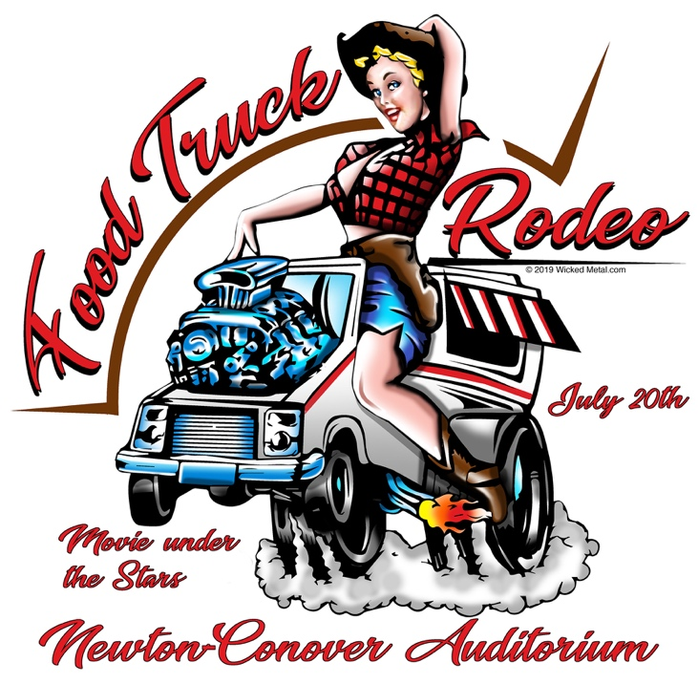

**Food Truck Application**

*Location: 60 W 6th Street Newton, NC 28658*

*Date/Time: Saturday, July 20th 3:00-10:00 pm*

*www.FoodTruckRodeoNewton.com*

**Food Truck Fees:** $75, Application and fee must both be received to hold your spot. Last day to apply for event will be July 12, 2019. All fees and deposits are nonrefundable after July 17, 2019.

**Food Truck Application Acceptance Policy:** Confirmation for the NCA’s Food Truck Rodeo is based on the date and time of application submissions AND payment. For food trucks, we will take your menu into account when we receive your completed application, as our goal is to provide a unique experience for attendees by ensuring variety.

**Proceeds:** Food trucks and vendors keep 100% of their proceeds for sales on the day of the event. Food trucks/vendors are not allowed to sell alcoholic beverages at the event. Our event is on school property and this is not allowed by the school system.

**Set-up, Hours, Teardown:** Food Trucks/Vendors may begin to arrive as early as 12 p.m. on Saturday, July 20th. All set-up must be completed by no later than 2:45 p.m. The event begins at 3 p.m. We expect NCA’s Food Truck Rodeo to be busy with music, eating, drinking & fun contests continuing until the end. Our “movie under the stars” on an outdoor movie screen will start between 8-8:30 p.m. All food trucks are required to remain open until 10 p.m. on event day. There will be NO teardown prior to 10 p.m.

**On-site Resources:** All food trucks and vendors must be able to operate independently of any provided resources at Newton-Conover Auditorium, including water, electrical, refrigeration and any materials. Vendors are responsible for all set-up and clean-up of their booth space on the baseball field and their immediate area surrounding such space.

Yes, we would like to be a participating food truck/vendor at the 2019 Food Truck Rodeo at Newton-Conover Auditorium. Our application and fees are enclosed.

Food Truck Name: ___________________________________________

Contact Person: ______________________Phone:_________________

Email:_____________________________________________________

Address: ___________________________________________________

Zip ____________Website: ____________________________________

Type of Set-up (circle one): Truck Trailer Cart Other

Type of Food/Theme: _________________________________________

**Operating License:** Food trucks must provide Newton-Conover Auditorium with a copy of their Operating License no later than 1 week prior to the event.

**Food Service License:** Food trucks must also provide the Newton-Conover Auditorium with all necessary required paperwork per Catawba County guidelines at least 1week prior to the event.

Applications will be reviewed on a first-come, first-served basis. The Newton-Conover Auditorium will be promoting all participating Food Trucks as well as craft vendors participating in the event. Please forward, via email, ([executivedirector@NCAuditorium.com](mailto:executivedirector@NCAuditorium.com)) your logo to be displayed at the event, as well as on www.FoodTruckRodeoNewton.com, and on the event website www.NCAuditorium.com.

Please Email, Mail, Drop-off your completed Application to: [ExecutiveDirector@NCAuditorium.com](mailto:ExecutiveDirector@NCAuditorium.com), Newton-Conover Auditorium ATTN: Food Truck Rodeo PO Box 1354 Newton, NC 28658. Fees may be paid by mail, in person to our office, or online at [www.NCAuditorium.com](http://www.NCAuditorium.com) – go to “store”.

Questions? Please call our office (828) 464-8100 or by email: [executivedirector@NCAuditorium.com](mailto:executivedirector@NCAuditorium.com)

Additional Food Truck Information and Guidelines:

* Food Trucks will be provided spaces based upon their order of arrival. Food trucks must plan on being there for the entirety of the event (3 – 10 p.m.).
* Post all prices for items at your food truck space.
* Please keep your area clean and do not throw trash on to the ground next to or behind your area.
* No Food Truck or Vendor may produce or sell any merchandise, apparel or promotional items with our Food Truck Rodeo logo or wording without prior consent.
* Number of expected attendees will be provided to Food Trucks/Vendors 1 week prior to the event for preparation purposes. This is no admission fee for the public to attend.

Yes, I am applying as a food truck or vendor for Newton-Conover Auditorium’s Food Truck Rodeo on Saturday, July 20, 2019. I have read and understand the event information, agree to comply with the requirements and have enclosed the $75 payment for the applicable fees. I agree to accept all responsibility for any personal injury, property damage, loss or other harm suffered by myself or otherwise due to my participation in the event. Further, I shall indemnify and hold harmless the Newton-Conover Auditorium and Newton Conover City Schools against all suits, claims, demands and losses including costs, expenses and attorney’s fees incurred as a result of any action or omission, neglect or misconduct.

Signature: ____________________________ Date: ______________