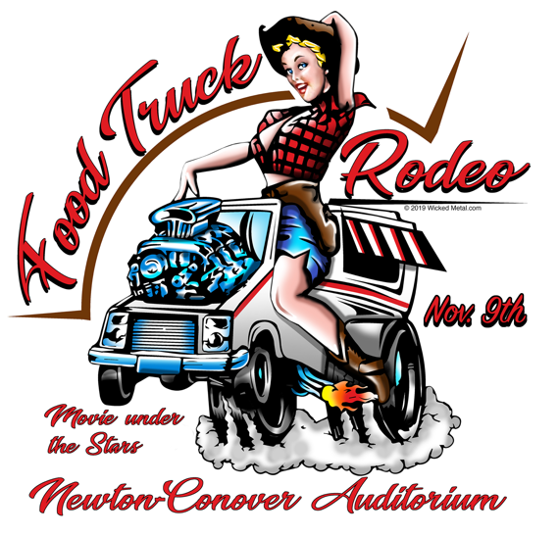

**Food Truck Application**

*Location: 60 W 6th Street Newton, NC 28658*

*Date/Time: Saturday, November 9, 2019 ~ 12:00 pm – 8:00 pm*

*www.FoodTruckRodeoNewton.com*

**Food Truck Fees:** $75, Application and fee must both be received to hold your spot. Last day to apply for event will be November 1, 2019. All fees and deposits are nonrefundable after November 4, 2019.

**Food Truck Application Acceptance Policy:** Confirmation for the NCA’s Food Truck Rodeo is based on the date and time of application submissions AND payment. For food trucks, we will take your menu into account when we receive your completed application, as our goal is to provide a unique experience for attendees by ensuring variety.

**Proceeds:** Food trucks and vendors keep 100% of their proceeds for sales on the day of the event. Food trucks/vendors are not allowed to sell alcoholic beverages at the event. Our event is on school property and this is not allowed by the school system.

**Set-up, Hours, Teardown:** Food Trucks/Vendors may begin to arrive as early as 10 am. on Saturday, November 9th. All set-up must be completed by no later than 11:45 am. The event begins at 12 p.m. We expect NCA’s Food Truck Rodeo to be busy with music, eating, drinking & fun contests continuing until the end. Our “movie under the stars” on an outdoor movie screen will start at 6:00 pm. All food trucks are required to remain open until 8 p.m. on event day. There will be NO teardown prior to 8 p.m. Our outdoor movie will be ‘National Lampoon’s Christmas Vacation’.

**On-site Resources:** All food trucks and vendors must be able to operate independently of any provided resources at Newton-Conover Auditorium, including water, electrical, refrigeration and any materials. Food Trucks & Vendors are responsible for all set-up and clean-up of their booth space on the baseball field and their immediate area surrounding such space. There are trash cans available, please place one in your area. The space in front of your Food Truck is your’s, you are free to set up a tent, tables, chairs in front of your booth space as long as they do not imped walking space.

Yes, we would like to be a participating food truck/vendor at the 2019 Food Truck Rodeo at Newton-Conover Auditorium. Our application and fees are enclosed.

Food Truck Name: ___________________________________________

Contact Person: ______________________Phone:_________________

Email:_____________________________________________________

Address: ___________________________________________________

Zip ____________Website: ____________________________________

Type of Set-up (circle one): Truck Trailer Cart Other

Type of Food/Theme: _________________________________________

**Operating License:** Food trucks must provide Newton-Conover Auditorium with a copy of their Operating License no later than 1 week prior to the event.

**Food Service License:** Food trucks must also provide the Newton-Conover Auditorium with all necessary required paperwork per Catawba County guidelines at least 1 week prior to the event.

Applications will be reviewed on a first-come, first-served basis. The Newton-Conover Auditorium will be promoting all participating Food Trucks as well as craft vendors participating in the event. Please forward, via email, ([executivedirector@NCAuditorium.com](mailto:executivedirector@NCAuditorium.com)) your logo to be displayed at the event, as well as on www.FoodTruckRodeoNewton.com, and on the event website www.NCAuditorium.com.

Please Email, Mail, Drop-off your completed Application to: [ExecutiveDirector@NCAuditorium.com](mailto:ExecutiveDirector@NCAuditorium.com), Newton-Conover Auditorium ATTN: Food Truck Rodeo PO Box 1354 Newton, NC 28658. Our office location is 601 Ashe Avenue in Newton. Fees may be paid by mail, in person to our office, or online at [www.NCAuditorium.com](http://www.NCAuditorium.com) – go to “store”.

Questions? Please call our office (828) 464-8100 or by email: [executivedirector@NCAuditorium.com](mailto:executivedirector@NCAuditorium.com)

Additional Food Truck Information and Guidelines:

* Food Trucks will be assigned spaces. This map will be emailed after the deadline of 11/1/19. Food trucks must plan on being there for the entirety of the event (12 - 8 p.m.).
* Post all prices for items at your food truck space.
* Please keep your area clean and do not throw trash on to the ground next to or behind your area.
* No Food Truck or Vendor may produce or sell any merchandise, apparel or promotional items with our Food Truck Rodeo logo or wording without prior consent.
* This is a free/no admission fee for the public to attend.

Yes, I am applying as a food truck or vendor for Newton-Conover Auditorium’s Food Truck Rodeo on Saturday, November 9, 2019. I have read and understand the event information, agree to comply with the requirements and have enclosed the $75 payment for the applicable fees. I agree to accept all responsibility for any personal injury, property damage, loss or other harm suffered by myself or otherwise due to my participation in the event. Further, I shall indemnify and hold harmless the Newton-Conover Auditorium and Newton Conover City Schools against all suits, claims, demands and losses including costs, expenses and attorney’s fees incurred as a result of any action or omission, neglect or misconduct.

Signature: ____________________________ Date: ______________