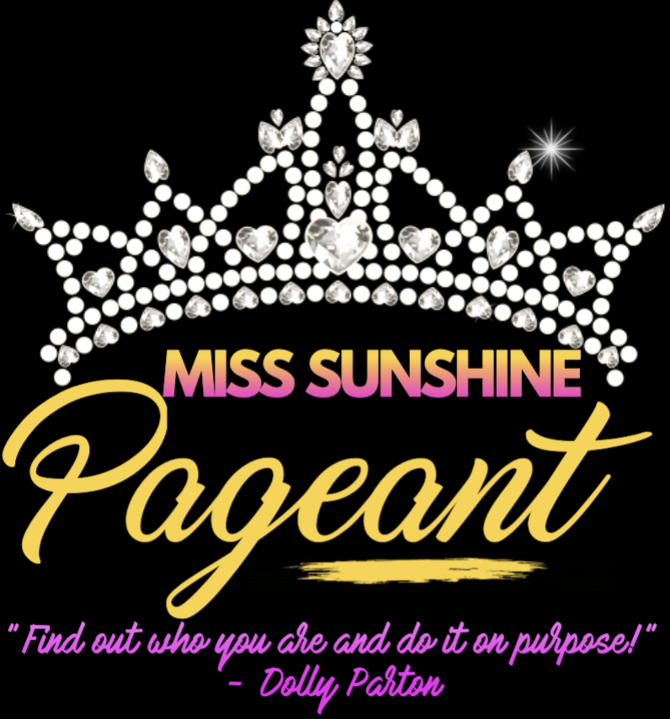

**Pageant Date: Saturday, October 2nd**

**Registration 8:30am/Pageant starts at 10am**

**Newton Performing Arts Center , 60 W 6th Street, Newton, NC**

###### Deadline to Enter September 27th

###### Age Division Break-Down

(Age as of pageant day)

*Baby Miss Sunshine: 0-12 months*

*Wee Miss Sunshine 13 months-3 years *

*Tiny Miss Sunshine: 4-7 years *

*Little Miss Sunshine: 8-12 years *

*Teen MissSunshine: 13-15 years*

*Miss Sunshine 16-18 years*

**\*Mini Majestic Miss Sunshine: 0-12 years\***

**\*Majestic Miss Sunshine 13-18 years\***

**Beauty:**

Sunday Best for 12 and Under. 13-18 prom or pageant dresses are acceptable- Makeup **MUST** be age appropriate. Remember to keep little ones their age! Contestants 12 and under should have no makeup other than light powder/blush and lip gloss. Contestants over the age of 13 need to be natural and look their age. Age Appropriateness is a major scoring factor!

**TALENT {Optional}**

Showcase your Talent! Dance, Sing, Play the banjo, recite a poem, whatever you can do… show us you are a star! This category adds towards a Majestic title. Each contestant gets 3 mins to perform on stage. please provide your own music via USB to be turned in at registration the morning of the pageant.

**Photogenic (Optional):**

Photogenic entries can be any photo of the contestant. Photos can be color or black and white and be no larger than an 8 ½ x 11. No frames please. The photo should look like the contestant. **NO GLITZ photos**. Photos should be turned in at registration in a clear photo protector. Entry fee includes **ONE** photo; you may turn in additional photos, for $5.00 each

**Prizes:**

Age division winners will receive a beautiful rhinestone crown, embroidered banner, bouquet of flowers, and gift bag full of goodies. Both Majestic winners will receive everything listed for age division winners and $100 cash.

**Rules:** We will try to be as organized as possible. Please be on time for each competition. Also please remember that neither the building, nor its employees, nor the pageant directors are responsible for loss, theft, injuries or damages incurred while on the premises or traveling to or from the pageant. Parents, friends, and contestants must agree not to show poor sportsmanship. The director and/or staff may disqualify a contestant due to poor sportsmanship, rule violations, or bad conduct, on part of the contestant or friend/family member, and etc. without refund. Also **No refund** is given if a contestant is unable to compete. No information about who is competing will be given out. No one will be allowed to stand behind the judges or in the audience and “coach” contestants. It doesn’t matter if your child goes to every X and turns around, or not. Contestants need to have fun and enjoy themselves on stage. Contestants in the age groups Infant, Baby and Wee may have a parent accompany them onto the stage. Please parents that do go on stage, we ask that you wear appropriate attire. The MC, only if needed, will give all other contestants that go on stage alone, help. The MC will assist them by asking them to turn around so the judges can see the back of their attire. Remember to applaud **ALL** the contestants. Remember to be quiet when contestants are on stage.

**The judges are made up of NON-pageant persons as well as some experienced pageant persons! This pageant is for EVERYONE- beginners AND veterans. It's a wonderful way to participate in a pageant that is fun and benefits a historic building!!**

**Admission: $5.00 for Adults & Children. Each Contestant & One Chaperone that’s with contestants at time of entry only will get in Free. All children 5 & under and visiting Queens will be admitted free, ALL OTHERS will pay full admission.**

**\* This includes hair and makeup people.**

**Pageant fees**

**ENTRY FEE FOR AGE DIVISIONS $40**

**Photo $5 each -no more than 2 please**

**To Compete for Majestic Titles**

**Talent $15**

**Please circle your choices and enter amount in fees paid**

**Age Divison_**______________________

**Number of photos__________**

**Total Fees paid___________________**

**PLEASE EMAIL/MAIL YOUR ENTRY FEE, ENTRY SHEET AND EMCEE SHEET TO:**

**Newton Performing Arts Center**

**PO Box 1354**

**Newton, NC 28658**

**Or complete online - www.newtonpac.com/pageant**

**We accept cash, money orders, and all major Credit Cards**

***Questions? Contact us at*** [***info@newtonpac.com***](mailto:info@newtonpac.com) ***or (828) 464-8100***

**RELEASE FORM**

**Please read carefully!**

Required for Participation

*I understand that all fees are non-refundable and I agree to abide by all pageant rules and regulations. Also please remember that neither the building, nor its employees, nor the pageant directors are responsible for loss, theft, injuries or damages incurred while on the premises or traveling to or from the pageant. Parents, friends, and contestants must agree not to show poor sportsmanship. The director and/or staff may disqualify a contestant due to poor sportsmanship, rule violations, or bad conduct, on part of the contestant or friend/family member, etc without refund. We DO NOT Double Crown. Pictures may be picked up at the auditor’s table after competition. You MUST present your contestant number badge to obtain your photos.* ***No information about who is competing will be given out. No one will be allowed to stand behind the judges or in the audience and “coach” contestants. It doesn’t matter if your child goes to every X and turns around, or not. Contestants in the age groups (0-5) may have a parent accompany them onto the stage. Please, parents that do go on stage, we ask that******you wear appropriate attire.*** *The emcee, only if needed, will give all other contestants that go on stage alone, help. The MC will assist them by asking them to turn around so the judges can see the back of the contestant, etc and so forth. Remember to applaud ALL the contestants.*

*Signature_______________________________________________________Date______________________*

***(Parent/Guardian if contestant under 18 yrs old}***

*Emcee Sheet and Contestant Information*

Miss Sunshine Pageant

Contestants Name: _____________________________________________

Parents Names: ________________________________________________

Address: ______________________________________________________

Phone Number______________________ (H) ________________________ (C)

Email Address: _________________________________________________

Birthday______________ Age_______ Division: ______________________

Grade: _______________ School: ___________________________________

Brothers and Sisters: _____________________________________________

Hair Color: ___________________ Eye Color_____________________________

Favorite Food: _____________________________________________________

Hobbies: __________________________________________________________

Favorite TV show: __________________________________________________

Pets: ____________________________________________________________

Future Plans: _______________________________________________________

Three Words that best Describes you are: ___________________________________

Person you admire: _______________________________________________________

Sponsor(s) ________________________________________________________

**Talent**

(Optional For Majestic Title)

Contestant Name __________________________________________________________

Talent ____________________________________________________________________

Music_____________________________________________________________________

Microphone Required? ________yes __________no