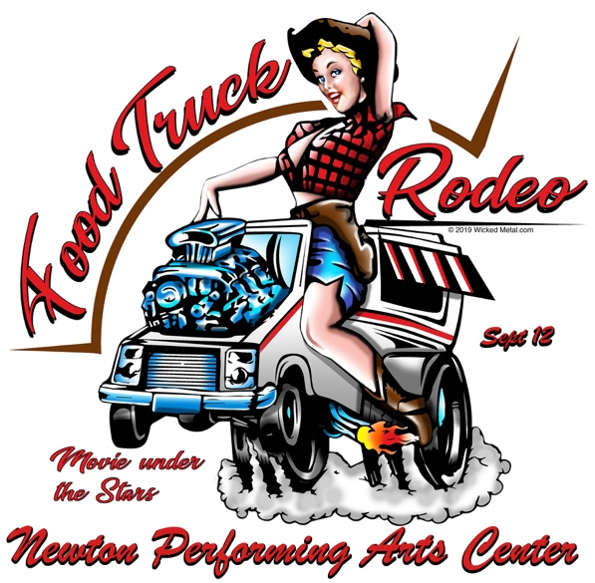
Vendor Application
Location: 60 W 6th Street Newton, NC 28658
Date/Time: Saturday, November 9th 12:00 - 8:00 pm
www.FoodTruckRodeoNewton.com

Vendor Fees: $50, Application and fee must both be received to hold your spot. Last day to apply for event will be August 31, 2020. All fees and deposits are nonrefundable after 9/4/2020.

Vendor Application Acceptance Policy: Confirmation for the NewtonPAC’s Food Truck Rodeo is based on the date and time of application submissions AND payment. For vendors, we will take your products into account when we receive your completed application, as our goal is to provide a unique experience for attendees by ensuring variety.

Proceeds: Vendors keep 100% of their proceeds for sales on the day of the event. Vendors are not allowed to sell any alcoholic beverages at the event.

Set-up, Hours, Teardown: Vendors may begin to arrive as early as 11 a.m. on Saturday, September 12th. All set-up must be completed by no later than 12:45 pm. The event begins at 1 pm. We expect NewtonPAC’s Food Truck Rodeo to be busy with music, eating, drinking & fun contests continuing until the end. Our “movie under the stars” on an outdoor movie screen will start at dusk. Vendors will be able to pack up when the movie begins. Our outdoor movie will be ‘The Goonies’.

On-site Resources: Vendors are responsible for all set-up and clean-up of their booth space on the baseball field and their immediate area surrounding such space.

Additional Vendor Information and Guidelines:
- Vendors spaces will be assigned, you will be sent your number and space location after the deadline on 8/31/2020. Vendors may choose to pack up when our outdoor movie begins dusk.
- Vendors are required to have a 10 x 10 tent, may be open air.
- Post all prices for items at your vendor space.
- Please keep your area clean and do not throw trash on to the ground next to or behind your area.
- Food Truck or Vendors may not produce or sell any merchandise, apparel or promotional items with our Food Truck Rodeo logo or wording without prior consent.
- This event does not charge an admission fee to attendees.

Yes, we would like to be a participating vendor at the 2020 Food Truck Rodeo at Newton Performing Arts Center. Our application and fees are enclosed.

Vendor Name:____________________________________________
Contact Person: ______________________Phone:
Email:______________________________________________________
Address: ___________________________________________________
Zip ____________Website: ____________________________________
Type of products sold: _________________________________________

Applications will be reviewed on a first-come, first-served basis. The Newton Performing Arts Center will be promoting all participating Food Trucks as well as craft vendors participating in the event. Please forward, via email, (executivedirector@NewtonPAC.com) your logo to be displayed at the event, as well as on www.FoodTruckRodeoNewton.com, and on the event website www.NewtonPAC.com.

Please Mail or Drop-off your completed Application to: Newton Performing Arts Center ATTN: Food Truck Rodeo PO Box 1354 Newton, NC 28658. Our office location is 601 Ashe Avenue Newton, NC. Fees may be paid by mail, in person to our office, or online at www.NewtonPAC.com– go to “store”.

Questions? Please call our office (828) 464-8100 or by email: executivedirector@NewtonPAC.com

Yes, I am applying as a food truck or vendor for Newton Performing Arts Center Food Truck Rodeo on Saturday, September 12, 2020. I have read and understand the event information, agree to comply with the requirements and have enclosed the $50 payment for the applicable fees. I agree to accept all responsibility for any personal injury, property damage, loss or other harm suffered by myself or otherwise due to my participation in the event. Further, I shall indemnify and hold harmless the Newton Performing Arts Center and Newton-Conover City Schools against all suits, claims, demands and losses including costs, expenses and attorney’s fees incurred as a result of any action or omission, neglect or misconduct.

Signature: ____________________________ Date: ______________

