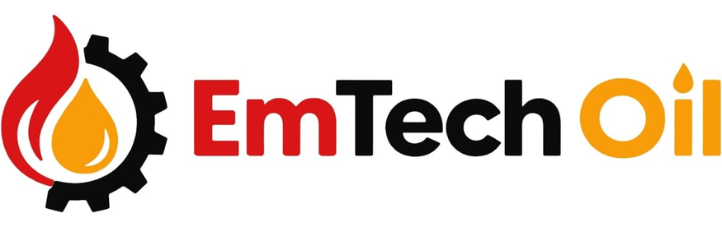

October 14, 2026

ALERT: FULL-SYNTHETIC MOTOR OIL SHORTAGE: SUPPLY CONSTRAINTS CONTINUE
The lubricant industry continues to face significant supply constraints affecting Group III base oils, a critical ingredient in full-synthetic passenger car motor oils (PCMO). This is impacting specific blends like 0W20, 5W20, 5W30 and Dexos. Recent industry reporting indicates that shortages, elevated costs and uncertainty around production recovery are continuing to affect lubricant availability, particularly for premium synthetic products and certain bulk formulations.
On October 13, 2026, JobbersWorld reported that Shell had partially restarted its Pearl GTL facility in Qatar, but the timeline for normalizing base-oil deliveries remained unclear. Meanwhile, the Financial Times reported in late September on retail motor-oil shortages and significant increases in Group III base-oil prices.
What This Means to you:
- Fleet operators: Expect potential price increases, longer lead times and less predictable availability for certain synthetic motor oils. Review consumption rates and plan bulk purchases ahead of scheduled maintenance.
- Automotive repair shops: Popular viscosity grades, including 0W-20 and 5W-30, may be more difficult to source consistently in bulk. Packaged supply in quarts, pails and bag-in-box should be considered as alternatives. Shops relying on bulk oil should verify availability before committing to customer appointments or service schedules.
- Consumers: Certain full-synthetic motor oils may be harder to find or more expensive. Retail availability can vary by brand, product and location.
- Dexos-approved applications: Supply constraints can be especially challenging because substitute formulations must meet applicable licensing and approval requirements. An alternative oil should not be represented as dexos-approved unless it holds the required approval.
Actual availability varies by manufacturer, supplier, viscosity grade, formulation and package sizes. Also, prices are fluctuating daily, so verify the dates on any estimates with your supplier.
Why This Is Happening
The disruption begins upstream in the base-oil supply chain. Group III base oils are highly refined materials used in many premium full-synthetic engine oils. They are not interchangeable with every other base oil without considering formulation requirements, performance testing and applicable approvals.
A significant source of Group III base oil is Shell's Pearl GTL complex in Ras Laffan, Qatar. The facility converts natural gas into liquid products, including high-quality base oils. Disruptions to production and exports from this region have tightened global supply. Shell's partial restart, reported by JobbersWorld on October 13, is an improvement, but it does not establish that normal deliveries have resumed.
Additional pressure comes from limited alternative supply, depleted inventory buffers and the time required to qualify substitute materials. The Independent Lubricant Manufacturers Association (ILMA) has documented the difficulties facing lubricant manufacturers and their efforts to obtain flexibility in dexos licensing. The American Petroleum Institute (API) has extended its emergency provisional licensing program in response to continuing base-oil supply disruptions.

What Is EmTech Oil's Advice?
During a challenging supply environment, we recommend three proactive steps to protect your operation, control costs and maintain reliable access to the lubricants you need.
1. Plan Ahead and Secure Your Supply
Don't wait until you're running low to discover a product is unavailable or has an extended lead time. Review your current inventory, identify your most critical products and plan upcoming purchases accordingly.
How EmTech can help: We work directly with our distribution partners to check product availability, confirm lead times and help you plan orders around your operational needs. We can help you evaluate bulk and packaged options to reduce the risk of unexpected shortages.
2. Keep Your Options Open Across Multiple Brands
When a particular product is constrained, limiting your purchasing to one brand can make it harder to maintain supply. However, switching products requires more than matching viscosity; specifications and required manufacturer approvals must also be considered.
How EmTech can help: EmTech represents StarFire, Lucas Oil, Shell, Pennzoil, Quaker State, Valvoline, Castrol, Mobil and other lubricant brands. Our multi-brand approach allows us to explore alternative sourcing options and identify products that meet your equipment requirements, applicable specifications and approvals. We'll help you evaluate availability and cost before making a change.
3. Improve Lubricant Efficiency and Control Costs
A supply disruption is an opportunity to look at how lubricants are purchased, stored and dispensed. Better inventory planning, bulk purchasing where appropriate and efficient dispensing can help reduce waste, handling time and operating expenses.
How EmTech can help: We provide more than lubricants. Through our lubricant distribution systems capabilities, we help automotive shops and fleet maintenance facilities evaluate bulk storage, pumps, piping, hose reels and metered dispensing equipment. We'll help you determine what makes sense for your operation, whether that's a simple solution for a small repair shop or a more comprehensive system for a larger fleet.
We Are Here to Help
When supply is uncertain, having options matters. Contact EmTech Oil to review your lubricant requirements, check current availability and find a solution that works for your business.
EmTech Oil — You Lubricant Solution Provider
Visit EmTechOil.com or call us at 866-497-LUBE or eMail us: john@emtechoil.com

