Links:
Piedmont Physical Medicine and Rehabilitation Dr. Schwartz



Electric Sympathetic Block: Current Theoretical Concepts and Clinical Results

Robert G. Schwartz, M.D.

Department of Physical Medicine and Rehabilitation, Medical University of South Carolina, Charleston, SC, USA

Abstract

The use of electricity for the treatment of pain has become increasingly popular as more potent devices that are clinically usable have become available. The basic medical and physical sciences required to use electricity for transdermally obtained sympathetic neuron blockade in patients with complex regional pain syndromes will be reviewed. Reported outcomes employing different parameters will be presented, with progression to the use of high intensity (115 mA), high voltage (50 V) 20 kHz carrier frequencies. Methods of application to optimize outcome and current theory concerning the mechanisms of action responsible for long-term effects will also be discussed. As the potency of the electrical modality is increased, results comparable to pharmaceutically-induced blockade can be achieved. © 1998 Elsevier Science Ireland Ltd.

Keywords: Electroceuticals; Electric sympathetic block; Pain

1. Introduction

Electroceutical medicine involves the use of electrical modalities of pharmaceutical strength. Along with electrodes of specific size, shape, and configuration, specialized medical devices can be utilized to obtain pharmacologic effects. The medical literature refers to alternating currents (a.c.) of 1000-100 000 Hz as middle frequency currents. While physical therapy devices utilize an a.c. of 1 –4000 Hz and intensities of 1 –20 mA, electroceutical devices utilize frequencies in the 20 kHz range. At these higher frequencies, both current perception thresholds (the intensity of current required for perception) and let-go thresholds (the amount of current tolerated before letting go) are increased [1,2]. As a result, it is possible to employ intensities up to 115 mA and 50 V.
The basic and physical science literature is replete with references demonstrating the effects of middle frequency a.c. upon cell membranes and voltage-dependant gates [3-11]. Computerized applications of a.c. parameters, which are derived from accepted research for different nerve fiber types and pathology, are now available [12-17]. This technology has been combined with higher frequencies and intensities to increase clinical potency.
In multiple clinical studies utilizing an a.c. of 4000 Hz and proper electrode montages, sympathetic blockade and perceived pain relief of 75% has been reported [18]. When a 20-kHz carrier frequency with a modulation frequency of 5-100 Hz is employed, intensities of up to 115 mA and 50 V become clinically usable. A clinical trial utilizing these parameters to achieve electric sympathetic block over a 1-week series not only produced pain relief of at least 75%, but also achieved thermographically proven vasodilatation which was greater on the ipsilateral side than the contralateral side in 60% and the presence of a Horner’s in 40% of the patients studied. Due to its potency, electroceuticals should only be utilized be physicians familiar with all of the precautions and side effects than can occur with pharmaceuticals that produce similar results.

2. Molecular biochemistry and cell biology

All cells have a measurable potential difference across their membranes. The normal 35-Å cell membrane has a transmembrane potential of – 70 mV. This is equivalent to 200 000 V/cm. Only a small number of ions must be affected to have a large impact upon cell transmembrane potential. The movement of less than 1 nmol of charged ion/mg of protein can create a greater than 200 mV potential difference [17, 19, 20].
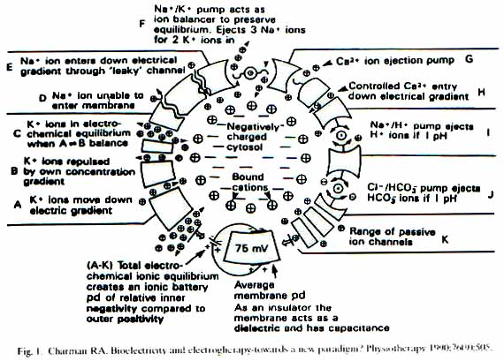
For proper cell function, membranes contain gated channels that are voltage-dependent (Fig. 1). Voltage dependent gates are pores through cell membranes that have changing permeability when influenced by electromagnetic signals. Changes in cell surface energy lead to conformational and chemical changes within the membrane, cytoplasm, and exoplasm [21-23].

3. Basic electricity

Current is the movement of charged particles (ions and electrons). Voltage is the tension that results from a difference in the supply of positive and negative charges between two points. Examples of voltage include electromagnetic forces created by different concentrations of Na⁺, K⁺, or Ca²⁺.
Resistance is the property that inhibits the flow of charged particles. Examples include cell membranes, mesenchym, and skin. Resistance is related to voltage by Ohm’s Law: V = IR, where V = voltage, I = current and R = resistance. Typical values of tissue resistivity are: nerve 1, blood 1.6, muscle 5, skin 10, fat 20, and bone 160 (k Ω) [23, 24].
Capacitance is the property of storage charge. Capacitance and resistance are both found in skin. Impedance is the property of resistance to alternating current flow. Its components include self-inductance, capacitance, and ohmic resistance. The relationship of impedance to voltage and alternating current flow is described by the equation: Z = E/I, where Z= impedance, E= voltage and I = alternating current flow [25].
Conductance is the ease with which an electrical current flows through a substance. It is the reciprocal of resistance. Frequency defines the number of electrical events, which occur in a unit of time. Hertz (Hz) are defined as equivalent to the number of cycles per second (pulse per second). Resistance, impedance, and capacitance are inversely proportional to frequency [25].

4. Electroceutical concepts

Electromedicine configurations are either direct current (d.c.) or alternating current (a.c.). Alternating currents are referred to as apolar and direct currents as polar. Most d.c. devices have a net negative charge and most a.c. devices have no net charge. When applied to extracellular fluids, d.c. polar currents enhance net positive charge under the anode (+), and therefore increase transmembrane potential. The resulting hyperpolarization is called anodal block [23, 25, 26].
Electromedical devices with 0 –1000 Hz alternating currents are referred to as Low Frequency and those with 1000 –100 kHz are called Middle Frequency. Low frequency currents cause a stimulatory effect between the electrodes [26]. The stimulatory effect of low frequency a.c. electrotherapy devices are thought to utilize the Gate Control Theory for their clinical effect [27, 28].
Unlike low frequency currents, middle frequency currents generate a cathodal effect referred to as ambipolar stimulation under each electrode [26]. Tissues have a lower impedance to middle frequency vs. low frequency currents (Fig. 2) [29]. Biologically significant effects can occur deeper within the tissue when middle frequencies are used due to the enhanced penetration and heightened disposition of current into the tissue depths [27].

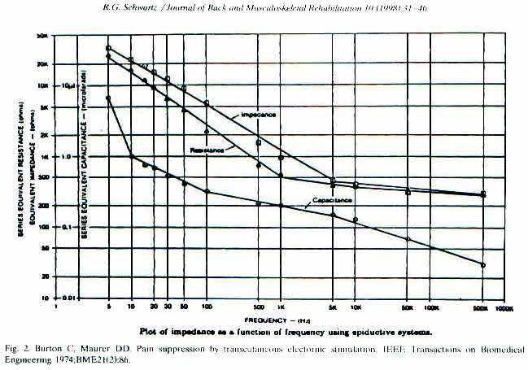
Cell membrane responsiveness to an electrical stimulus is determined by the characteristics of its strength duration curve. Strength duration curves are derived from Weiss-Lipque relationships. These relationships describe the physical characteristics of nerve fiber responsiveness to electrical currents, controlling for factors such as charge, stimulus duration, and strength. Rheobase refers to the lowest possible stimulus strength that can be applied for an indefinite period of time and still obtain threshold.
Chronaxie describes the stimulus strength that is twice that of rheobase. All nerve fibers have unique and distinct characteristics that can be plotted out in the form of strength duration curves [30].
Middle frequency currents of at least 4000 Hz are needed to provide successive stimuli that fall within relative refractory periods such that repolarization cannot occur; the continuous refractory state that results is called Wedensky Inhibition. Wedensky inhibition and anodal block are both temporary phenomenon that cease as soon as the applied current is turned off [31, 32]. Tissues act like condensers – they offer lower impedance at higher frequencies. When higher frequency currents are used, however, higher intensities are required for a tissue to reach threshold. This drawback is overshadowed by the fact that sensory perception are reduced at higher frequencies, both current tissue penetration and usable intensity can be increased as the frequency used is increased [1,2,29].
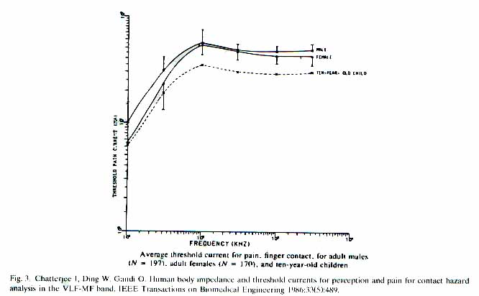

Weaver [33], Prausnitz [34], and Pliquett [35], have demonstrated that currents with sufficient voltage (50 –150) and short pulse lengths (100 –200 μs) can create ‘pores’ within the skin lipid bilayer, creating a transdermal channel into the depths of tissue. A 20-kHz carrier frequency, with a 50-V output, satisfies these criteria. Electroporation provides another explanation for the improved delivery of current into the depths of the tissue with proper parameter selection.
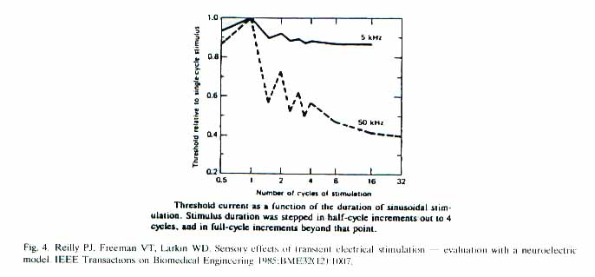
With increasing concentration and intensity, greater current density occurs in the depths of the tissue. Joule’s law states that as the resistance of a tissue increases, there is more electrical energy converted into heat. The relationship is expressed as follows: P = I² X R where P = heat, I = current and R = resistance. In order to avoid tissue destruction, limits have to be placed upon the total energy delivered into the tissue [24].
Total energy delivered into the tissue is limited by the patient’s current perception threshold. At frequencies less then 100 kHz, patient perception will limit the intensity of electricity delivered before internal heating occurs. By limiting the flow of current to 115 mA, with a 20-kHz carrier frequency, there is a very high margin of safety for any potential tissue destruction [2]. As shown in Figs. 2 and 3, at 20 kHz the benefits of middle frequency can be maximized. The unwanted electrical effect of increasing threshold with increasing frequency is minimized by dosing for a sufficient duration of time (Fig. 4) [36].
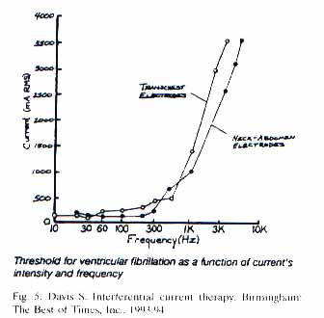
A 20-kHz middle frequency a.c. also provides an extremely high margin of safety for cardiac pacing. When device design limits are set at 115 mA and 50 V, transthoracic electrode placement cannot physiologically capture the ventricular rhythm [37]. In addition, patient current perception thresholds, as well as federal regulations on maximum amperage and voltage outputs, preclude the possibility of cardiac pacing at this frequency (Fig. 5) [26].
Middle frequencies of less then 100 kHz have a greater direct effect upon the extracellular fluid and cell membrane surface as compared to the intracellular fluid. This is because in order for an externally applied a.c. to lower impedance enough to penetrate through cell membranes, frequencies of 100 kHz or greater must be used [38]. The Cell Membrane surface density theory explains why only a small amount of electrical change has to occur on the extracellular side of a cell membrane to create a significant change in the potential difference across the membrane (Fig. 6) [22].

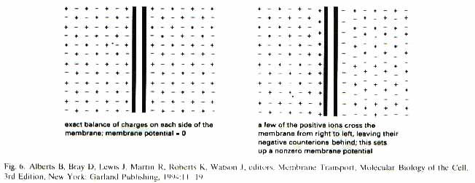
5. Voltage-dependent gates

The literature is full of references concerning the effects of pharmaceuticals upon voltage-dependent gates, which have been found in cell membranes of many different tissue types [39 –41]. Because voltage-dependent gates have specific voltage sensing proteins, they are highly selective for specific ions. Each type and subtype of voltage gate has its own threshold and inactivation range, agonist/antagonistic effects and specific functions [17,42,43].
Transmitter (hormonal or ligand) voltage gated channels convert extracellular chemical signals into electric signals. This type of gate cannot create a self-amplifying excitation by itself. It can, however, trigger voltage-gated channels to open or close. Ligand voltage gated channels are dependent upon an intact transmembrane potential difference for membrane translocation system function (transport of ions or molecules across the cell membrane) and second messenger formation (internal cellular response) to occur [17,44].
The calcium voltage-dependant gates are amplified relative to other ionic channels due to higher transmembrane concentration gradient of calcium. Due to the increased molecular weight and size of Ca²⁺, this gate is also harder to turn on than K⁺ or Na⁺ [4].
The sodium voltage-dependant gates are heavily concentrated at Nodes of Ranvier and at neuromuscular junctions. They work in an ‘all or none’ fashion and are responsible for nerve hyperexcitability. Six Na⁺ ions must move from the extracellular to the intracellular side to turn the gate on [42].
The potassium voltage-dependant gates heavily concentrated at the paranodal (fast) and nodal (slow) areas. Slow channels regulate the rate of firing response to a repetitive stimulus and fast channels are required for intensity of response. The Ca²⁺ activated K⁺ channel inhibit membrane depolarization when exposed to a continuous stimulus. The potassium voltage-dependent gate is the most responsive channel to an externally applied electrical stimulus [5,17].
The voltage-dependent Na⁺/K⁺ pump is activated during the ‘supernormal’ period of repolarization. Depending upon the physiological state of the pump, an a.c. can either inhibit or stimulate it. Maximal effects upon the pump with an a.c. occur at 100 Hz with an intensity of 4 x 10⁻³ V/cm and 6 μA/cm² [6,7].
There are numerous citations that demonstrate how a.c. affects ions and voltage-dependant gates to create both conformational changes in the cell membrane and second messenger formation within the cell [3,6,17,19,45]. When an a.c. is applied across a voltage gated channel, frequency-specific ion concentration changes occur [4,42]. These ion-gated channels have a greater affinity for low frequency currents than middle frequency currents [3,46]. Middle frequency carrier currents can be configured with low frequency modulation so as to maximize the beneficial effects of each (Fig. 7).
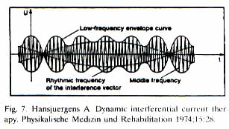
6. The post-hyperactivity depression (PHD) effect

The PHD effect refers to the prolonged, hyopexcitable state of a nerve that arises from the application of a relatively short duration electrical current. For example, a 20-min application results in a nerve block that may last for hours. Full recovery may even take days. To obtain the PHD effect, a series of stimuli are timed so that each falls within the refractory range of its predecessor.
There is more than one mechanism of action to explain the long duration of the PHD effect. Theories include experimentally proven conformational change at the cell membrane, second messenger formation within the cell, and ephaptic inhibition (a direct inhibition of action potential propagation by the electroceutically exposed segment). Wedensky inhibition does not explain the PHD effect as the block is long lasting and does not abate upon removal of the electroceutical [17,19,47,48].
The C fiber is more sensitive to the PHD effect than the A fiber. Theories explaining this address the larger surface/volume ratio of small fibers vs. large fibers, which make them more susceptible to transmembrane potential effects resulting from extracellular ion concentration changes and known nerve fiber physiology concerning easier fatigue of small nerve fibers vs. large fibers. [49]. Central mechanisms of habituations do not explain the pronounced effect on the C fiber [31,49].

7. Pathology

The sympathetic nerves are of special interest in the treatment of pain. These fibers are responsible for cold or weather sensitive pain that is described as burning, achy, tingling and numbing in character [50]. When practitioners hear this kind of complaint they should begin to this about a diagnosis of Reflex Sympathetic Dystrophy (RSD), now frequently referred to as acute or chronic complex regional pain syndrome (CRPS I or II) [51].
In RSD, there is a decrease in the local blood flow of the injured part. If allowed to persist, cold, sweaty and swollen skin (stage 1) develops. It may progressively worsen until there is loss of range of motion or even loss of muscle mass (stage 2). In more severe cases, the bones may thin as well (stage 3) [52]. In RSD, the sympathetic nerve is felt to be overacting; even when the injury itself is old, it continues to monitor the injury site and generate an abnormally sustained response [53].
The abnormal response is not always the same in all of those whom are afflicted. The Angry Backfiring ‘C’ (ABC) Syndrome occurs when the sympathetic never becomes angry, or backfires, in response to an underlying injury. This axon reflex causes the C fiber to emit various vasoactive chemicals such as substance ‘P’, kinens and histamine. These patients are usually warm sensitive and the involved segment is vasodilated [16, 54].
The Triple ‘C’ Syndrome variant occurs when the C fiber fires excessively, causing intense, local vasoconstriction. People with this problem complain of cold hypesthesia (abnormal cold perception), cold hyperalgesia (cold burns) and have regionalized hypothermia [16, 54]. Given the persistent and diverse nature of sympathetic pain syndromes, it is not surprising that the effectiveness of sympathetic blockade can be quite variable.

8. Electric sympathetic block

Reeves [55] noted that mixed results with electric sympathetic blockade occur secondary to at least two procedural factors: ‘simulation parameters have not been consistent across prior studies…and previous studies have investigated the effects of TENS on the SNS (sympathetic nervous system) under resting conditions – which may result in the ‘floor effect,’ of ‘physiological levels too flow to demonstrate further reduction.’
Finney [56] reported ‘Vasomotor equalization usually begins within 15 min and is associated with a decreased in perceived pain.’ He also states ‘Generally patients in stage I hot phase RSD and those who undergone sympathectomy do not respond as well as stage I or II cold RSD.”
Since many of the papers on electric sympathetic block have not utilized skin blood flow studies to determine the clinical condition being treated, it is not surprising that outcomes would be different. If a patient is vasodilated prior to treatment, then sympathetic blockade should not be expected to produce relief [16].
The duration of treatment also makes a difference. At least 20 min is the proper treatment time in order to obtain the maximal effect when using electroceuticals [18,57 –60]. Beyond 20 min, the body’s physiologic protection mechanisms begin to respond, attempting to regain normal homeostasis. This response is known as the Hunting Reaction and occurs maximally at 30 min [58, 61].
Scudds [62] used infrared thermography to measure skin temperature and studied patients receiving electric sympathetic block for 60-min periods of time. He concluded ‘the first 30 min of the stabilization period demonstrated a significant increase in skin temperature (t = 4.35, P = 0.001).’ A 20 –30 min duration of electroceutical application time is recommended [18, 57, 59, 60,62].
Jenkner [63,34] has done extensive work demonstrating the importance of proper electrode size, shape, configuration and placement. If attention is not paid to these requirements, potency will be reduced, increasing the likelihood of mixed results. Whitters [65] demonstrated ‘that increases in spacing correlate with a decrease in rheobase current’ and that ‘Parallel load results demonstrated a large increase in rheobase.’ Rubinstein [66, 67] has published that nerve fibers have different stimulation thresholds along their length, concluding ‘Chronaxie for stimulation near the terminal may be much smaller that at a distance from the terminal and the strength-duration curve may be non-monotonic.’
When factors such as electrode size, shape, configuration, placement, electrical parameter selection, duration of application and patient selection are assessed, it becomes clear that inconsistent parameter utilization, electrode montages, and patient selection criteria have made a significant contribution toward outcomes with mixed results.
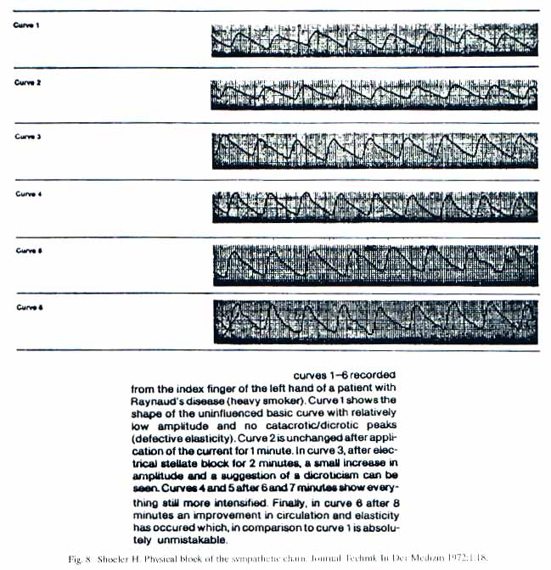
The literature states the obtainment of sympathetic block can be objectively measured by three methods: skin galvanic impedance studies, test of skin temperature and pain score tests [68]. Utilizing these methods of measurement the literature has shown that electric nerve/ganglia block is possible [57,60,63,69– 71]. As the choice of electrical parameters improves, so does the literature supporting the obtainment of block (Figs. 8-10) [18, 57,60,71].

Different fiber types have different voltage thresholds, with the A fiber threshold less then that of the C fiber [14,31]. Thresholds, firing frequencies and refractory periods among fiber types vary proportionately. The most effective carrier frequency is determined by using known nerve fiber physiology (absolute refractory period, nerve fiber diameter, etc.). Experimental evidence has shown that the effects of increasing carrier frequency are maximized for the A α fiber at 5000 Hz [32, 47, 48]. Carrier frequencies for the A β, A δ and C fiber can be mathematically extrapolated (Table 1). As per prior discussion, an upper limit of 20 kHz should be used in order to minimize the undesirable elevation of activation threshold intensity and associated heating effect, while maximizing impedance and current perception threshold lowering effects associated with middle frequencies.
Using the functional approach (parameter selection based on known nerve fiber function), them most effective modulation frequency to restore normal nerve firing is determined by mimicking the targeted nerve’s physiologic firing frequency [23, 63]. Modulation frequencies set at the upper limit of the nerve’s firing frequency will tend to have a fatiguing effect on excitability (Table 2) [22, 63].
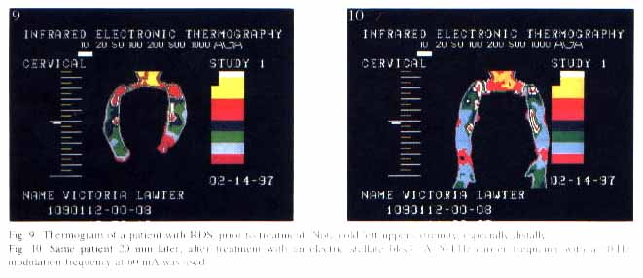
Ion Cyclotron Resonance (ICR) has also been used to determine modulation frequency. Cyclotron resonance theory exploits the relationship between an ion’s mass and charge to its inherent resonance frequency. It then mathematically determines the surrounding electromagnetic field required to maximally effect movement of differing ions. The cyclotron resonance equation is w = (q/m) B, where w = resonance frequency, q = ionic charge, m = ionic mass and B = the surrounding uniform magnetic field [3, 72].
In accordance with cyclotron resonance theory, specific frequencies and amplitudes are required in order to manipulate ion movement across voltage-dependent gates. Due to the structure of the gates themselves, only certain harmonics (or multiples of the resonance frequency) will actually allow for ion movement through the voltage-dependent gate [73]. Table 3 lists ICR calculated modulation frequencies when a 20-kHz carrier frequency is utilized. The coupling of an ICR based electromagnetic field to an alternating current carrier frequency would be expected to provide an additive effect.
Electrodes of dissimilar size should be utilized. The smaller one is placed over the ganglia/nerve and the large one over the opposing surface. This provides for both the most efficient configuration to minimize nerve rheobase, but also helps to focus the electroceutical onto the specified target (Fig. 11) [56,63,74].

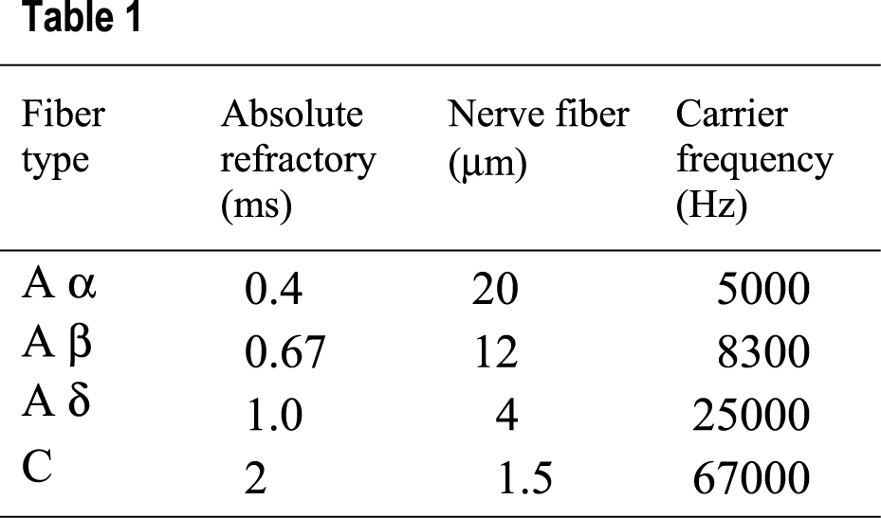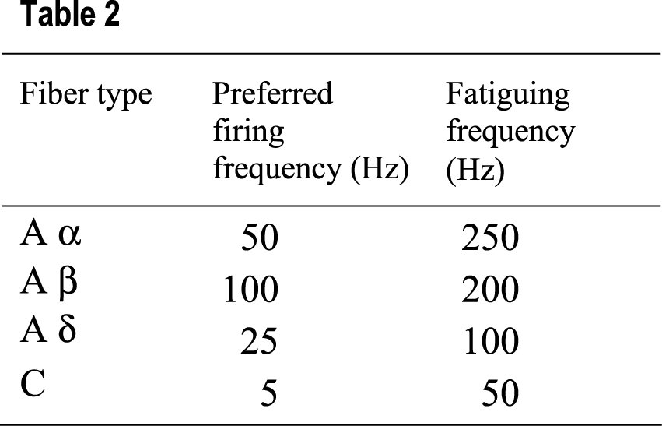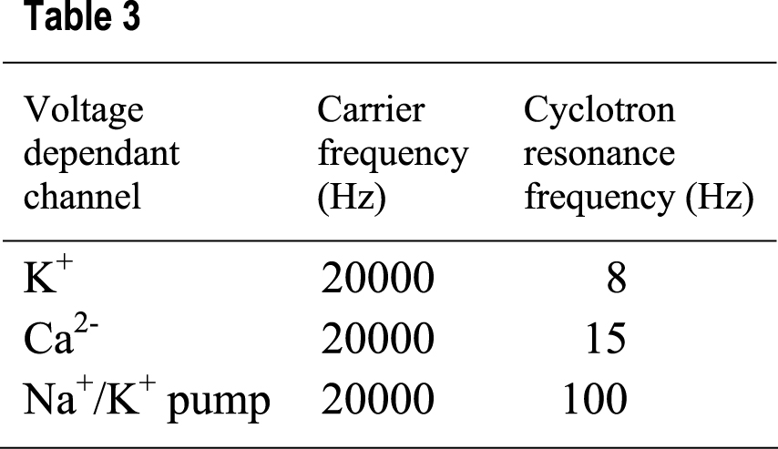

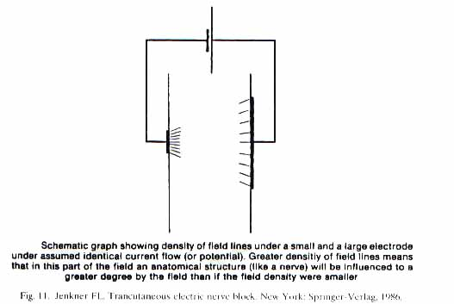
9. Case report

V.L. is a 47-year old female status post-motor vehicle accident 1 year prior. She has complained of persistent pain that is cold sensitive and burning in character in her neck and left upper extremity. Prior X-rays, MRI and Electro-diagnostic studies were normal. She denied any weakness, but stated her arm always felt cold and numb. She complained of skin discoloration and noted blister formation upon her palm whenever her pain worsened. She never had symptoms like this in the past. She has been treated with medications by mouth, physical therapy, point injections and nerve blocks. Due to her persistent pain, she was applying for social security disability.
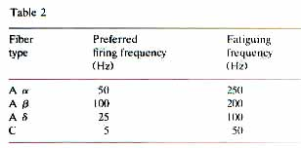

Physical exam revealed a female holding her left upper extremity in a guarded fashion. She had obvious red skin discoloration, more intensely upon the lateral aspect, that extended from the wrist to the shoulder. The hand itself was both cold to touch and moist with sweat. Light touch was painful and cold was reported to be both painful and burning in character. Reflexes were symmetric, motor strength 5/5 and sensation hyperesthetic to pin prick in a non-dermatomal distribution. Phalen’s, Tinel’s, and Spurling’s were negative. There was palpable spasm of the C2 and C5 myotomal musculature surrounding the neck and shoulder. Electronic infrared thermographic study revealed a heat asymmetry pattern crossing multiple dermatomes, with the cold, left upper extremity demonstrating a greater than 1°C temperature difference as compared to the right, especially distally (Fig. 9).
An electric stellate block was performed utilizing clean technique, with a small, 5/8 inch diameter focusing electrode placed over the left stellate ganglion and a large, 3 x 5 inch oval dispersive electrode over the opposing body surface. A constant voltage device (50 V maximum) drove a 50-Hz modulation frequency superimposed upon a 20-kHz carrier frequency; 60 mA of current was introduced into the stellate ganglion for 20 min. The patient was notified of potential complications and tolerated the procedure well. Thermographic recordings were taken at 5-min intervals (Fig. 12). Ipsilateral limb warming greater than the contralateral side did occur. One hundred percent pain relief was reported.

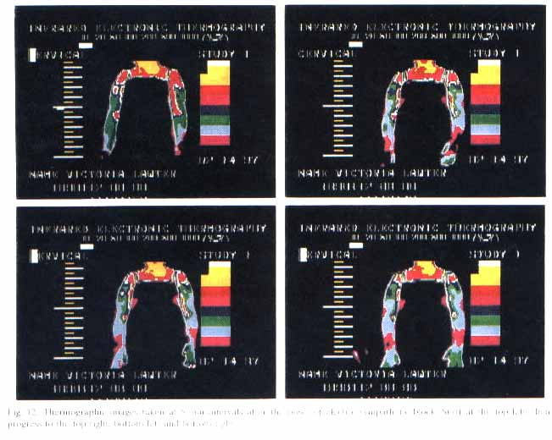
10. Clinical trials

Numerous disorders have been listed as indications for sympathetic block [12,68]. Clinical conditions include circulatory insufficiency (vasospasm, traumatic or embolic occlusion, scleroderma, frostbite and other occlusive vascular diseases), pain (including sympathetic syndromes and CRPS types I and II), shingles, phantom limb, paget’s disease, neoplastic lesions, CNS lesions, myofascial pain, fibromyalgia) and miscellaneous conditions such as shoulder/hand syndrome, hyperhydrosis, stroke, Miniere’s disease and tinnitus.
In this instance, 19 patients (11 women and eight men) were treated with a 1-week course of electric sympathetic blocks. Their diagnostic categories include reflex sympathetic dystrophy (4), radiculopathy with (4) and without herniated disk (2), lumbar ligamentous strain (4), whiplash (3) and myofascial pain syndrome (2). All patients described a sympathetic component to their pain consistent with complex regional pain syndrome type I, including symptom aggravation with cold exposure or shifting barometric pressure and had been unresponsive to other non-surgical interventions, including medicines by mouth, physical therapy, anesthetic injection and mobilization.
Prior to entering the 1-week series, a one time, 20-min trial block was performed. A constant voltage device (50 V maximum) drove either a 50 or 100 Hz modulated frequency at up to 115 mA of current. Electrode size, placement and configuration was utilized in order to be consistent with either stellate ganglion block (5/8 inch diameter focusing electrode over the stellate ganglion and a 3 x 5 inch oval dispersive electrode on the opposing body surface) or lumbar sympathetic block (1 inch diameter focusing electrode place two finger breaths lateral to the midline and one vertebral level above the involved lumbar segment with a 3 x 5 inch oval dispersive electrode on the opposing body surface).
Pain scores were obtained prior the block. If at least 30% relief was reported immediately after the block, then a 1-week series was scheduled. Pain score tests were used to assess relief. At the end of the 1-week series, 75% of the patients treated reported at least 80% relief.
Other clinical studies have confirmed the experimentally proven effectiveness of electric sympathetic block. Individual and multi-center studies have both shown at least 75% relief in the three-quarters of patients treated [75,76]. This compares favorably to studies assessing the effectiveness of chemical block, where 60% of those treated reported pain relief [77]. While there are no long-term studies on the effectiveness of chemical block, at least one study of electrically induced block reported 68% having retaining some relief on 1-year follow-up [63].
The effectiveness of electric sympathetic block also compares favorably to chemical block when thermography is utilized to measure outcome. In a series of 10 patients with RSD (CRPS I) who received electric stellate block (utilizing a 50-Hz modulation frequency superimposed upon a 20 0000-Hz carrier frequency), six showed ipsilateral warming that exceeded the contralateral side, three showed no change and one showed paradoxical cooling. Concurrent pain score assessments were consistent with the thermographic findings. Studies of the effectiveness of chemical stellate block, when performed at C7, have found a 65% success rate. The effective yield of chemical clock is only 30% if performed at C6. The demonstration of greater ipsilateral limb warming is a more important indicator of block than the presence of a Horner’s [77,78].

11. Side effects and indications

The most frequent side effect of electrical block is skin burn. The incidence has been estimated at 2-3%. The burn is usually first or second degree in nature and while slow to heal, as long as the wound is kept clean, closure is the expected result. A small area of disfigurement (usually ½ inch in diameter or less) may result, especially in patients with a history of easy keloid formation. Patients should be told of this potential side effect (and all other side effects typically reported with ganglia/neuron blockade) prior to treatment. The appropriate procedural releases should be signed.
The same indications that have been previously discussed for chemical sympathetic block apply to electric sympathetic block. An additional indication for electric sympathetic block exists in the patient who is on anticoagulants, creating a relative contraindication for the block by needle injection. Patients are more likely to accept sympathetic block as a treatment option when done electrically vs. by needle injection. Electric sympathetic block should be considered as appropriate for painful or vascular conditions that have failed to respond to other interventions.

12. Rehabilitation

While electric sympathetic blocks may be done without any other interventions, like all blocks, they do not preclude the use of other appropriate interventions. They are easily integrated into a multidisciplinary, integrated rehabilitation program. Due to their relative ease of administration and higher safety and patient acceptance level, they do not interfere as much with the rest of a coordinated rehabilitation program as would chemical blocks.
It is generally recommended that individuals who are receiving physical or occupational therapy have their block done prior to these restorative sessions. This facilitates aggressive activities such as range of motion or other exercises, capitalizing upon the normalized vascular tone and pain relief obtained from the block.
If the block is done in the medical office, it is preferred to have easy access to a therapy clinic so that these services may begin shortly afterwards. Depending upon the proximity of medical services accessibility, the block may be performed in the therapy clinic itself. The goal is to produce pain relief with restoration of neuromuscular, vasomotor and sudomotor tone. In cases of management, goals also include prevention of spread or progression of the syndrome.
Pharmacologic supplementation, as with other physical interventions, should be used as appropriate. As vasoactive agents can impact the outcome of sympathetic syndromes, medical manipulation of these drugs should be considered. Unexpected benefits associated with physiologic responses to sympathetic block may also be seen. This is most noticeable, for example, in the case of the asthmatic patient who may incidentally comment that they were able to decrease their uses of bronchodilators during the period when the blocks were administered.

13. Conclusion

Advances in research application have been utilized in the study of cell membrane physiology to demonstrate that voltage-dependent gates are an important mechanism of action of pharmacologic and electrical agents upon the cell membrane itself. When properly configured alternating electrical currents of sufficient strength, duration, and intensity are utilized in conjunction with correctly situated electrode size shape and placement, pharmacologic effects upon the cell membrane result. These electroceutical effects have been proven both in research and clinical settings to be effective for the obtainment of sympathetic ganglia and neuron blockade. The long duration of action can be explained by direct conformational changes in cell membrane structure, second messenger formation and ephaptic inhibition. Only physicians who are knowledgeable about potential side effects of pharmacologic agents that produce similar effects should utilized electroceutical devices.

References

[1] Dalziel C. Effect of frequency on let-go currents. IEEE Trans Elect Eng 1943;62:745-749.
[2] Chatterjee I. Human body impedance and threshold currents for perception and pain for contact hazard analysis in the VLF-MF band. IEEE Trans Bio Eng 1986;33(5):486-494.
[3] Frey A, editor. On the nature of electromagnetic field interactions with biological systems. New York: Springer, 1995:99-126.
[4] Brighton C, Pollack S, editors. Electromagnetics in medicine and biology. San Francisco: San Francisco Press, 1991:79-93,111-115.
[5] Burke D. Microneurography, impulse conduction, and paresthesias. Muscle Nerve 1993;16:1025-1032.
[6] Blank M., editor. Electricity and magnetism in biology and medicine. San Francisco: San Francisco Press, 1992:474-476.
[7] Blank M, Na,K-Atpase activity as a model for the effects of electromagnetic fields on cells. Frederick: World Congress For Electricity and Magnetism in Biology and Medicine, 1992:37.
[8] May H. Acceleration of ossification by means of interferential current. Temecula: Nemectron, 1985:469-78.
[9] Goldman R. Electrically induced modulation of collagen synthesis in cultured human fibroblast. Frederick: World Congress For Electricity and Magnetism in Biology and Medicine, 1992:70.
[10] Karba R. Electric stimulation of soft tissue repair – 30 years after first clinical studies. Frederick: World Congress For Electricity and Magnetism in Biology and Medicine, 1992:78.
[11] Norden B, editor. Interaction mechanism of low-level electromagnetic field in living systems. Oxford: Oxford University Press, 1992:105-129.
[12] Bonica J, editor. The management of pain. Philadelphia: Lea and Febiger, 1990;31:265-1938
[13] Bullock J, editor. Introduction to the nervous systems. San Francisco: W.H. Freeman, 1984:209.
[14] Ganog W. Review of medical physiology. Los Altos: Lange Medical Publications, 1983:36-37.
[15] Hahn M, editor. Regional anesthesia. St. Louis: Mosby, 1996:7.
[16] Ochoa J. The human sensory unit and pain: new concepts, syndromes, and tests. Muscle Nerve 1993; 16:1009-1016.
[17] Alberts B, Bray D, Lewis J, Martin R, Roberts K, Watson J, editors. Molecular biology of the cell. New York: Garland Publishing, 1994:523-540.
[18] Schwartz R. Electric sympathetic block: an advanced clinical technique for the treatment of complex acute and chronic pain. Frederick: Second World Congress For Electricity and Magnetism in Biology and Medicine, 1997:138.
[19] Darnell J, Lodish D, editors. Molecular cell biology. New York: Scientific American Books, 1990:771-777.
[20] Norernstrom B. Biologically closed electric circuits. Stockholm: Nordic Medical Publications, 1983:1-2.
[21] Charman R. Bioelectricity and electrotherapy – towards a new paradigm? Physiotherapy 1990; 79(9):502-508.
[22] Blank M. The surface compartment model: a theory of ion transport focused on ionic processes in the electrical double layers at membrane protein surfaces. Biochim Biophys Acta 1987;906:277-294.
[23] Low J. Electrotherapy Explained. Oxford: Butterworth-Heinemann Ltd., 1994:1-3,23,54-63,372-373.
[24] Rosen P. Concepts in clinical emergency medicine. St. Louis: Mosby, 1992:970.
[25] Nelson R. Clinical electrotherapy. Norwalk: Appleton and Lang, 1987:6,11-15.
[26] Davis S. Interferential current therapy. Birmingham: The Best of Times, 1993:9-16.
[27] Hansjuergens A. Dynamic interferential current therapy. Phys Med Rehabil 1974;15:24-28.
[28] Hansjuergens A. Differences between dynamic interferential current (DIC) analgesia and TENS-analgesia. Temecula: Nemectron Medical reprints, 1980.
[29] Burton C. Pain suppression by transcutaneous electronic simulation. IEEE Trans Biomed Eng 1974; BME21(2):81-88.
[30] Goodgold J. Electrodiagnosis of neuromuscular diseases. Baltimore: Williams and Wilkins, 1983:32-34.
[31] Brazuer N. Electrical activity of the nervous system. Baltimore: The Williams and Wilkins Co., 1977:27-49.
[32] Bowman B. Electrical block of peripheral motor activity. Downey: Rancho Los Amigos Rehabilitation Engineering Center, 1981:89-102.
[33] Blank M, editor. Electricity and magnetism in biology and medicine. San Francisco: San Francisco Press, 1992:95-100.
[34] Prausnitz M. The effects of electrical current applied to skin: a review for transdermal drug delivery. Adv Drug Delivery Rev 1996;18:395-425.
[35] Pliquett U. Recent advances in skin electroporation: mechanism and efficacy. Frederick: Second World Congress for Electricity and Magnetism in Biology and Medicine, 1997:44.
[36] Reilly P. Sensory effects of transient electrical stimulation – evaluation with a neuroelectric model. IEEE Trans Biomed Eng 1985;BME2(12):1007.
[37] Turner H. Human responses to electricity: a literature review. Columbus: Ohio State University Research Foundation, 1972:1-11,39-50.
[38] Foster K. Dielectric properties of tissues and biological materials: a critical review. Crit Rev Biomed Eng 1989;17(1):25-104.
[39] Devor M. Neurobiological basis for selectivity of Na⁺ channel blockers in neuropathic pain. Pain Forum 1995;4(2):83-86.
[40] Sato K. Whole cell K and cl currents in dissociated eccrine secretory coil cell during stimulation. J Membr Biol 1993;134(2):93-106.
[41] Fabi F. Evidence for sympathetic neurotransmission through presynaptic N-type calcium channels in human saphenous vein. Br J Pharmacol 1993;110(1):338-342.
[42] Freidlander M, Mueckler M, editors. Molecular biology of receptors and transporters. San Diego: Academic Press, 1993:39-97.
[43] Ohnishi S. Cellular membrane. Boca Ration: CRC Press, 1993:7-12,23-78.
[44] Devlin TM, editor. Textbook of biochemistry. New York: Wiley-Liss, 1992:221,875,931.
[45] Cararsi S. Cyclic AMP mediates inhibition of the Na(+)-K+ electrogenic pump by serotonin in tactile sensory neurons of the leech. J Physiol (Long) 1993;462:229-242.
[46] Blank M. Membrane channel energetics: role of surface charge protein subunit interactions. Frederick: World Congress for Electricity and Magnetism in Biology and Medicine, 1992:69.
[47] Katz B. Experimental evidence for a non-conducted response of nerve to subthreshold stimulation. Proc R Soc 1937;612.816.3:244-276.
[48] Raymond S. The role of length of nerve exposed to local anesthetics in impulse blocking action. Anesth Analgesia 1986;68:563-570.
[49] Torebjork H. Responses in human A and C fibers to repeated electrical intradermal stimulation. J Neurol, Neurosurg Psychiatry 1974;37:653-644.
[50] Raj P, editor. Pain medicine, a comprehensive review. St Louis: Mosby, 1996:466-487.
[51] Merskey H, Bogduk N. Classification of chronic pain: descriptions of chronic pain syndromes and definitions of pain terms. Seattle: ISP Press, 1994.
[52] Stanton-Hicls M, Jaing W, Boas R, editors. Reflex sympathetic dystrophy. Boston: Kluwer Academic Publishers, 1990:1-8.
[53] Hooshmand H. Chronic pain. Boca Raton: CRC Press, 1993:33-56.
[54] Gonzalez E, Materson, editors. The nonsurgical management of acute low back pain. New York: Demos Vermande, 1977: in press.
[55] Reeves J. The effects of Tens on SNS reactivity and pain. Clin J Pain 1991;7(1):64.
[56] Finney J. Low frequency trancutaneous nerve stimulation in reflex sympathetic dystrophy. J Neurol Orthop Meg Surg 1991;12:270-273.
[57] Schwartz R. Electric sympathetic block: methods of measurement and a study assessing its effectiveness. Adv Ther 1990;7(5):289-291.
[58] Lehmann J, editor. Therapeutic heat and cold. Baltimore: Williams and Wilkins, 1982:416,455,475.
[59] Gerhardt J. Schmerz pain douleur, 1988;9:185-189.
[60] Shoeler H. Physical block of the sympathetic chain. J Tech Med 1972;1:16-18.
[61] Downey J. Darling RC, editors. Physiological basis of rehabilitation medicine. Philadelphia: W.B Saunders Co., 1971:160.
[62] Scudds R. Helewa A, Scudds RA. The effect of transculataneous electrical nerve stimulation (TENS) on skin temperature in normal healthy subjects. Abstracts – 7th World Congress on Pain, 1993;416.
[63] Jenkner F. Transcutaneous electric nerve block. New York: Springer-Verlag, 1986:3-16.
[64] Jenkner F. Transcutaneous electric nerve stimulation for pain: the search for an optimal wave-form. Appl Neurophysiol 1981;44([5-6):330-337.
[65] Whitters D. An examination of the effects on the strength-duration response of nerve tissue with different stimulation conditions. Frederick: World Congress for Electricity and Magnetism in Biology and Medicine, 1992:137.
[66] Rubinstein J. Axon termination conditions for electrical stimulation. 1EEE Trans Biomed Eng 1994;41(2):203.
[67] Rubinstein J. Analytical theory for extracellular electrical stimulation on nerve with focal electrodes. Biophys J 1988;54:975-981.
[68] Cousins M, Bridenbaugh P, editors. Neural blockade. Philadelphia: J.B. Lippincott Company, 1988:474-480.
[69] Abram SE, Asiddas CB, Reynolds AC. Increased skin temperature during transcutaneous electrical stimulation. Anesth Analgesia 1980;59(1):22-25.
[70] Owens S, Atkinson R, Lees DE. Thermographic evidence of reduced sympathetic tone with transcutaneous nerve stimulation. Anesthiology 1979;50:62-65.
[71] Schwartz R. Electric sympathetic block: a review of electrotherapy physics. Adv Ther 1991;8(1):1-5.
[72] Liboff AR, McLeod BR. Kinetics of channelized membrane ions in magnetic fields. Bioelectromagentics 1988;9:39-51.
[73] Liboff AR, McLeod BR, Smith S.D. Electromagentic gating in ion channels, J Theoretical Biol 1992;158:15-31.
[74] Witters D. Krauthamer V. An examination of the effects on the strength-duration response of nerve tissue with different stimulation conditions. Frederick: World Congress for Electricity and Magnetism in Biology and Medicine, 1992:137.
[75] Jenkner FL. Electric pain control. Beaverton: T.T. Charters, 1988:1-7.
[76] Clinical electromedical research academy. Bioelectric non-invasive neuron blockade. North Las Vegas: CERA, 1993:1-7.
[77] Hogan QH, Taylor ML, Goldstein M, Stevens R, Kettler R. Success rates in producing sympathetic blockade by paratrachael injection. Clin J Pain 1994;10:139-145.
[78] Matsumoto S. Thermographic assessments of sympathetic blockade by stellate ganglion block. Jpn J Anesthesiol 1991;40(5):692-701.

