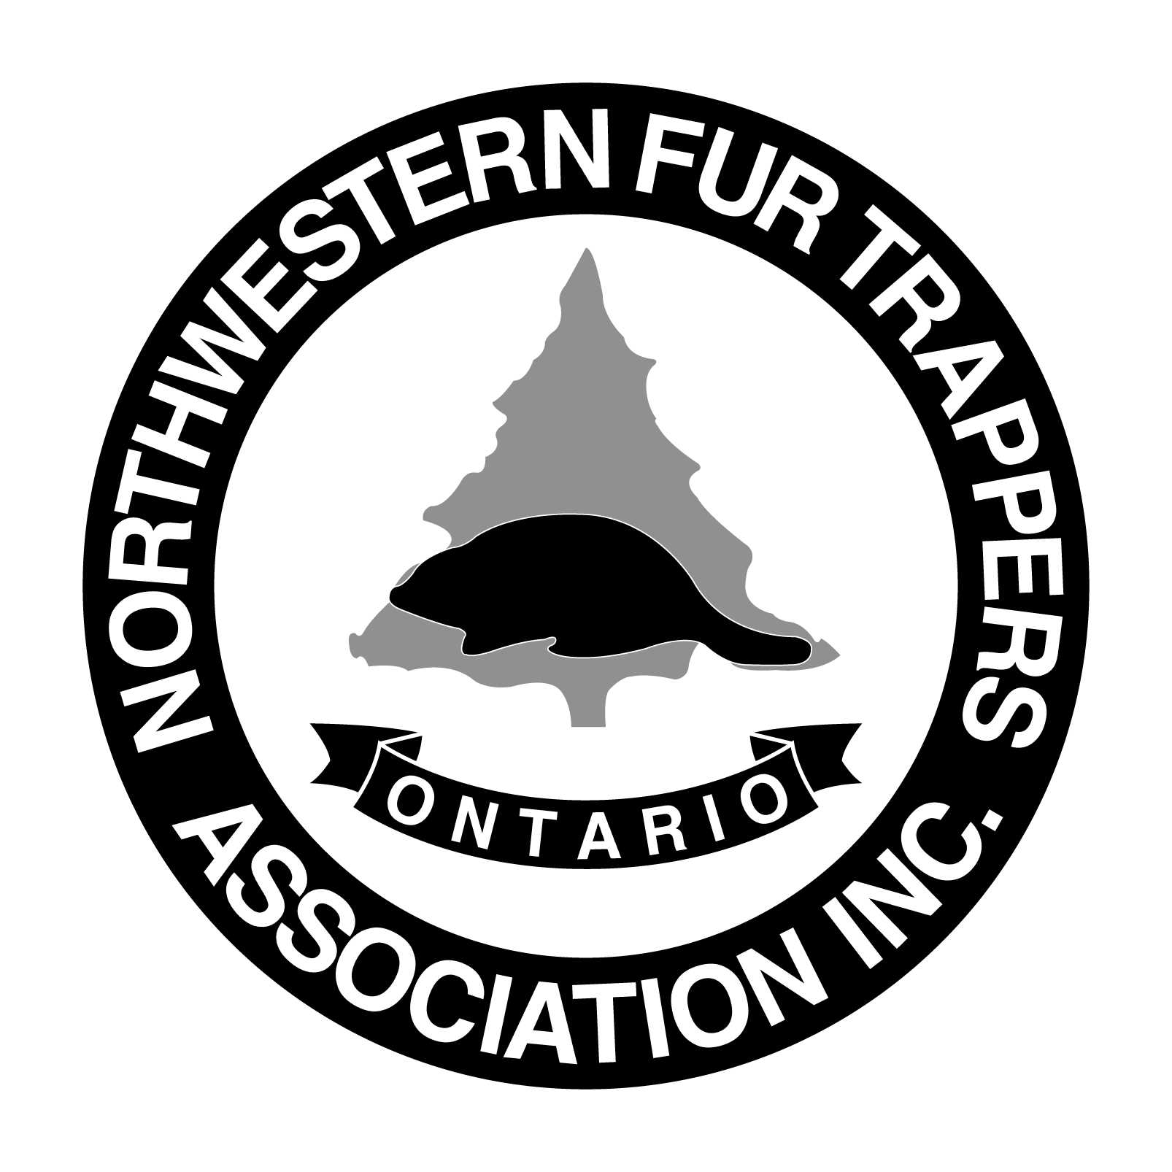
Northwestern Fur Trappers Association Inc.
P.O. Box 10163, Thunder Bay, ON. P7B 6T7

“CONVENTION 2020”
RESERVATION FOR DISPLAY SPACE

March 6th and 7th
CLE – Coliseum Building

Set Up Date: Thursday March 5th after 6:00 pm
- All Displays must be completely set up by 10:30 a.m. on Friday -
Dismantle Date: Saturday, March 7th Complete dismantle After 3 p.m.

N.W.F.T.A. will not be responsible for any items not cleared out at that time.
Name of Business/Organization:
_______________________________________________________________
Contact Name:
________________________________________________________________
Address: _____________________________________________________
Postal Code: ____________Phone #:_________________ Email: ________________________

Single: $50.00 (Width 8’ wide x Depth 4’) Booth _________ Floor Space (same size)
*essentially a single table booth that can be arranged however you would like.
Double: $100.00 (Width 16’ wide x Depth 4’) Booth _________ Floor Space (same size)
*essentially two table booth that can be arranged however you would like.
Premium Single $100.00 (width 8’ wide x Depth 8' ) Booth __________ Floor Space ( same size)
*This is an against the outer wall single booth that is much deeper and can accommodate different arrangements/ shelves etc.
Premium Double: $150 (width 16’ wide x Depth 8') Booth ___________ Floor Space ( same size)
*This is an against the wall double booth that is much deeper and can accommodate different arrangements, selves etc..
Floor Space: $200.00 ( Ex. Boats/atv etc. ) with table and chairs _________
Please list the dimensions requested for Floor Booth ___________________
______________________________________________________________________________

__________# of Tables ____________ # of Chairs ________ Electricity __________
Other Special Requests:__________________________________________________________ _____________________________________________________________________________
Note: There will be no additional cost for tables, chairs or electricity. Security will be provided. All space are first come first serve and will not be confirmed until payment is received. Please note that premium spaces are limited and are likely to sell out.
Please return application along with a cash, cheque or money order payable to: Northwestern Fur Trappers Association as soon as possible to reserve your space. * New this year…. NWFTA will now accept E-transfers! Email your application and payment to nwfta@outlook.com .

