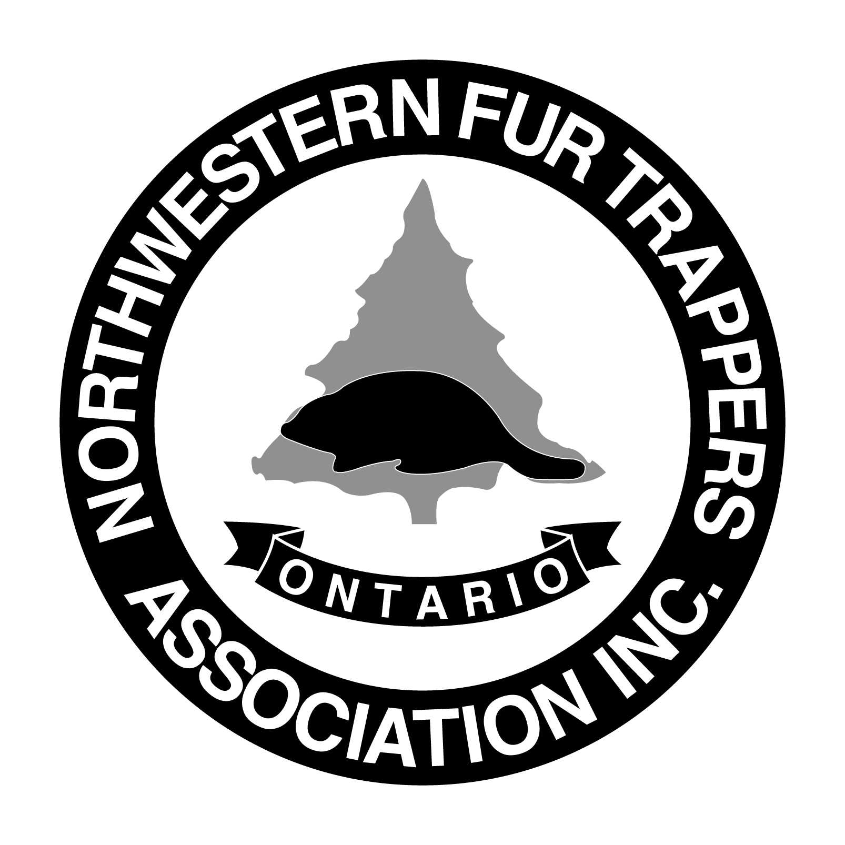**Northwestern Fur Trappers Association Inc.**

P.O. Box 10163, Thunder Bay, ON. P7B 6T7

**2020 ANNUAL TRAPPERS CONVENTION**

The Northwestern Fur Trappers Association will be holding their Annual Convention on **March 6th and 7th, 2019** to promote education, awareness and management practices of the fur industry.

This event will take place in the Coliseum Building at the Canadian Lakehead Exhibition, 425 Northern Avenue. Numerous displays will be available to the public for viewing both days.

We would like to invite you to participate in this fun filled weekend that will be attended by trappers, hunters, fishermen and outdoor enthusiasts alike from the Thunder Bay district as well as throughout Northwestern Ontario. The weekend consists of displays, demonstrations, pelt handling competitions, a Friday evening social and auction, and a smorgasbord and dance on Saturday evening.

Display hours are as follows:

Friday, March 6th - 11:00 a.m. - 5 p.m.

Saturday, March 7th - 9:30 a.m. - 3 p.m.

Displays must be set up by 10:30 a.m. on Friday. The display area will be closed after the hours listed above. Overnight security will be provided. Dismantling will be done after 3 p.m. on Saturday. The N.W.F.T.A. will not be responsible for any materials not removed at that time. Displays must have someone in attendance at all times.

**Booth Cost: 5 Options Available**

**Single** (8’ wide x 4’ depth) $50.00 – a centre table booth

**Double** (16’ wide x 4’depth) $100.00 – a centre table booth

**Premium Single** $100.00 (width 8’ wide x Depth 8' ) – an against the wall booth that can be configured differently to suit larger items, display racks etc..

**Premium Double:** $150 (width 16’ wide x Depth 8') – an against the wall booth that can be configured differently to suit larger items, display racks etc.

**Floor Space with tables** ( for boats/quads) $200.00

Each space will be provided with a table and chairs. Electrical outlets are on first come, first served basis. Space is limited! Reserve now! An application form is attached.

Deadline date is **February 13th , 2019.**

If you have any questions, please do not hesitate to contact me.

Yours in Trapping,

Sarah Cardy

Sec./Treas. N.W.F.T.A.

Email:nwfta@outlook.com

Phone: (807)627-4229