# BUILDING YOUR CORE PAGES FOR MAXIMUM IMPACT

## INTRODUCTION

Creating effective core website pages is fundamental to your online success. A study conducted by Stanford University emphasizes that 75% of potential customers judge your credibility based on your website design, making it crucial to get these foundational pages right.

This guide will walk you through creating the four essential pages every business website needs:

1. Homepage
2. About page
3. Products/Services page
4. Contact page

## Part 1: Planning Your Core Pages Structure

### Initial Planning Phase

Before diving into page creation, you need to establish a clear framework:

1. **Define Your Goals**

* List primary objectives for each page
* Identify key actions you want visitors to take
* Determine success metrics for each page

1. **Gather Essential Materials**

* Brand guidelines (colors, fonts, logo usage)
* High-quality images and videos
* Company information and statistics
* Customer testimonials
* Product/service details

1. **Create Content Hierarchy**

* Determine most important information for each page
* Plan content flow from most to least critical
* Map out user journey through your site

*Planning Template:*

| **Page** | **Primary Goal** | **Key Action** | **Success Metric** |
| --- | --- | --- | --- |
| Homepage | First Impression | Contact/Purchase | Conversion Rate |
| About | Build Trust | Learn More | Time on Page |
| Products/Services | Showcase Offerings | Purchase/Inquiry | Click-through Rate |
| Contact | Enable Communication | Form Submission | Form Completion Rate |

## Part 2: Homepage Creation

### Hero Section Development

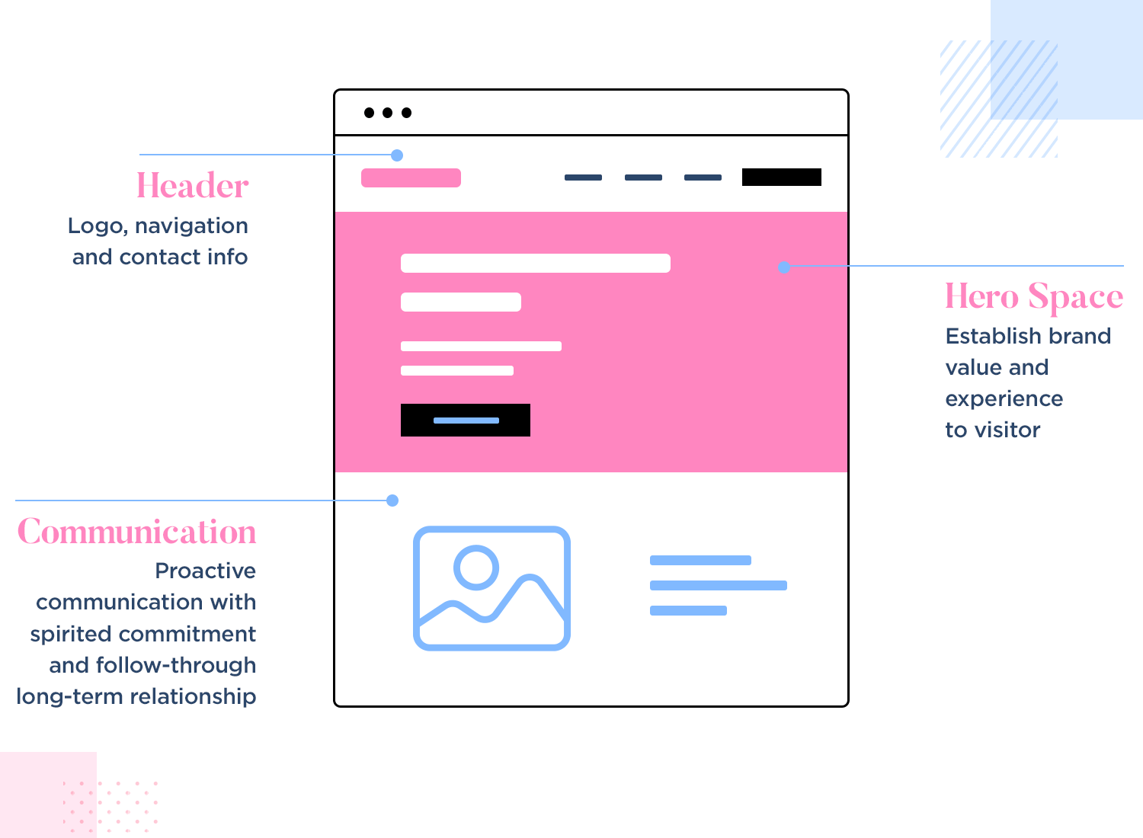

Your homepage's hero section is crucial for making a strong first impression:

1. **Craft Your Value Proposition**

* Write a clear, compelling headline (5-7 words)
* Add supporting subheadline (1-2 sentences)
* Include strong call-to-action button

1. **Visual Elements**

* Select hero image/video that represents your brand
* Ensure high contrast between text and background
* Optimize image size for fast loading

1. **Key Components**

* Logo placement (top left recommended)
* Navigation menu (5-7 main items)
* Contact information or button
* Social proof elements

### Main Content Sections

Structure your homepage content in logical segments:

1. **Benefits Section**

* List 3-4 key benefits
* Use icons or images to illustrate each
* Keep descriptions concise (2-3 sentences)

1. **Featured Products/Services**

* Display best-selling or flagship offerings
* Include clear pricing if applicable
* Add "Learn More" buttons to each

1. **Social Proof**

* Customer testimonials (2-3 featured)
* Industry awards or certifications
* Key statistics or achievements

## Part 3: About Page Development

### Company Story Section Create an engaging narrative about your business:

1. **Story Elements**

* Company founding story
* Mission and values
* Key milestones and achievements

1. **Team Presentation**

* Leadership team profiles
* Professional headshots
* Brief bios highlighting expertise

1. **Credibility Builders**

* Years in business
* Number of customers served
* Industry recognition

### Trust-Building Components

Include elements that reinforce credibility:

1. **Social Proof**

* Detailed case studies
* Client testimonials
* Industry partnerships

1. **Company Culture**

* Behind-the-scenes photos
* Team events and activities
* Community involvement

## Part 4: Products/Services Page Creation

### Product/Service Presentation

Organize your offerings effectively:

1. **Category Structure**

* Group similar items together
* Create clear category names
* Use logical hierarchy

1. **Individual Product/Service Listings**

* Detailed descriptions
* High-quality images
* Clear pricing structure
* Features and benefits
* Technical specifications

1. **Comparison Tools**

* Feature comparison tables
* Pricing tiers
* Package options

### Purchase Process

Make buying easy:

1. **Call-to-Action Placement**

* Clear "Buy Now" or "Contact Us" buttons
* Multiple CTAs throughout page
* Mobile-friendly button sizing

1. **Supporting Information**

* Shipping details
* Return policy
* Warranty information
* FAQs

## Part 5: Contact Page Development

### Contact Form Design

Create an effective contact form:

1. **Essential Fields**

* Name
* Email
* Phone (optional)
* Message purpose (dropdown)
* Message field

1. **Form Optimization**

* Clear field labels
* Error message handling
* Success confirmation
* Mobile responsiveness

### Additional Contact Information

Provide multiple ways to connect:

1. **Business Details**

* Physical address
* Phone numbers
* Email addresses
* Business hours

1. **Map Integration**

* Embedded Google Map
* Directions
* Parking information

## Part 6: Technical Optimization

### Mobile Responsiveness

Ensure perfect display across devices:

1. **Responsive Design Checklist**

* Text readability
* Button size and spacing
* Image scaling
* Menu functionality
* Form usability

1. **Speed Optimization**

* Image compression
* Code minification
* Browser caching
* Content delivery network

### SEO Implementation

Optimize for search engines:

1. **On-Page SEO**

* Page titles
* Meta descriptions
* Header tags
* Image alt text
* Internal linking

1. **Local SEO**

* Business schema markup
* Local keywords
* NAP consistency
* Google Business Profile integration

## Common Challenges and Solutions

### Content Overwhelm

***Challenge****:* Too much information to organize

* ***Solution****:* Use the content hierarchy template to prioritize information

### Technical Limitations

***Challenge****:* Limited technical knowledge

* ***Solution****:* Utilize website builder templates and seek support when needed

### Design Consistency

***Challenge****:* Maintaining visual coherence

* ***Solution****:* Create and follow a style guide for all pages

## ACTION PLAN

### Day 1-2: Planning and Content Gathering

* Complete page planning template
* Gather all necessary content
* Create content hierarchy

### Day 3-4: Homepage Development

* Create hero section
* Develop main content sections
* Add social proof elements

### Day 5-6: About Page Creation

* Write company story
* Add team information
* Include credibility elements

### Day 7-8: Products/Services Page

* Organize offerings
* Create detailed descriptions
* Set up purchase process

### Day 9-10: Contact Page Setup

* Design contact form
* Add business information
* Implement map integration

### Day 11-14: Testing and Optimization

* Mobile responsiveness testing
* Speed optimization
* SEO implementation
* Cross-browser testing

# CONCLUSION

Creating effective core website pages requires careful planning and execution. Follow this guide systematically, focusing on one section at a time. Remember that your website is a living entity that can be continuously improved based on user feedback and analytics data.

Start today by completing the planning template and gathering your essential materials. Your professional web presence awaits!

