# A COMPLETE PRE-LAUNCH PROTOCOL

## INTRODUCTION

Launching a website is a critical milestone for any business, but it requires careful planning and execution to ensure success. According to Ledgeview Partners’ study, 88% of online consumers are unlikely to return after a poor first experience, making your website's debut a crucial moment that demands meticulous preparation.

This comprehensive protocol will guide you through every essential step needed for a successful website launch, helping you avoid common pitfalls and ensure your site makes a strong first impression.

## Phase 1: Technical Preparation

### Server and Domain Setup

* Verify domain name is properly configured
* Confirm hosting service is activated
* Install SSL certificate
* Set up backup system
* Configure server caching
* Test server response time

### Cross-Browser Testing

*Priority: High*

1. **Test website functionality on:**

* Google Chrome
* Firefox
* Safari
* Microsoft Edge
* Mobile browsers

1. **Check for:**

* Layout consistency
* Font rendering
* Image display
* Interactive elements
* Form submissions
* Payment processing (if applicable)

### Mobile Responsiveness

*Mobile optimization is crucial for modern websites.*

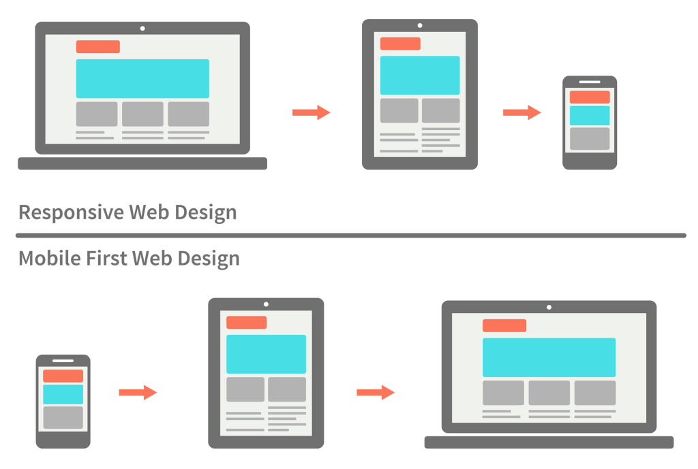

**Test on multiple devices:**

* Various smartphones (iOS and Android)
* Tablets
* Different screen sizes
* Portrait and landscape orientations

**Check for:**

* Text readability without zooming
* Button/link tap areas
* Image scaling
* Navigation usability
* Form functionality

## Phase 2: Content Verification

### Content Audit

1. **Homepage Review:**

* Value proposition clarity
* Call-to-action visibility
* Key message placement
* Contact information accessibility

1. **Core Pages Check:**

* About page completeness
* Service/product descriptions
* Contact information accuracy
* Policy pages (Privacy, Terms, etc.)

### Content Quality Control Checklist

* Proofread all text content
* Verify image quality and optimization
* Check for broken links
* Ensure consistent formatting
* Verify meta descriptions and titles
* Confirm all CTAs are working

## Phase 3: Performance Optimization

### Speed Testing

*The pages should load in under three seconds.*

Use Google PageSpeed Insights to check:

1. **Largest Contentful Paint (LCP)**

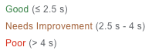

* ***Target***: Under 2.5 seconds
* Optimize largest page elements

1. **First Contentful Paint (FCP)**

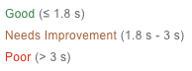

* ***Target***: Under 1.8 seconds
* Improve server response time

1. **Cumulative Layout Shift (CLS)**

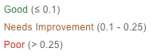

* ***Target***: Under 0.1
* Fix any layout instability

### Image Optimization

1. **Compress all images using tools like:**

* TinyPNG
* ImageOptim
* Squoosh

1. **Implement lazy loading for:**

* Below-fold images
* Gallery content
* Video content

## Phase 4: Security Implementation

### Security Measures

1. **Basic Security:**

* Install SSL certificate
* Set up firewall rules
* Configure backup system
* Implement strong passwords

1. **Advanced Protection:**

* Enable two-factor authentication
* Set up malware scanning
* Configure DDoS protection
* Implement file integrity monitoring

### Payment Security (If Applicable)

* Verify PCI compliance
* Test payment gateway integration
* Confirm order process security
* Check transaction encryption

## Phase 5: Analytics and Tracking Setup

### Analytics Implementation

1. **Install Google Analytics 4:**

* Set up property
* Configure data streams
* Define conversion goals
* Set up custom events

1. **Additional Tracking:**

* Heat mapping tools
* User behavior analytics
* Form tracking
* Error monitoring

### Goal Setting

1. **Define key metrics:**

* Page views
* Time on site
* Bounce rate
* Conversion rate
* User flow

1. **Set up custom reports for:**

* Traffic sources
* User behavior
* Conversion tracking
* Site performance

## Phase 6: Final Testing Phase

### Functionality Testing

1. **Test all interactive elements:**

* Forms
* Buttons
* Links
* Search functionality
* Navigation menus
* Social media integration

1. **Check all automated processes:**

* Email notifications
* Order confirmations
* Newsletter signups
* Automated responses

### User Experience Testing

1. **Conduct user testing with:**

* Team members
* Beta testers
* Target audience members

1. **Test specific scenarios:**

* New user journey
* Returning user experience
* Purchase process
* Contact/inquiry flow

## Phase 7: Launch Preparation

### Pre-Launch Checklist

1. **Final Checks:**

* Backup current site
* Update DNS settings
* Configure redirects
* Test loading speed
* Verify security certificates

1. **Documentation:**

* Create launch protocol
* Prepare troubleshooting guide
* Document emergency contacts
* Set up monitoring alerts

### Launch Day Protocol

1. **Morning of Launch:**

* Final backup
* Team communication setup
* Systems check
* Monitor availability

1. **During Launch:**

* Remove maintenance mode
* Monitor server performance
* Check vital pages
* Test key functionality

## Phase 8: Post-Launch Monitoring

### First 48 Hours

1. **Monitor continuously:**

* Server performance
* User activity
* Error reports
* Payment processing

1. **Track key metrics:**

* Page load times
* User engagement
* Conversion rates
* Error rates

### Ongoing Monitoring

1. **Daily checks:**

* Security scans
* Performance metrics
* User feedback
* Error logs

1. **Weekly reviews:**

* Analytics data
* User behavior
* Content performance
* Technical issues

## ACTION PLAN

### Immediate Steps:

1. Create a project timeline with specific deadlines for each phase
2. Assign team responsibilities for each checklist item
3. Set up monitoring tools and analytics
4. Prepare emergency response procedures
5. Schedule regular check-ins during launch day

### One Week Before Launch:

1. Complete all major testing
2. Finalize content updates
3. Verify all security measures
4. Test backup systems
5. Brief team on launch protocol

### Launch Day:

1. Execute pre-launch checklist
2. Monitor all systems continuously
3. Have support team ready
4. Document any issues
5. Maintain communication channels

### Post-Launch Week:

1. Monitor performance metrics
2. Gather user feedback
3. Address any issues promptly
4. Document lessons learned
5. Plan regular maintenance Schedule

CONCLUSION

A successful website launch requires careful planning, thorough testing, and meticulous attention to detail. By following this comprehensive protocol, you'll minimize risks and ensure your website debuts professionally and effectively.

Remember that launching your website is just the beginning. Continue monitoring, maintaining, and improving your site based on user feedback and performance data. Regular updates and optimization will help ensure your website remains a valuable asset for your business growth.

Take action now by starting with the pre-launch phase, working methodically through each checklist item, and maintaining clear documentation throughout the process. Your careful preparation will pay off in a smooth, successful launch that sets the foundation for your online success.

