Bandera Library
515 Main
PO BOX 1568
Bandera, TX 78003

Meet Apollo by Biblionix
Your On-Line
Account
Patron #
and
Phone Number

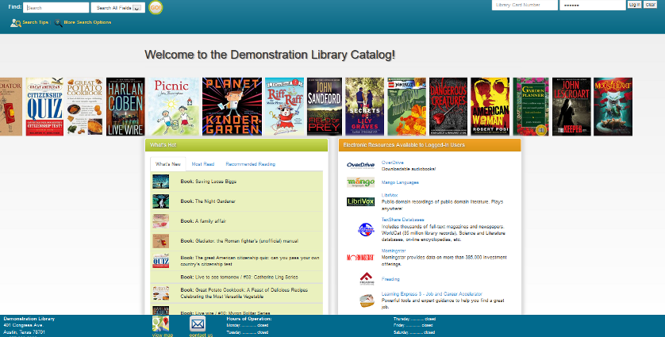
Your Bandera Library Catalog has conveniences and powerful ways for you to access information. The on-line catalog is available for your use from any Internet capable computer in the library, at home, or anywhere. There are two primary capabilities: Searching for a book, a DVD, or etc, and managing your library account. This document covers instructions and tips on how to get the most out of your library account. If you need help, please don’t hesitate to ask a staff member for assistance.

Overview:
The catalog maintains an account for each member.
The many features and functions are available including:

- view items checked out and their status
- renew items
- reserve items
- reserve authors
- balance due (and payable on-line)
- designate a vacation delay so you won’t miss your turn
- designate how you wish to be contacted

Let’s take a quick tour of your “My Account”.

Logging In:

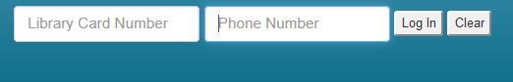
To log-in to your account, enter your “Library Card Number” and phone number or password in to the fields in the upper right corner of the catalog welcome/search page. Enter your phone number (with or without the dash). If it has the same area code as the library, you may not need to enter it.. Select the 'Log In' button.

Click “My Account” button - There will be tabs allowing you access to the different sections of your account information.

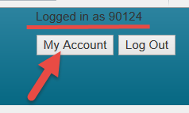

Let’s look at each section.

My Account Info
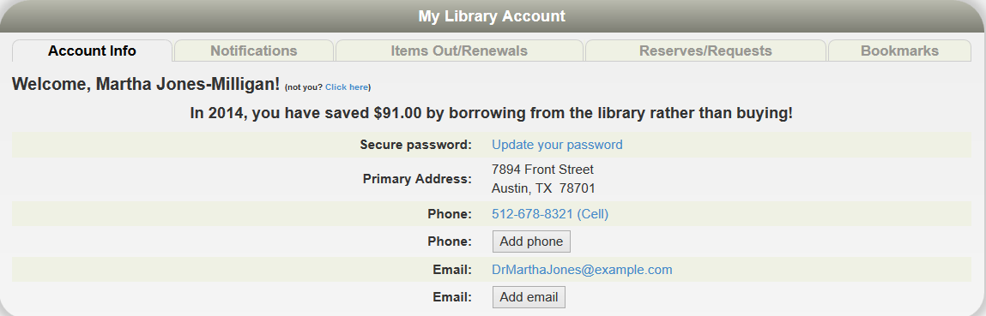

Here you will find your name, address, phone numbers, email address, etc. You can set or change your secure Apollo password here. Changes can be made here for personal information seen in blue. Just click on what you want to change and a box will appear. Make your changes and click save. If you have moved recently, please drop by the library to make the address change.

Notification Options:

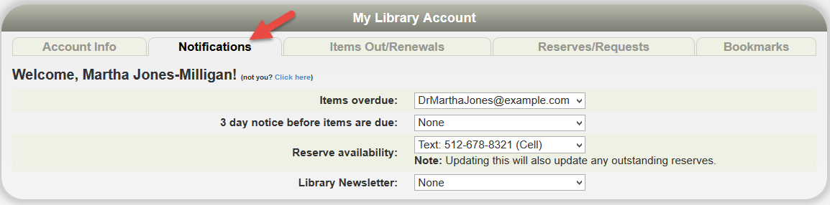
The library will notify you of various situations using the contact method selected in this section. To change an option, click the drop down box. The options are derived from your “Account Info” in the first tab. The feature “3 day Notice Before Items Are Due” is only available through text message and email, otherwise you may choose the options phone call, text message, or e-mail.

Items Out, Renew
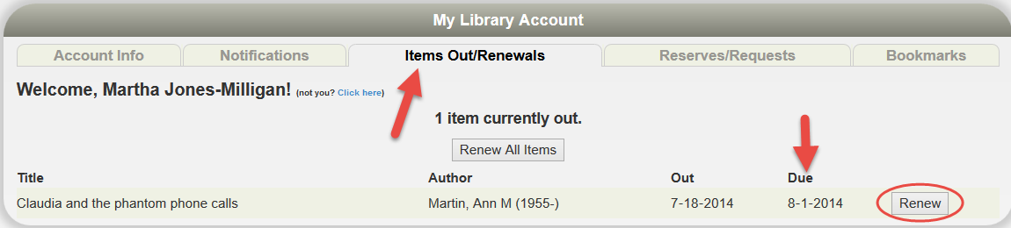
This next section shows all items currently checked out to your account. You’ll see the title, due date, and etc. If a renew button is shown to the right of the due date, you can just click on it to renew the item. The item might show “Not Renewable”. This might be for a number of reasons: If it is on reserve by someone else, or that type of item (e.g. DVD) is not renewable, or you have fines over the limit, or your card has expired.

Reserves

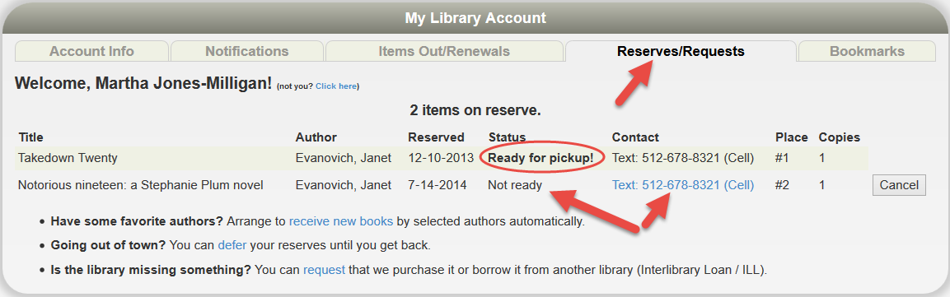
This section lists any reserves you have placed and it typically notes your place on the reserve waiting list. It also shows how you elected to be notified. The “Copies” column indicates how many copies the library has of that title. Note that you can cancel the reservation on items that are not ready.

Have Some Favorite Authors? – Click the “receive new books” link and a list of popular authors will appear. Select your favorite(s) from the list and a reserve will automatically be placed for you when any new titles arrive at the library.

Going Out Of Town? – You can avoid losing your place in any reserve line by indicating when you will not be available. If your turn comes up, you simply move one place down in line. You’ll get that favorite item you’ve been waiting for without going to the end of the line. To indicate when you're unavailable, click “defer” and you’ll see a calendar pop-up. Click any date to mark it is an unavailable. It will turn blue. Click again to mark it is as available. It will return to white. You can move to different months as necessary with the arrows in the top left and right. You can also click/hold across days or weeks to mark a date range.

Is The Library Missing Something? Place a request for an item here and this will inform the library staff of your request.

Bookmarks

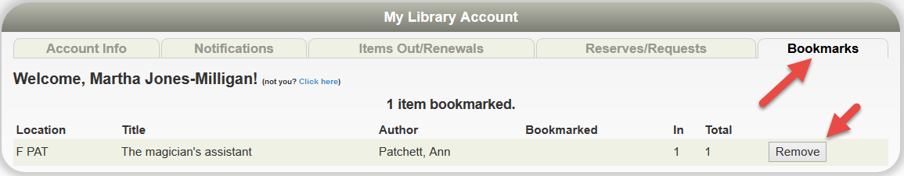
The bookmark section is for your convenience. The library does nothing with your list. This feature could be very useful when doing research and a bibliographic reference will be needed. You may wish to use bookmarks as a reminder of things you want to read in the future or have read in the past. When you are logged-in to the Public Catalog, and view individual records, you can simply click the, “Bookmark This Item” button. To remove a bookmark, click the “Remove” button found at the end of a book marked title in your account.

We hope you enjoy these capabilities. Let us know what you think.



Accessing the Bandera County Public Library’s Digital Collection

Bandera Public Library offers hundreds of titles for e-books (electronic books) and digital audiobooks. Here’s a quick guide to access all these exciting titles. Happy Reading!

From the library’s website: http://banderacountylibrary.org/

Click on the tab Online Catalog

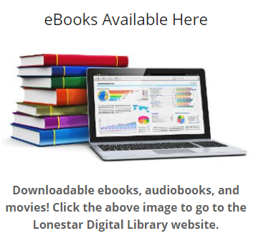
Next, click on the link that looks like this:

OR you can go directly the Lone Star Digital Library website:
http://lonestardigitallibrary.overdrive.com/

First, click on the link that says Sign In

Next, click the drop down menu and select “Bandera County Library”

Two windows will pop up and you can enter your Card Number/Patron Number and your password. If you do not have a password set up, it is most likely the phone number attached to your library card account.
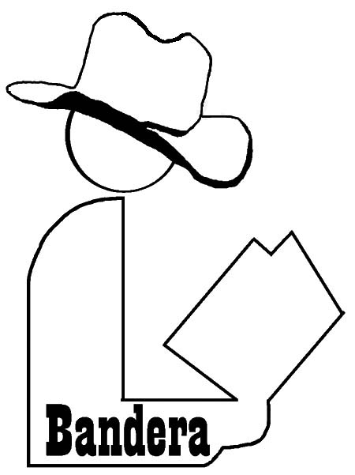
From this page you can search the digital collection. Hooray!

Check out Flipster
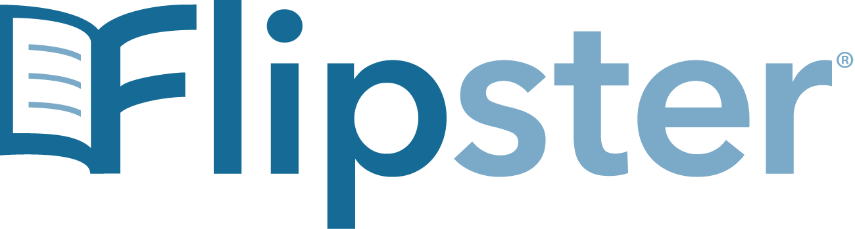

Get Access to online Magazines using Flipster!
Magazines found on Flipster include:

- American Craft
- Birds and Bloom
- Brides
- Cowboys & Indians
- Discover
- Gun Digest
- Horse and Rider
- Kiplinger Personal Finance
- Macworld

- Muscle and Fitness
- NY Review of Books
- Reader’s Digest
- RV Travel & Lifestyle
- TX Fish & Game
- True West
- Vanity Fair
- Vogue
- And much more!

How to use:
  - Go to the Bandera County Library Online Catalog
  - Log in to the Catalog with your Patron ID and Phone Number
  - Scroll down to Electronic Resources and click on Flipster
  - Begin reading your favorite magazines!

Using the Libby App



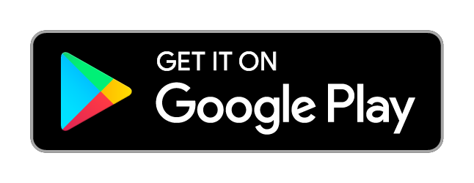


One of the easiest ways to access your digital books is to use the Libby app. Libby is offered through the Apple App store, Google Play store and on Microsoft’s app store.

Benefits of using Libby
- Access the digital collections of the libraries which you have a card
- Download e-books and audio books for offline reading
- Keep a history of your reading in the Activity tab
- Sample any book with a tap- no need to download or delete
- Borrow graphic novels with zoom able pages or picture books with read-a-long audio
- Libby can send your books to your e-reader too!

