5,800,000 people pass this digital sign a month!
AFTERNOON TRAFFIC SEES THIS SIGN FOR 20 SECONDS!
2,442,064 Impressions per month!
https://thechattanoogasign.com and https://youtu.be/8NTI1jEx-cY and https://youtu.be/YzgMB3jeijw
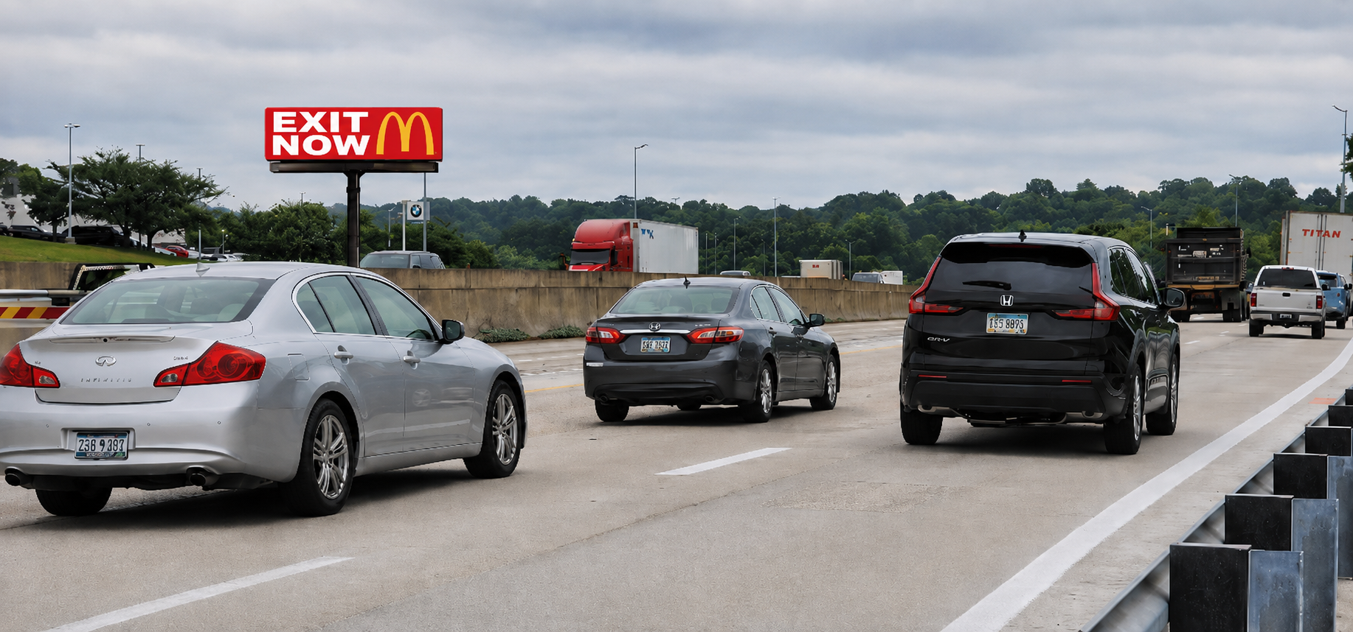
I-75 at the BMW dealership at 6806 E. Brainerd Road, Chattanooga, TN. 37421 (35.014050, -85.183016)
Right-hand read on I-75 going southbound to downtown Chattanooga

