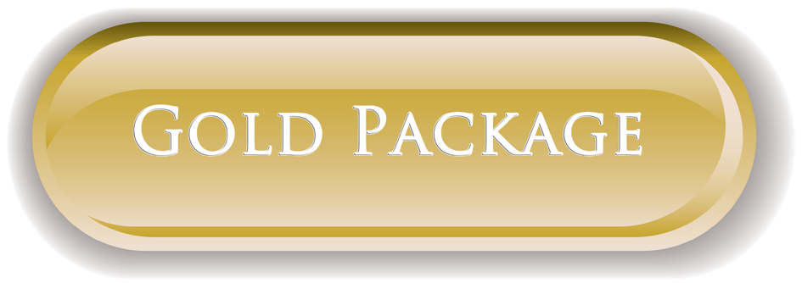  $1200 month per face on a 1-year contract  -In 30 days, you will have a guaranteed delivery of 40,000 ads  -Customers will receive an ad every 1 minute.  -Customers can run up to 4 different ad campaigns in rotation. | 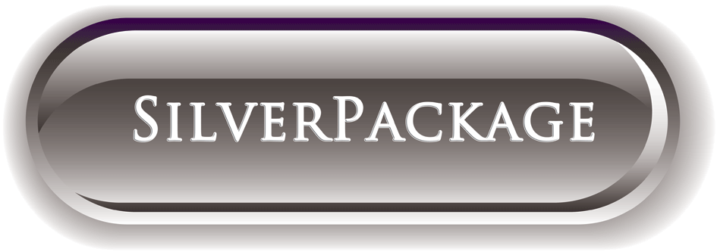  $600 / month per face on a 1-year contract  -In 30 days, you will have a guaranteed delivery of 20,000 ads  -Customers will receive an ad every 2 minutes.  -Customers can run up to 2 different ad campaigns in rotation. | 3 Month Package  $1500 per month  1 Month Package  $1600 per month  DESIGN PRINTING AND POSTING FREE WITH ALL PACKAGES

