THE CHATTANOOGA SIGN SM
5,838,705* people passing this digital sign a month!
AFTERNOON TRAFFIC SEES THIS SIGN FOR 40 SECONDS!
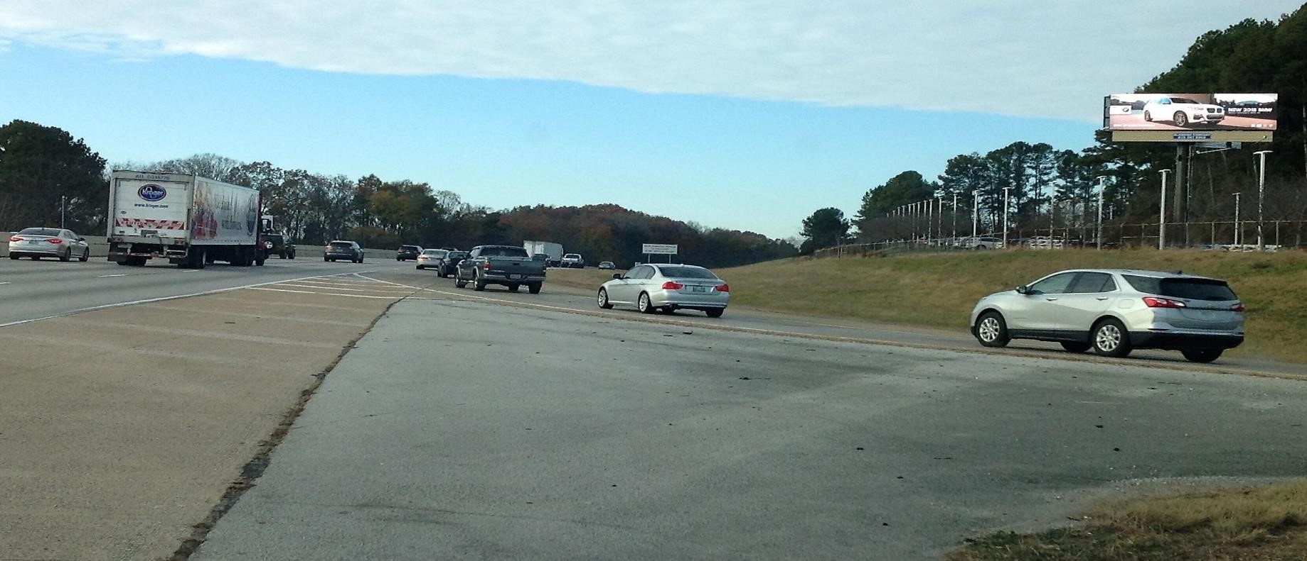
https://youtu.be/8NTI1jE
x
-
c
Y

and
https://youtu.be/YzgMB3jeij
w

I-75 at the BMW dealership at 6806 E. Brained Road Chattanooga, TN. 37421 (35.014050, -85.183016)
Right hand read on I-75 going South inbound to downtown Chattanooga
Blanning Company, LLC 1600 Fair House Road-Spring Hill, Tn. 37174-(615) 587 5969-keith@blanningco.com
*2017 TDOT COUNTING STATION #0163-129,749 CARS PER DAY*30 DAYS*1.5 PEOPLE PER CAR AVG.

