**5,838,705* people passing this digital sign a month!**

**AFTERNOON TRAFFIC SEES THIS SIGN FOR 40 SECONDS!**

**http://thechattanoogasign.com**

<https://youtu.be/8NTI1jEx-cY> and <https://youtu.be/YzgMB3jeijw>

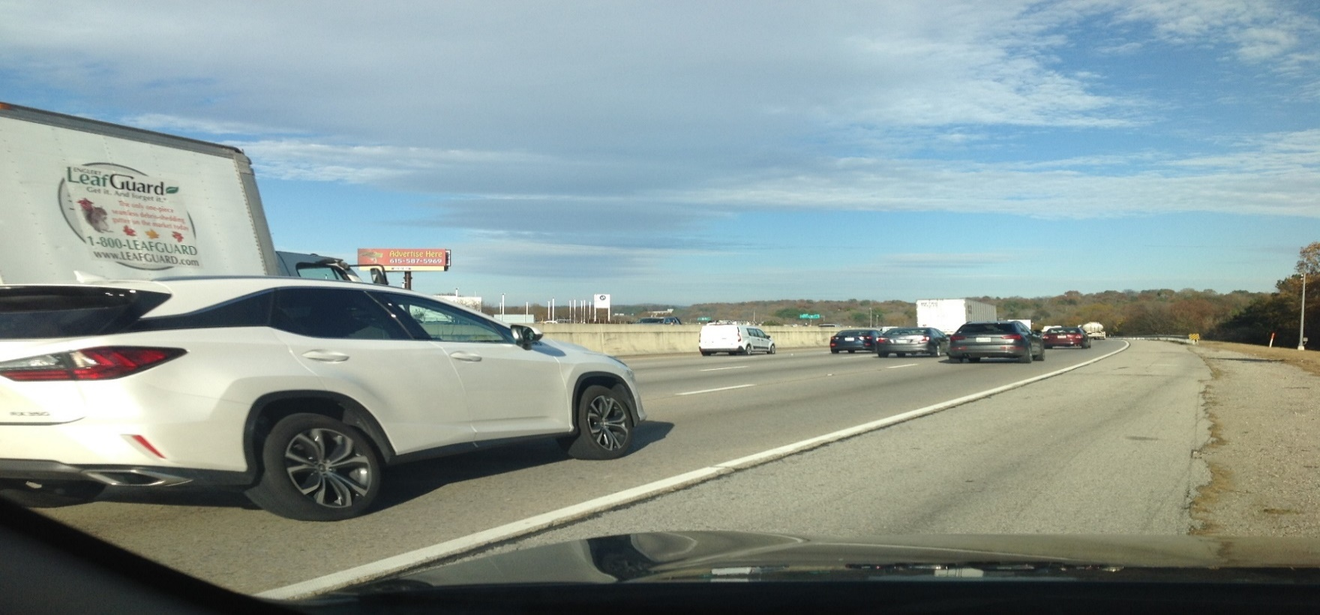

**I-75 at the BMW dealership at 6806 E. Brained Road Chattanooga, TN. 37421 (35.014050, -85.183016)**

**Left hand read on I-75 going Northbound to Hamilton Place Shopping and Knoxville**

**Blanning Company, LLC 1600 Fair House Road-Spring Hill, Tn. 37174-(615) 587** [**5969-keith@blanningco.com**](mailto:5969-keith@blanningco.com)

*2017 TDOT COUNTING STATION #0163-129,749 CARS PER DAY*30 DAYS*1.5 PEOPLE PER CAR AVG.