Three Forks Treatment, Blue Ridge
Project Details
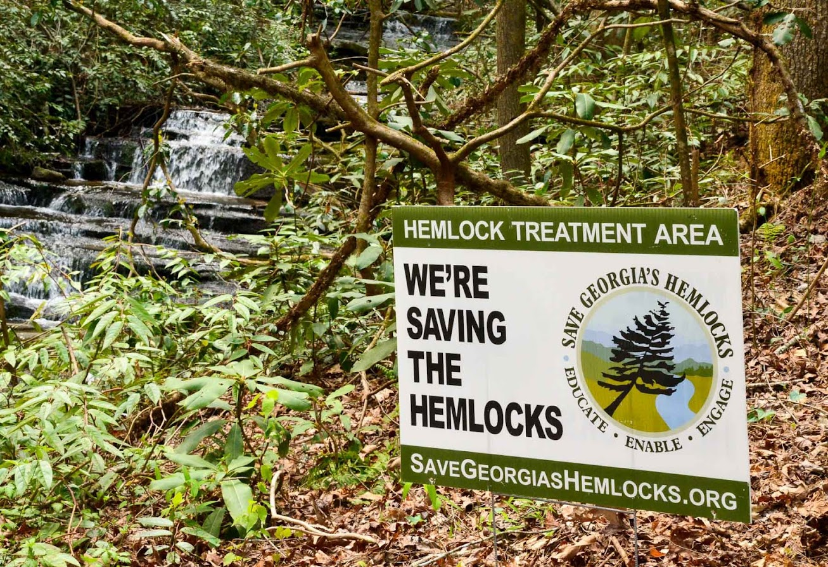
Date | Saturday, Aug. 30, 2025
Event | Service event to treat or retreat the hemlocks  at Long Creek Falls near Three Forks in Fannin County. According to prior treatment logs, we expect to treat or retreat 200 trees.  Photo of project site  or other appropriate image
Notice | As SGH is committed to protecting the health  and safety of our volunteers at all events, please bring water and dress appropriately.
Where to Meet | Fellowship Primitive Baptist Church, 5850 Doublehead Gap Rd., Blue Ridge near FS Rd. 58. Directional signs will be posted. GPS 34.708189/-084.222005__________________________
Schedule | 8:45 a.m. - 9:00 a.m. – All volunteers meet at the church. First, you’ll receive a briefing on the condition of the hemlocks, treatment process to be used, and safety reminders. You’ll be organized into small teams including at least one experienced SGH Facilitator per team and receive your equipment and supplies. Then we’ll caravan in as few vehicles as possible to the access point for each work site and begin treating trees up to Three Forks.  12:30 p.m. – Everyone will break for lunch. After lunch, we’ll resume work.  By 3:00 p.m. (probably sooner) – We’ll stop work, clean the equipment, caravan back to the meeting church, and head for home.
Access | Access to the treatment sites is via Forest Service roads. Four-wheel drive is not necessary but high clearance vehicles are recommended.
Terrain | The terrain at the work sites is flat in some places and hilly in others but not dangerously steep anywhere. We’ll make sure everyone is assigned to a work site or job assignment where they can be safe and comfortable.
What to Wear | Dress for the weather and the activity, including long pants and long sleeves, gloves and sturdy footgear, and rain gear in case of light rain. Nitrile gloves will be provided for those who will be handling chemicals. All 3 sites involve creek crossings, so wear shoes that can get wet or if you have waders or high-top waterproof boots, bring them!
What to Bring | Pack a personal water bottle, sack lunch, and camera if you like. A hiking stick and small day pack to carry things might also come in handy. We’ll provide extra bottled water and snacks.  If you have any serious allergies (like bee stings), bring whatever you need to manage.
Don’t Bring: | This is an environmentally friendly, pack-it-in pack-it-out event, so please don’t bring any glass or Styrofoam items. Also, as much as we love dogs, please don’t bring them.
Registration: | Participants must sign up in advance. Contact Heidi Hunter at heidi@savegeorgiashemlocks.org or 912-660-1250. Please provide both your phone number AND email address.
If you have questions, please call or email before you get to the area as phone service is not available.

Driving Directions

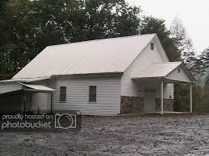
From Blairsville- Take the Old Blue Ridge Highway west for approximately 7 miles. Turn left on Skeenah Gap Road and go approximately 8 miles. Turn right on GA Highway 60N and go 0.2 miles to the first left on Doublehead Gap Road. Go 5.8 miles to Fellowship Primitive Baptist Church (on right).

From Suches - Take GA Highway 60 N for 15.5 miles. Turn left on Doublehead Gap Road. Go 5.8 miles to Fellowship Primitive Baptist Church (on right).

From Blue Ridge -Take Aska Road south for approximately 13 miles. Turn right on Newport Road and go approximately 4 miles. Turn left on Doublehead Gap Road and go 0.6 miles to Fellowship Primitive Baptist Church (on right)

From Ellijay and points south - Take GA Highway 52 east for approximately 5 miles. Turn right on Big Creek Road and go 8.5 miles. Stay straight on Doublehead Gap Road and go 6.7 miles to Fellowship Primitive Baptist church (on left)
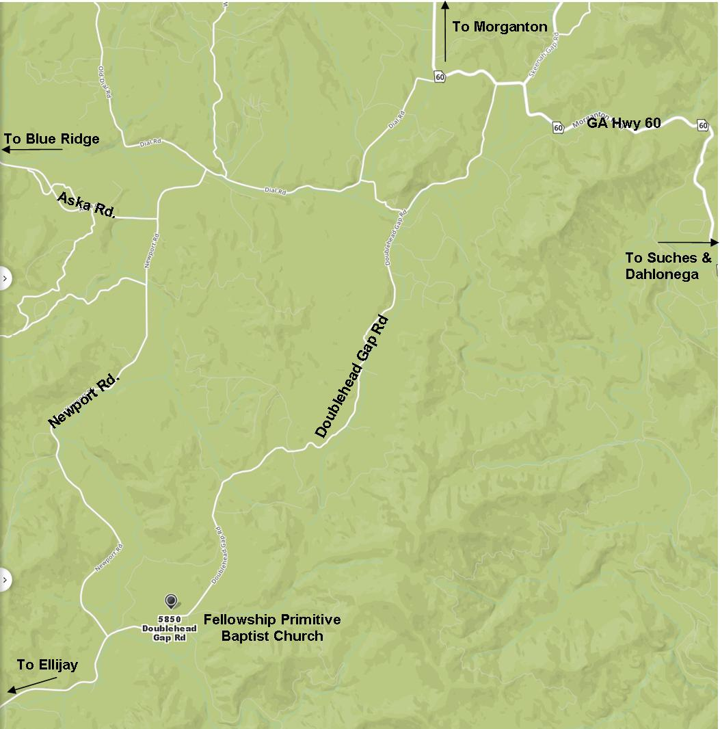

See close-up map on next page.

