**Daily Body Restore (DBR) Research Programme**

**Gut microbiota, malnutrition, inflammation and oxidative status in chronic kidney disease progression. Effect of probiotic/digestive enzyme supplement**

**Final Report**

***BACKGROUND*:** Chronic Kidney Disease (CKD or IRC) has been defined by the National Kidney Foundation as a condition in which abnormality of kidney structure or function (decline of excretory, endocrine, and metabolic function) occurs with glomerular filtration rate <60 ml/min/1.73m2 for at least 3 months, with important health implications.

Inflammation and oxidative stress play a very important role in CKD progression. In the literature, it has been shown that in patients with acute or chronic kidney disease, characterized by high oxidative stress, increased production of IL-6, IL-8, TNF-α, and CCL-2 often occurs, because there is a high correlation between changes in oxidative stress and plasma levels of cytokines. Over the last decade, there has been increased awareness that changes in the quantitative and/or qualitative composition of the gut microbiota are implicated in the systemic inflammatory state, CKD progression, and CKD-related cardiovascular disease (CVD).

Constant changes in the gut microbiota were also observed during the CKD, inducing a metabolic load that could further increase CVD risk in CKD patients. Thanks to corrections of habits of daily life, such as low protein diets, correction of disorders of mineral metabolism and anemia, control of blood pressure and proteinuria, and other lifestyle interventions (smoking and exercise), it is possible to delay the progressive loss of kidney function and/or prevent the development of CKD. Moreover, intervening directly in the modulation of the intestinal microbiota, going to integrate with probiotics, could be effective in modifying clinical outcomes, thanks to a direct or indirect change of the inflammatory and oxidative state.

***AIM OF THE STUDY:***The purpose of this study was to evaluate the effect of probiotic supplementation (DBR), exploring potential changes in parameters associated with inflammation and gut microbiota composition in CKD patients.

***PATIENTS, MATERIALS, AND METHODS:***A sample of 30 patients with CKD (stages III to V) was recruited for conservative therapy at A.S.S.T. Santi Paolo and Carlo, who were given a supplement of probiotics and digestive enzymes (**DBR**) for a total time of three (T1) or six months (T2). Blood chemistry tests were carried out to evaluate renal function; body composition analysis (body mass index - BMI, waist circumference, and bioimpedance examination), and analysis of food intake (EphoodTM software) for the assessment of nutritional status*.*

The ELISA kit (Fluorokine, Multianalyte Profiling (MAP), and Luminex) was used to analyze the inflammatory state of the patients before and after taking the probiotic. Analysis of the main protein-bound uremic toxins (p-cresyl sulfate, PCS, and indoxyl-sulfate, IS) was performed by liquid chromatography-mass spectrometry (LC-MS/MS). The study of the gut microbiota was carried out through Next Generation Sequencing (NGS), using the 16STM Metagenomics Kit and Ion ReporterTM Software.

Each patient was asked to complete the questionnaire "Health and Wellbeing" (KDQOL-SFTM v1.3) which, together with the help of a specialist psychologist, allowed us to evaluate their quality of life and their relationship with the disease. For a more precise analysis of changes in the gut microbiota, 20 healthy subjects were recruited, comparable by sex and age. The control group was subjected also to anthropometric, bioimpedance, and nutritional analysis, together with the assessment of the gut microbiota.

***RESULTS AND CONCLUSIONS****:* The analysis of body composition (bioimpedance) showed that, after six months of treatment, the value of ICW (intracellular water) was significantly increased (IRC T0: 19.14±3.43 L, IRC T1: 20.05±3.09 L; p-value=0.00457). Under physiological conditions, the value of ICW (obtained from the difference between total and extracellular water) is an indicator of the metabolically active mass of the organism. We can conclude that the DBR administration caused an increase in metabolically active mass in the CKD population under study.

Regarding the haematochemical parameters, a slight reduction of phosphorus from time T1 (3.64 ±1.03 meq/L; p-value=0.02896) at time T2 (3.18 ±0.94 meq/L; p-value=0.02880), important for limiting the progression of renal pathology, was found. Patients with impaired kidney function gradually lose the ability to excrete phosphorus. From the point of view of kidney disease, the improvement of the level of phosphorus is positive for its stability, thus reducing the risk of progression of pathology.

The levels of sodium (139,28 ±12,28 meq/L; p-value < 0,0001) and calcium (T0: 9,20 ±1,55 meq/L, T1: 9,10 ±1,94 meq/L, T2: 8,89 ± 2,28 meq/L; p-value <0,0001) found in the CKD population, in the three measured times, resulted all in the reference ranges, due to the excellent monitoring of the patients by the Nephrologists and the good response to the therapy.

Although 40% (n=12/30) of CKD patients were under a hypocholesterolemic treatment, the blood concentration of triglycerides was statistically higher than the controls (p-value=0.00799), confirming a situation of dyslipidemia typical of the CKD patient.

The analysis of food intake of CKD patients showed a decrease in the consumption of fiber (p- value=0.0125) and soluble carbohydrates (p-value= 0.0120) between basal (T0) and T1, indicating the good compliance of patients to the nutritional advice given (Figure 1).

Since inflammation is the basis of chronic kidney disease, the concentrations of pro-inflammatory cytokines at serum level (CCL-2, IL-1β, IL-6, IL-18, INF-γ, IL-4, IL-12p70, TNF-α) have been evaluated. These analyses showed that, after six months of treatment with DBR, CCL-2 levels decreased significantly (p-value 0.072; Figure 2).

Given the correlation between dysbiosis and chronic kidney disease, the assessment of the gut microbiota of CKD patients has been deepened, through semi-quantitative analysis of 16S ribosomal RNA sequencing (rRNA). From these analyses, a relative abundance of the main phyla *Firmicutes, Bacteroidetes, and Proteobacteria* was found, in different proportions between the CKD populations (T0, T1, and T2) and the control population. Taxonomic analysis at the household level showed a greater presence of *Streptococcaceae* (T0: 2.60% ± 2.98%, Cntrl: 0.58% ± 0.76%; p-value=0.0153) in the CKD population at baseline, possibly associated with the use of proton pump inhibitory drugs taken by CKD patients (Figure 3).

In addition, there was an increase in the presence of *Enterobacteriaceae* (T0: 3.90 % ± 5.99%, Cntrl: 15.62 % ± 22.14%; p-value= 0.0493) in the control population related to a state of dysbiosis, possibly influenced by the average age found (73 years) (Figure 4). Through the analysis of alpha-diversity, the Shannon indices obtained for the population’s groups were compared, resulting in statistically significant differences between controls and T0 (3,2 0,35, p-value=0,0321) and between controls and T2 (2,8 0,62, p-value = 0,0256) (Figure 5).

Analysis of uremic toxins showed a significant increase in indoxyl sulfate (IS) levels in CKD patients from basal to 6 months of supplementation (Figure 6).

The main result of the present study is the potential of DBR supplementation in decreasing CCL-2, a pro-inflammatory chemokine responsible for CKD worsening, together with an increase in metabolic active mass.

In conclusion, DBR could be a promising adjuvant in CKD treatment.



Figure 1. Main results of food intake in CKD patients and control group. CTRL: control group; IRC T0: CKD patients at baseline; IRC T1: CKD patients after 3 months of DBR supplementation; IRC T2: CKD patients after 6 months of DBR supplementation.

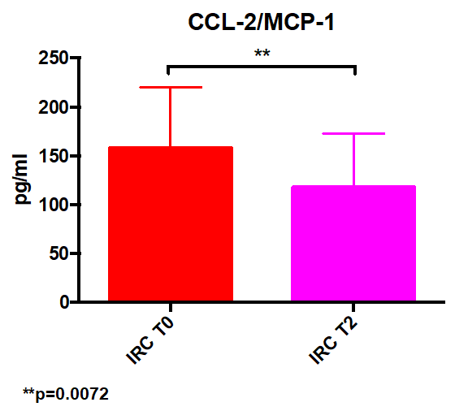

Figure 2. Levels of pro-inflammatory chemokine CCL-2/MCP-1 in CKD patients. IRC T0: CKD patients at baseline; IRC T2: CKD patients after 6 months of DBR supplementation.



Figure 3. Amount of *Streptococcaceae* in the gut microbiota of CKD patients and control group. CTRL: control group; IRC T0: CKD patients at baseline; IRC T1: CKD patients after 3 months of DBR supplementation; IRC T2: CKD patients after 6 months of DBR supplementation.



Figure 4. Amount of *Enterobacteriaceae* in the gut microbiota of CKD patients and control group. CTRL: control group; IRC T0: CKD patients at baseline; IRC T1: CKD patients after 3 months of DBR supplementation; IRC T2: CKD patients after 6 months of DBR supplementation.

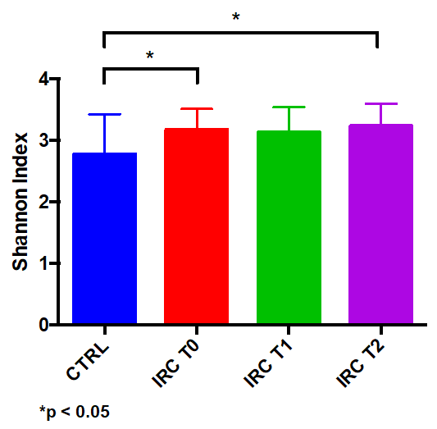

Figure 5. Alpha-diversity (Shannon Index) in the gut microbiota of CKD patients and control group. CTRL: control group; IRC T0: CKD patients at baseline; IRC T1: CKD patients after 3 months of DBR supplementation; IRC T2: CKD patients after 6 months of DBR supplementation.

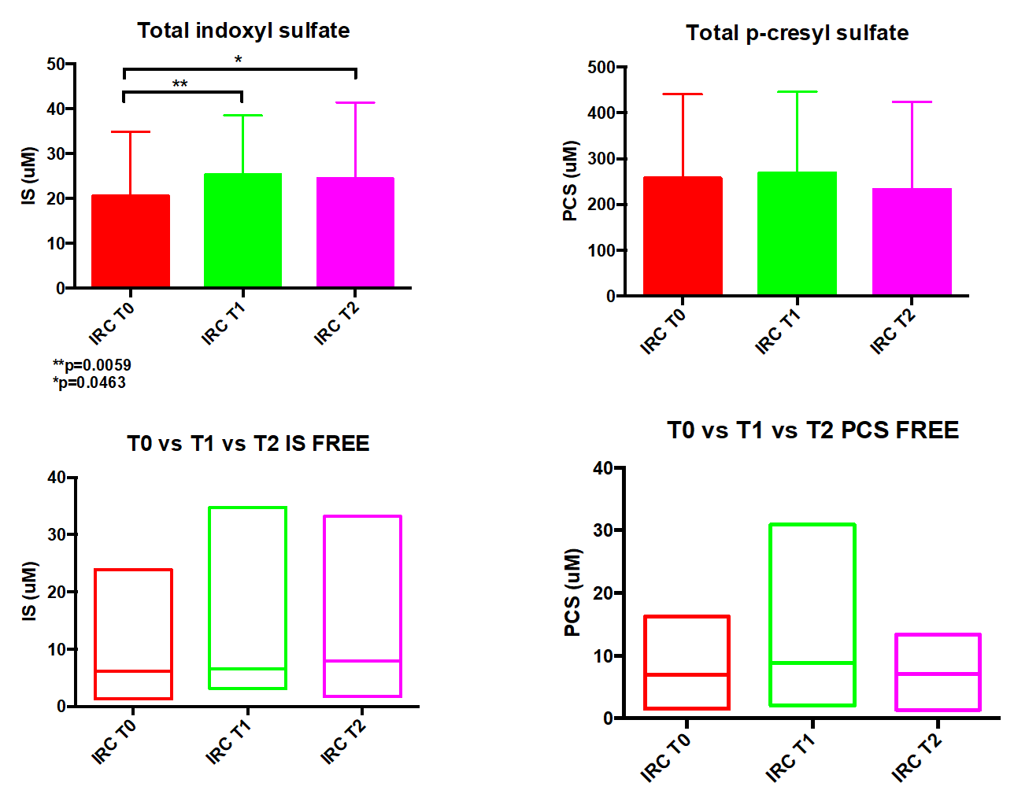

*Figure 6. Levels of total and free uremic toxins in CKD patients. IRC T0: CKD patients at baseline; IRC T1: CKD patients after 3 months of DBR supplementation; IRC T2: CKD patients after 6 months of DBR supplementation; IS, indoxyl sulfate; PCS, p-cresyl sulfate.*

**References**

Kidney Disease: Improving Global Outcomes (KDIGO) CKD Work Group. KDIGO 2012 Clinical Practice Guideline for the Evaluation and Management of Chronic Kidney Disease. Kidney inter., Suppl. 2013; 3: 1–150.

M. Van Der Velde et al., “Lower estimated glomerular filtration rate and higher albuminuria are associated with all-cause and cardiovascular mortality. A collaborative meta-analysis of high-risk population cohorts,” Kidney International, 2011, doi: 10.1038/ki.2010.536.

E. Riccio, A. Di Nuzzi, and A. Pisani, “Nutritional treatment in chronic kidney disease: the concept of nephroprotection,” *Clinical and Experimental Nephrology*, vol. 19, no. 2. Springer-Verlag Tokyo, pp. 161–167, Apr. 01, 2015. doi: 10.1007/s10157-014-1041-7.

V. M. R. et al. Krishnamurthy, “High dietary fiber intake is associated with decreased inflammation and all- cause mortality in patients with chronic kidney disease. ,” *Kidney Int. (2012). doi:10.1038/ki.2011.355*.

S. Al Khodor and I. F. Shatat, “Gut microbiome and kidney disease: a bidirectional relationship,” *Pediatric Nephrology*. 2017. doi: 10.1007/s00467-016-3392-7.

H. Fujii, K. Nakai, and M. Fukagawa, “Role of Oxidative Stress and Indoxyl Sulfate in Progression of Cardiovascular Disease in Chronic Kidney Disease,” Therapeutic Apheresis and Dialysis, vol. 15, no. 2, pp. 125– 128, Apr. 2011, doi: 10.1111/j.1744-9987.2010.00883.x.

M. B. Stockler-Pinto, D. Fouque, C. O. Soulage, M. Croze, and D. Mafra, “Indoxyl Sulfate and p-Cresyl Sulfate in Chronic Kidney Disease. Could These Toxins Modulate the Antioxidant Nrf2-Keap1 Pathway?,” Journal of Renal Nutrition, vol. 24, no. 5, pp. 286–291, Jan. 2014, doi: 10.1053/j.jrn.2013.11.006.

E. Castillo-Rodriguez et al., “Impact of Altered Intestinal Microbiota on Chronic Kidney Disease Progression,” Toxins, vol. 10, no. 7, p. 300, Jul. 2018, doi: 10.3390/toxins10070300.

Milano May 3rd 2023