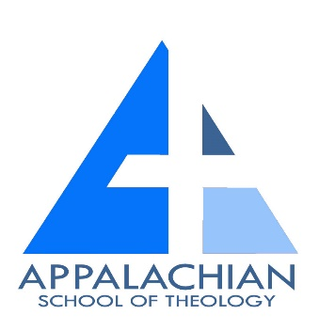
Appalachian School of Theology, UG & US
Domestic & International Student’s Course of Studies
(Current & Upcoming Classes)

- BS 135 & 535 – Old Testament Prophets
- NT 445 & 545 – Encountering Romans
- BS 145 & 545 – The Synoptic Gospels
- BS 170 & 570 – Johannine Literature
- PH 245 & 545 – Philosophy of Religion
- PH 265 & 565 – Christian Ethics
- BIBL – 323 & 523 – Encountering John
- MS 485 & 585 – Spiritual Leadership
- BS 111 & 511 – Introduction to the New Testament (Fall 2025 Online)
- BS 112 & 512 – Introduction to the Old Testament (Spring 2026 Online)
- THE 365 & 565 – Spiritual Development
- MS 415 & 615 – Preaching and Communication
- MS 465 & 565– Formation for Ministry (Fall 2025, Dover Baptist Association Site)
- TP 201 & 501– Christian Theology (Summer 2026 Online)
- TP 202 & 502 – Christian Theology (Summer 2026 Online)
- MS 455& 655 – Pastoral Care and Counseling
- TS – 230 – History and Theology of the Church
- HC 301 & 501 – Church History
- HC 321 & 521– Evangelical Beliefs and History
- MS 365 & 665 – Missiology (Fall 2026, Nickelsville Location)
- BIBL 425 & 525 – Encountering Revelation Part I
- BIBL 426 & 526 – Encountering Revelation Part II
- THE 485 & 585 – A Theology of Paul and His Letters (Fall 2025, Nickelsville Site)
- THEO 495 & 695 Demonology (Spring 2026, Nickelsville Location)
- BIBL 465 & 565 – Encountering Genesis (Coming Soon)
- BIBL 475 & 575 – Encountering Job (Coming Soon)
- THE 485 & 585 – Encountering the Holy Spirit (Spring 2027, Nickelsville Site)
- THE 425 & 525 – Evangelism (Fall 2027, Nickelsville Site)
- CH 455 & 655 – Church Administration (Coming Soon, Nickelsville Site)

*Please know that many of these classes are readily available to students enrolled in our Bachelor’s and Master’s Programs which enables them to work at their own pace in fulfilling the requirements of the degree programs they are enrolled in. If you have questions contact Steve Collins at president@astva.org or Tammy Lane at academicdean@astva.org concerning any questions you may have. International students in Africa, Asia, or India should contact Apio Sarah at africacoordinator@astva.org

For more information such as our school catalog and student enrollment forms please visit our website at astva.org

