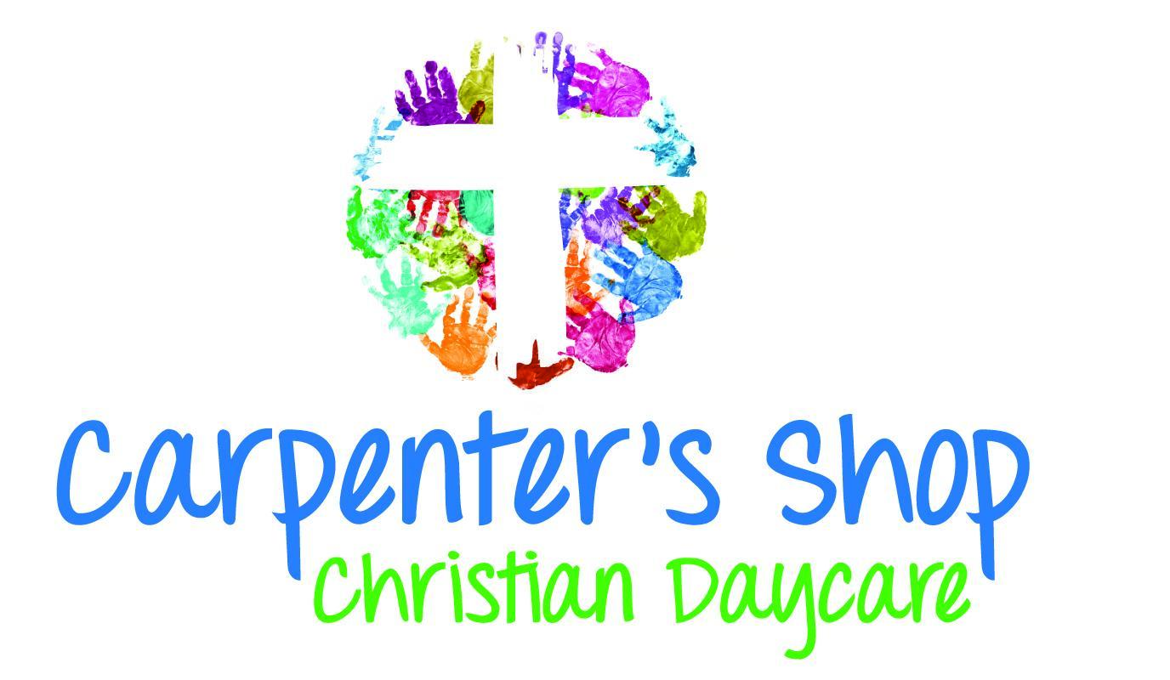

819 E. Silver Spring Drive

Whitefish Bay, WI 53217
431-0306

Tuition Rates – March 2026
Age | Weekly | Daily
6 weeks- 23 months | $422/434 | $95/98
2 year olds | $365/375 | $91/93
3 year olds | $342/351 | $84/86
4 & 5 year olds | $320/328 | $78/80

Check-ACH / Credit Card

