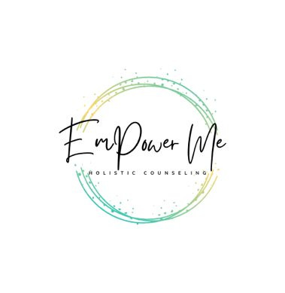

Counseling Intern

If you are a passionate individual who is aligned with our [vision, mission, and values](https://emholisticcounseling.com/about-emhc) and is passionate about serving children and/or adults in recovering from grief, trauma, depression, and anxiety we would love to hear from you!

# We want you if you:

* Enrolled in a Clinical Mental Health Counseling program
* Have a desire to work with individuals age 8+
* Want to work with individuals in a way that is EmPowering
* Self-Motivated and comfortable using technology

# This position is ideal for:

* Someone looking to maintain their current employment while gaining post graduate experience
* Someone who is looking to slowly building their caseload

# There are several beneﬁts of joining our team:

* Flexible hours and autonomy over schedule
* Fully virtual practice
* Professional Zoom account
* Supervision provided
* Opportunity to facilitate groups, workshops, and talks
* Administrative support
* Free marketing, advertising, and branding
* Opportunities for growth within the company
* Safe, energetic, collaborative, and inspiring team

Please submit your cover letter and CV/resume to our CEO, Brandon Shurn at [shurn@emholisticcounseling.com](mailto:shurn@emholisticcounseling.com). You will get a follow up from Brandon within 24-48 business hours regarding next steps.

Thank you for your interest in serving on our team!