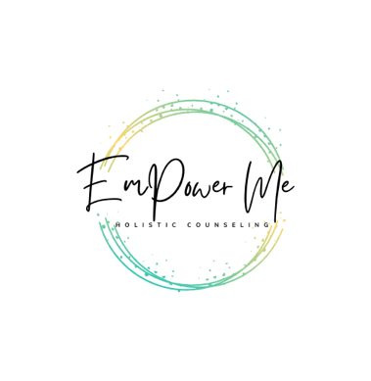

EMHC is Expanding: Join Us!

If you are a passionate individual who is aligned with our [vision, mission, and values](https://emholisticcounseling.com/about-emhc) and is passionate about serving children and/or adults in recovering from grief, trauma, depression, and anxiety we would love to hear from you!

# We want you if you:

* Have recently been licensed in Maryland or will be in the within the next two months
* Have a desire to work with individuals age 8+
* Want to work with individuals in a way that is EmPowering
* Self-Motivated and comfortable using technology

# This position is ideal for:

* Someone looking to maintain their current employment while gaining post graduate experience
* Someone who is looking to slowly building their caseload

# There are several beneﬁts of joining our team:

* Competitive compensation
* Flexible hours and autonomy over schedule
* Fully virtual practice
* Professional Zoom account
* Opportunity to facilitate groups, workshops, and talks
* Administrative support
* Free marketing, advertising, and branding
* Safe, energetic, collaborative, and inspiring team

We are seeking mental health counselors to join our team willing to devote up to 10 hours a week to start with the option to increase to full-time hours. The hours available are ﬂexible and may include daytime, evening, or weekend hours depending on your availability and personal life commitments.

**Important: This is a part-time W2 position with the ability to grow into a full-time position. Pay is connected to the services you provided.**

Please submit your cover letter and CV/resume to our CEO, Brandon Shurn at [shurn@emholisticcounseling.com](mailto:shurn@emholisticcounseling.com). You will get a follow up from Brandon within 24-48 business hours regarding next steps.

Thank you for your interest in serving on our team!