Title
Names of authors (presenting author underlined) e.g. J. Smith¹, B. Lee^{2*}
¹Institution of first author, Address, City, Country
²Institution of second author, Address, City, Country
*Email address of corresponding author
Preferred presentation format: ☐ Poster ☐ Oral presentation
Tick this box if you are an early career researcher (within 5 years of finishing PhD): ☐
Keywords: (up to three, separated by semicolons) keyword 1; keyword 2; keyword 3
Abstract (<300 words): Write your abstract here. Up to one captioned figure may be included. An example is provided below. The limit of the abstract is one page of A4, including references. Paragraphs are justified on both left and right. Do not change the font, line spacing, and page margins.
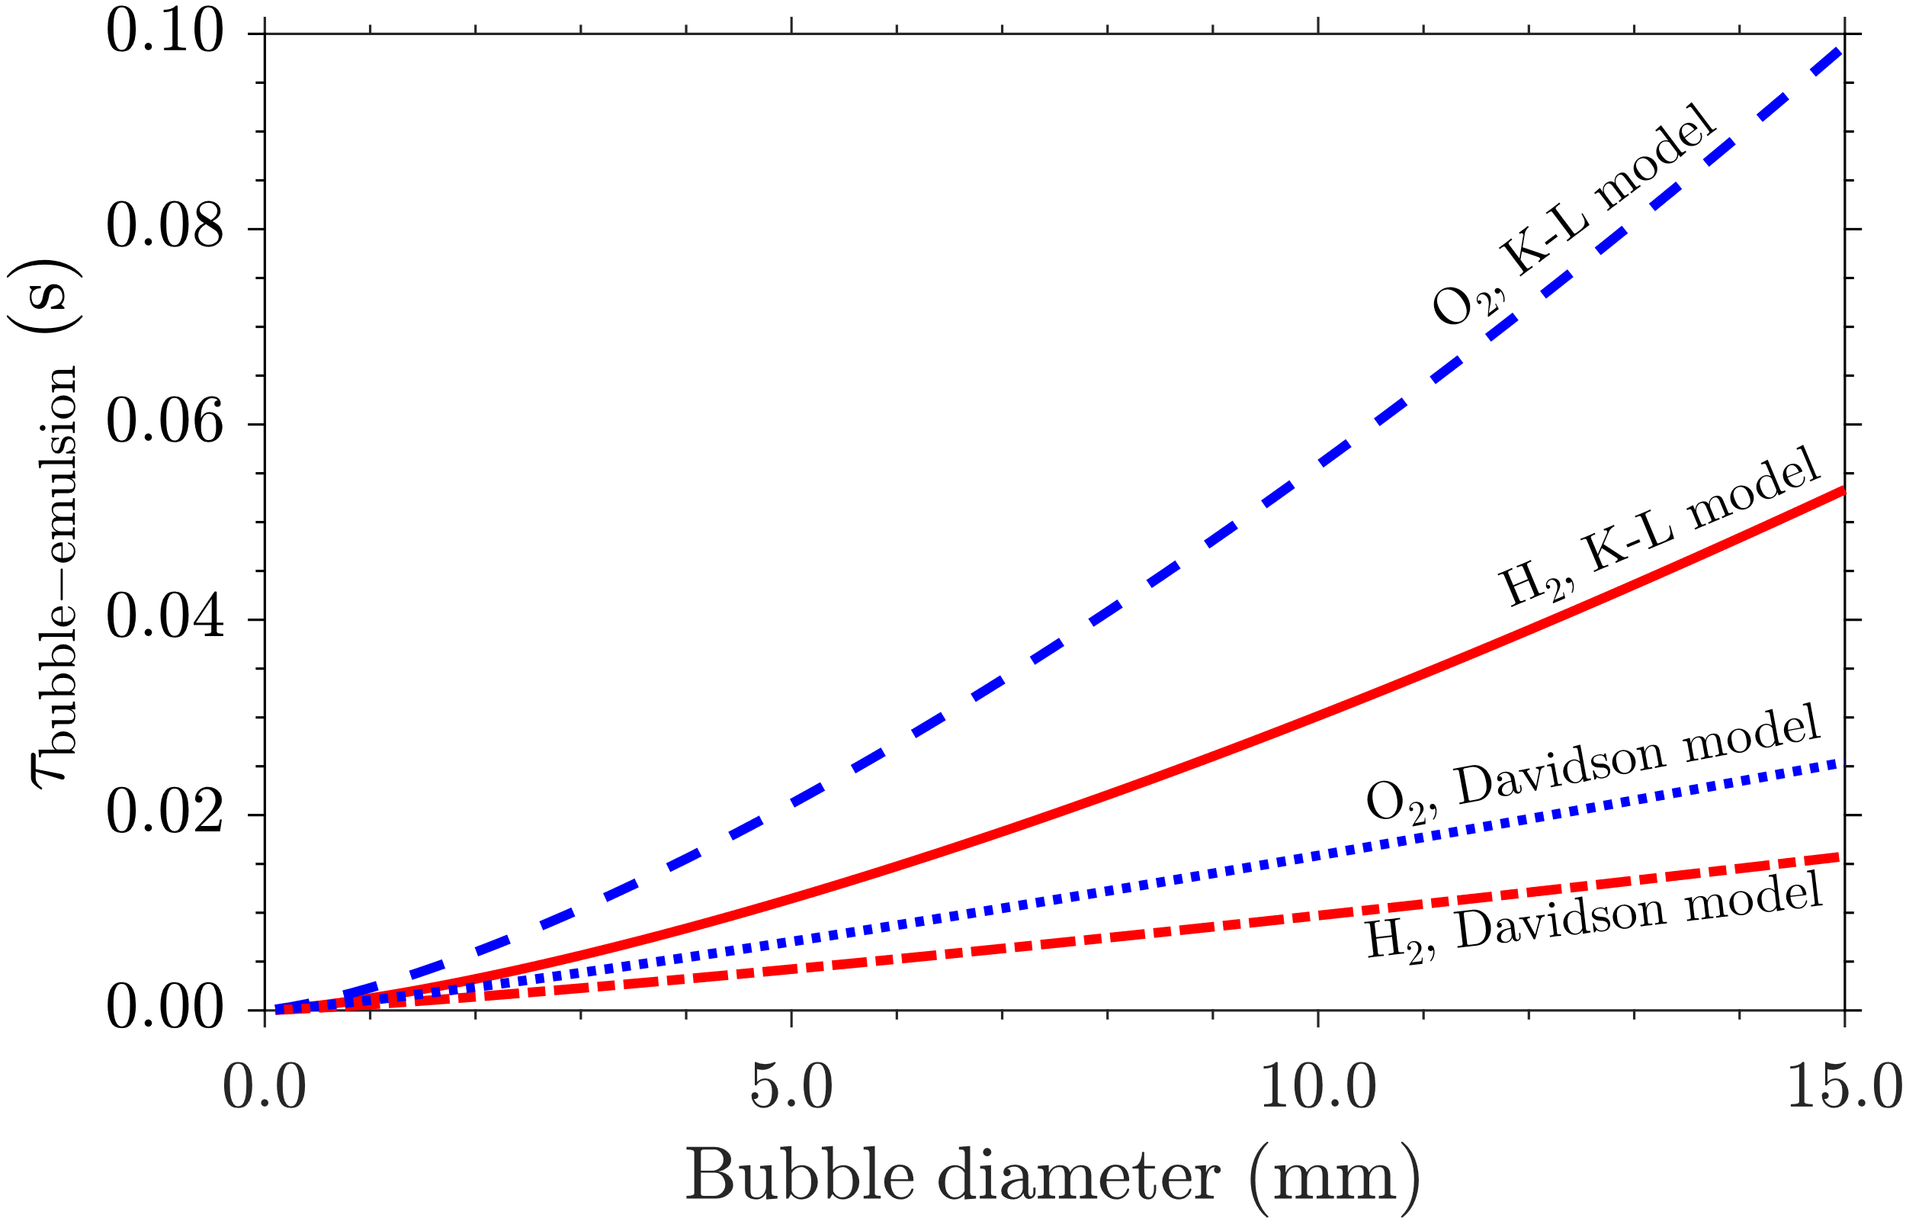
Figure 1: The characteristic time of convective and diffusive transport of hydrogen (H₂) and oxygen (O₂) between a bubble and the emulsion gas in a bubbling fluidised bed, based on the Kunii-Levenspiel (K-L) model¹ and the Davidson model², as a function of bubble diameter.
Instructions for submission: convert the file into a PDF format. Submit the PDF file by email to support@wsetc.org
References:
1. Kunii et al., Ind. Eng. Chem. Fund., 1968, 7, 3, 446-452. https://doi.org/10.1021/i160027a016
2. Davidson et al., Cambridge University Press, 1963.

