3rd Grade Lessons Table of Content

Unit 1: Reptiles and Amphibians
Page(s)
Science Activity 1: Comparing Reptiles and Amphibians…………...1,2
Comparison Chart Worksheet…………………………………..3
Science Activity 2: Reptile and Amphibian Comparison………….…..4
Reptile and Amphibian Comparison Graphic Worksheet….....5
Science Activity 3: Reptiles Field Trip……………………………….…6
Math Activity 1: Venn Diagram………………………………………...7
Venn Diagram Worksheet……………………………………….8
Math Activity 2: Making a “Favorite Reptile” Graph………….……..9
Language Arts Activity 1: Reptile and Amphibian Reports……..10, 11
Language Arts Activity 2: Story Comprehension…………………12,13
Story: “A Day in the Life of Harry Horned Lizard”…..14,15,16
“A Day in the Life of Harry Horned Lizard” Worksheet……17
Story: “Shovel, the Spade Foot Toad”…………………18,19,20
“Shovel, the Spade Foot Toad”……………………………21,22
Language Arts Activity 3: Reptile or Amphibian Stories……………23
Songs: Rattle, Rattle, Rattle……………………………………………24
Dusty Roads……………………………………………………..24
I’m Horny Toad…………………………………………...…25,26
Tortoise Song……………………………………………………27
Froggie Grows Up…………………………………………..28,29

Unit 2: Bird Beaks

Science Activity 1: Bird Beak Adaptations
Docent Classroom Visit………………………..…30

3rd Grade Lessons Unit 1: Reptiles and Amphibians Page 1

Science Activity 1: Comparing Reptiles and Amphibians

Strand II: Content of Science
Standard II (Life Science): Understand the properties, structures, and processes of living things and
the interdependence of living things and their environments.
K-4 Benchmark I: Know that living things have diverse forms, structures, functions, and habits.
Performance Standards
- Know that an adaptation in physical structure or behavior can improve an organism’s chance for survival.
- Observe that plants and animals have structures that serve different functions.
3. Classify common animals according to their observable characteristics.

Strand II: Content of Science
Standard II (Life Science): Understand the properties, structures, and processes of living things and
the interdependence of living things and their environments.
K-4 Benchmark II: Know that living things have similarities and differences and that living things change over
time.
Performance Standard
2. Know that some kinds of organisms that once lived on the Earth have become extinct (e.g., dinosaurs)
and that others resemble those that are alive today (e.g., alligators, sharks).

Objective: The students will demonstrate knowledge of the similarities and differences of reptiles and amphibians by completing the “Reptile and Amphibian Chart.” The students will know that some animals that are alive today resemble extinct animals.

Materials:
“Reptile” Power Point and “Amphibian” Power Point
“Reptile and Amphibians Comparison Chart” (p. 3) handouts

Procedure:
Tell the students that they are going to see Power Points about characteristics of reptiles and amphibians, and while they are watching them, they should complete the “Reptile and Amphibians Comparison Chart” handout because they will use it to do several activities after the presentation.

Show the “Reptiles” and “Amphibians” Power Points.

Have students use their “Reptile and Amphibians Comparison Chart” (p. 3)
to discuss the similarities and differences of reptiles and amphibians.
Discuss how some animals alive today resemble animals that once lived on Earth.

Answers are on the next page.

3rd Grade Lessons Unit 1: Reptiles and Amphibians Page 2

Answers for Reptiles and Amphibians Comparison Chart

Reptiles Amphibians

Skin dry scaly thin, permeable
Body Temp. exothermic exothermic
Skeleton vertebrates vertebrates
New Born looks like little adult metamorphism
Eggs tough and leathery or hard lays in jelly-like protective
substance
Feet have claws don’t have claws

Note: Students will need the completed “Reptiles and Amphibians Comparison Chart” when they do Unit 1: Science Activity 2 and Unit 1: Math Activity 1.

Page 3

Reptiles and Amphibians Comparison Chart

Name__________________________________________

Circle the correct characteristic for the reptiles and amphibians.

 | Reptiles | Amphibians
Skin | Dry, scaly skin that keeps them  from losing moisture  Thin, permeable skin that lets  moisture enter the body | Dry, scaly skin that keeps them  from losing moisture  Thin, permeable skin that lets  moisture enter the body
Body temperature | Exothermic (cold-blooded)  Endothermic (warm-blooded) | Exothermic (cold-blooded)  Endothermic (warm-blooded)
Skeleton | Invertebrates (no backbone)  Vertebrates (has a backbone) | Invertebrates (no backbone)  Vertebrates (has a backbone)
New born body appearance | Body changes through  metamorphism  Body looks like a little adult | Body changes through  metamorphism  Body looks like a little adult
Eggs | Lays eggs in a jelly-like protective substance  Lays tough, leathery or hard-  shelled eggs | Lays eggs in a jelly-like protective substance  Lays tough, leathery or hard-  shelled eggs
Feet | Do not have claws or nails on  their toes  Have claws on their toes | Do not have claws or nails on  their toes  Have claws on their toes

3rd Grade Lessons Unit 1: Reptiles and Amphibians Page 4

Science Activity 2: Reptile and Amphibian Comparison

Strand II: Content of Science
Standard II (Life Science): Understand the properties, structures, and processes of living things and the
interdependence of living things and their environments.
K-4 Benchmark I: Know that living things have diverse forms, structures, functions, and habits.
Performance Standards
- Classify common animals according to their observable characteristics.

Objective: The students will demonstrate knowledge of the characteristics of reptiles and amphibians by completing the “Reptile and Amphibian Comparison Graphic.”

Materials:
Completed “Reptile and Amphibians Comparison Chart” worksheet (p. 3)
“Reptile and Amphibian Graphic” worksheet (p. 5)

Procedure:
Have student use their “Reptile and Amphibian Comparison Chart”
to fill in the characteristics of reptiles and amphibians on their “Reptile and Amphibian Graphic” handout.

Answers for “Reptile and Amphibian Graphic” handout

Amphibian- Frog Reptile- Tortoise
Skeleton vertebrate vertebrate
Skin thin, permeable dry, scaly
Toes no claws claws
Eggs lays in a jelly-like substance tough and leathery or hard

Note: Students will need the completed “Reptile and Amphibian Comparison Chart: when they do Unit 1: Math Activity 1 (p. 7).

Page 5

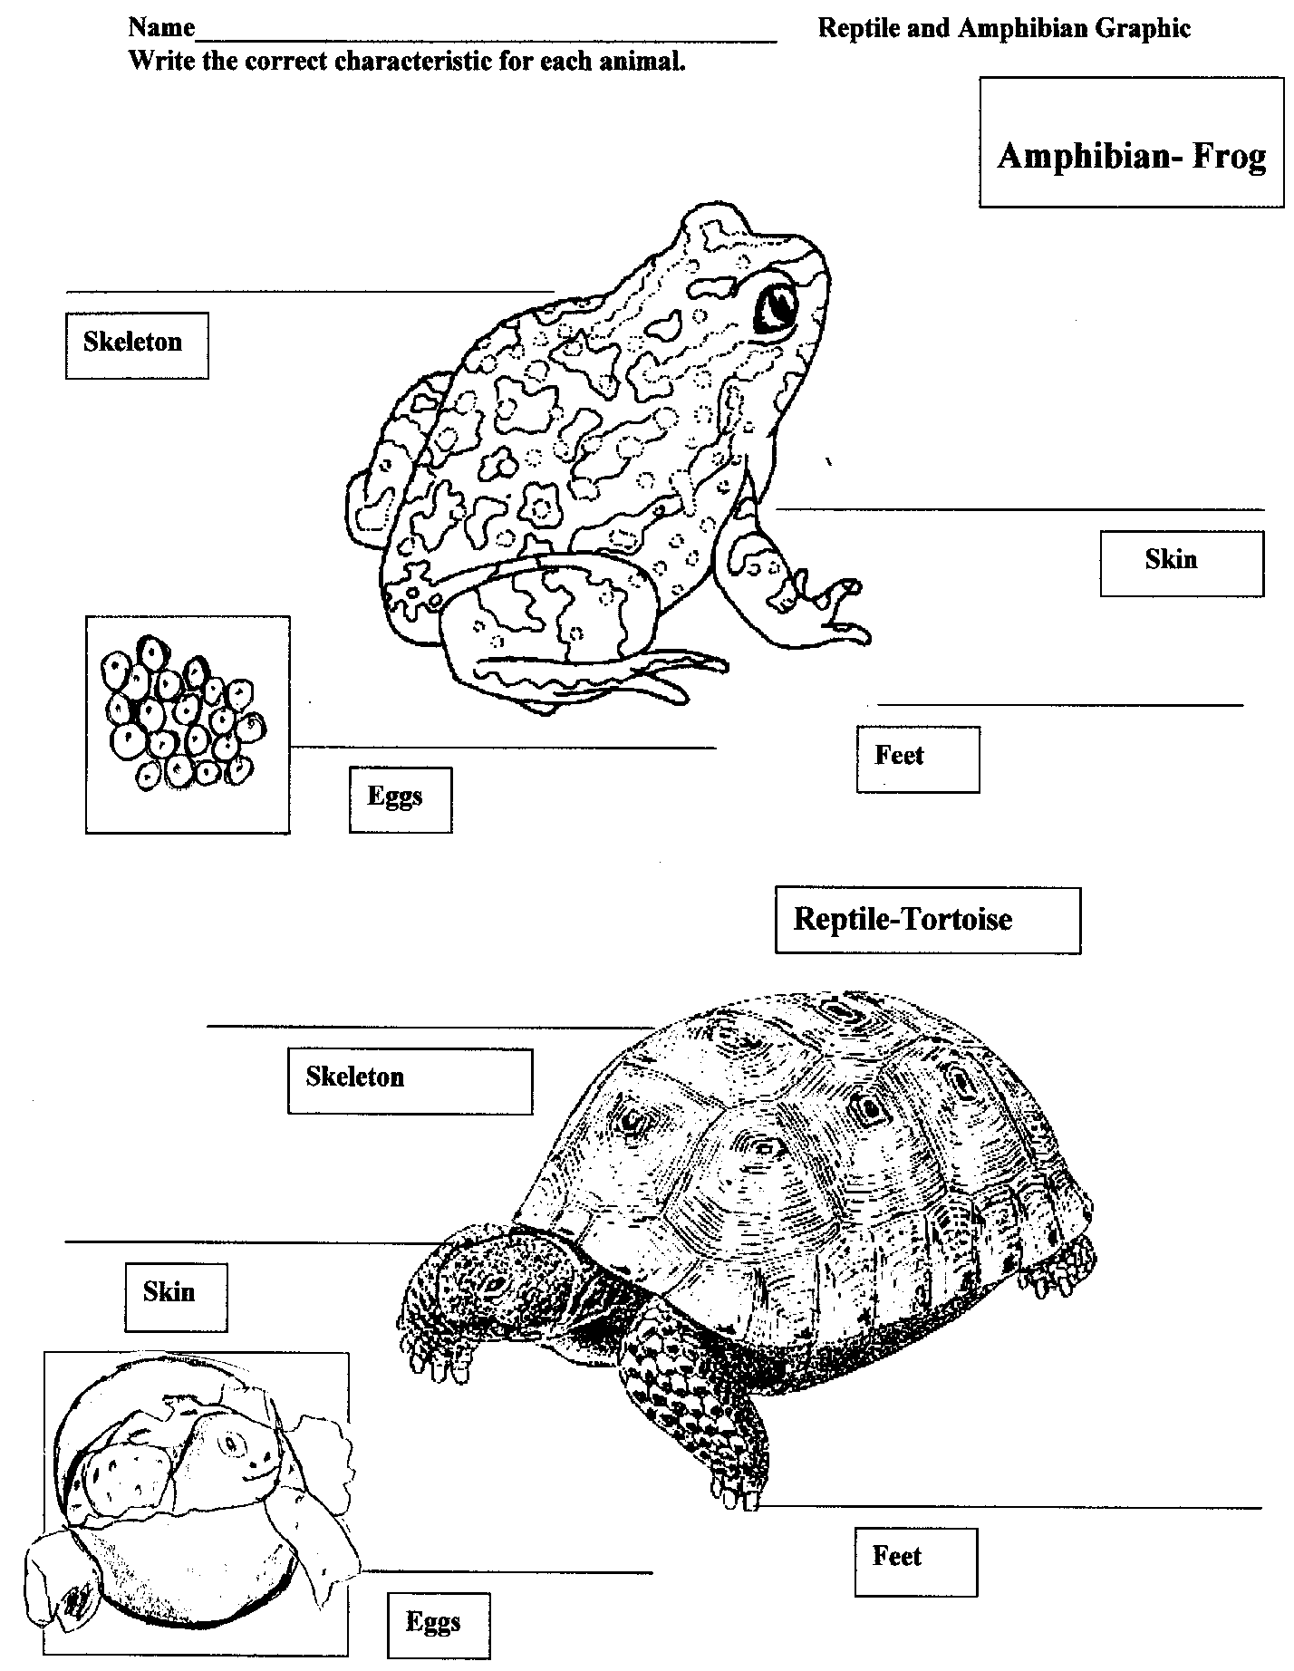

3rd Grade Lessons Unit 1: Reptiles and Amphibians Page 6

Science Activity 3: Reptiles: A Living Desert Zoo and Gardens State Park Field Trip

Strand II: Content of Science
Standard II (Life Science): Understand the properties, structures, and processes of living things and
the interdependence of living things and their environments.
K-4 Benchmark I: Know that living things have diverse forms, structures, functions, and habits.
Performance Standards
- Know that an adaptation in physical structure or behavior can improve an organism’s chance for survival.
- Observe that plants and animals have structures that serve different functions.
3. Classify common animals according to their observable characteristics.

Strand II: Content of Science
Standard II (Life Science): Understand the properties, structures, and processes of living things and
the interdependence of living things and their environments.
K-4 Benchmark II: Know that living things have similarities and differences and that living things change over
time.
Performance Standard
2. Know that some kinds of organisms that once lived on the Earth have become extinct (e.g., dinosaurs)
and that others resemble those that are alive today (e.g., alligators, sharks).

Objective: Students see and learn about reptile adaptations that help them survive and examine characteristics of present day animals that resemble those that have become extinct.

We have docents or a staff member that will provide a special presentation at our park’s reptile house for classes that have completed the study of reptiles. They will be able to see and learn about reptiles. If we know far enough ahead of time, your class might be able to see one of the snakes being fed. Please call the park at (575) 887-5516 to make arrangements for your visit. Please note that this special presentation needs be done one class at a time, so if multiple classes are coming, the classes will need to have the presentation done in intervals.

3rd Grade Lessons Unit 1: Reptiles and Amphibians Page 7

Math Activity 1: Venn Diagram

Strand : DATA ANALYSIS AND PROBABILITY
Standard: Students will understand how to formulate questions, analyze data, and determine probabilities.
K-4 Benchmark D.1: Formulate questions that can be addressed with data and collection, organize, and display
relevant data to answer them.
Performance Standards
3.D.1.1 Collect and organize data using observations, measurements, surveys, or experiments.
3.D.1.2 Represent data using tables and graphs.

Objective: The students will correctly place reptile and amphibian information on a Venn diagram.

Materials:
Completed “Reptile and Amphibian Comparison Chart ” (p. 3) and “Reptile and Amphibian Graphic” (p. 5)
Venn diagram worksheets(p. 7)

Procedure:
Have students use their “Reptile and Amphibian Comparison Chart ” (p. 3) and “Reptile and Amphibian Graphic” (p. 5) to complete the Venn diagram (p. 8)

Page 8
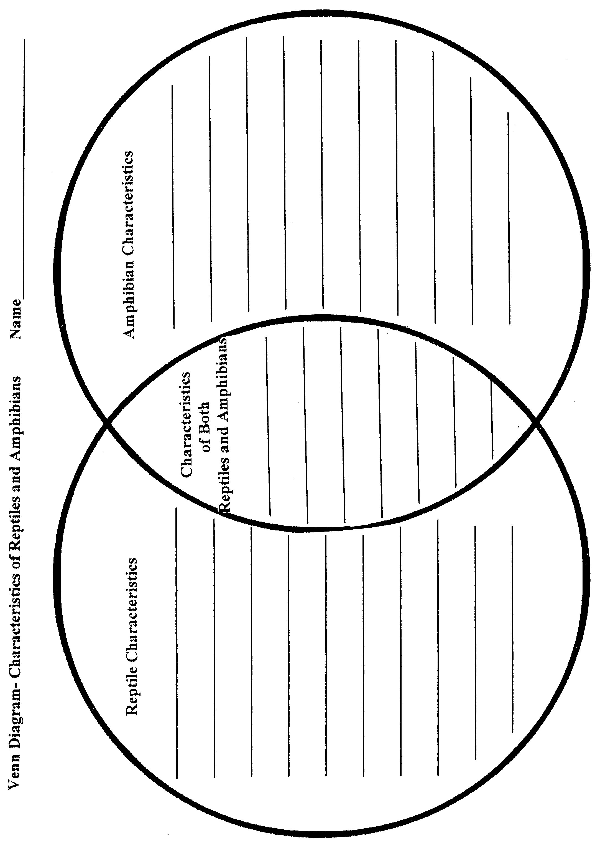

3rd Grade Lessons Unit 1: Reptiles and Amphibians Page 9

Math Activity 2: Making a” Favorite Reptile” Graph

Strand : DATA ANALYSIS AND PROBABILITY
Standard: Students will understand how to formulate questions, analyze data, and determine probabilities.
K-4 Benchmark D.1: Formulate questions that can be addressed with data and collection, organize, and display
relevant data to answer them.
Performance Standards
3.D.1.1 Collect and organize data using observations, measurements, surveys, or experiments.
3.D.1.2 Represent data using tables and graphs.
K-4 Benchmark D.2: Select and use appropriate statistical methods to analyze data.
Performance Standards
3.D.2.1 Apply and explain the uses of sampling techniques (e.g. observations, polls, tally marks) for
gathering data.

Objective: The students will make graphs using data they have collected and tallied.

Materials:
Paper for making graphs

Procedure: Have the students vote on their favorite group of reptiles - crocodilians, snakes, lizards, or turtles/tortoises. They should use tally marks to record the votes. Have them make a graph either on the computer or on paper to show the results of their votes.

3rd Grade Lessons Unit 1: Reptiles and Amphibians Page 10

Language Arts Activity 1: Reptile and Amphibian Reports

Strand I: Reading and listening for comprehension.
Content Standard I: Students will apply strategies and skills to comprehend information that is read, heard, and
viewed.
K-4 Benchmark 1-B Locate and use a variety of resources to acquire information across the curriculum.
Performance Standards: Grade 3
2. Use encyclopedias, dictionaries, and electronic resources to gather information.

Strand II: Writing and speaking for expression.
Content Standard II: Students will communicate effectively through speaking and writing.
K-4 Benchmark II-A: Demonstrate competence in speaking to convey information.
Performance Standards: Grade 3
- Present information in a logical manner, with a clear main point.
- Sustain conversation on a topic.
- Answer open-ended questions.
- Explain own learning.

Strand II: Writing and speaking for expression.
Content Standard II: Students will communicate effectively through speaking and writing.
K-4 Benchmark II-B Apply grammatical and language conventions to communicate.
Performance Standards: Grade 3
- Use correct subject/verb agreement.
- Use correct capitalization and punctuation.
- Use a variety of complete sentences (declarative, imperative, interrogative and exclamatory) in writing and speaking.
- Compose two or more paragraphs with: topic sentences, supporting details, appropriate logical sequence and sufficient elaboration.
- Use strategies for spelling.
- Proofread own writing for spelling and edit (with assistance) for language conventions and format.
- Create readable documents with legible handwriting.
- Write compositions that have few significant errors in use of pronouns,
adjectives, adverbial forms and coordinating conjunctions.

Strand II: Writing and speaking for expression.
Content Standard II: Students will communicate effectively through speaking and writing.
K-4 Benchmark II-C Demonstrate competence in the skills and strategies of the writing process.
Performance Standards: Grade 3
- Compose a draft that conveys major ideas and maintains focus on the topic by using preliminary plans.
- Compose a variety of fiction, non-fiction, poetry, and drama select using self-selected topics and
multimedia forms.
- Suggest and implement reflections and revision (with assistance) on target elements by:
  - clarifying ideas, adding descriptive words and phrases,
  - sequencing events and ideas,
  - combining short, related sentences and
  - strengthening word choice
- Combine information from multiple sources, using technology as a tool, in writing reports and stories.

Continued on the next page.

3rd Grade Lessons Unit 1: Reptiles and Amphibians Page 11

Language Arts Activity 1: Reptile and Amphibian Reports - Continued

Objective: The students will research information about a specific reptile or amphibian and create reports using grade appropriate language arts skills. The students will do oral presentations about their reports using grade appropriate speaking and grammar skills.

Materials:
Resource books about reptiles and amphibians
Computers and printers

Procedure:
Have each student look up information about their favorite reptile or amphibian and write a report about it. Once the paper has been edited, have the students write them on the computer, print them out, and orally present them to the class.

3rd Grade Lessons Unit 1: Reptiles and Amphibians Page 12

Language Arts Activity 2: Story Comprehension

Strand 1: Reading and listening for comprehension.
Content Standard I: Students will apply strategies and skills to comprehend information that is read, heard, and
viewed.
K-4 Benchmark I-A Listen to, read, react to, and retell information.
Performance Standards: Grade 3
- Interact with text before, during, and after reading, listening, or viewing by:
d. locating information for a specific purpose
4. Employ active listening skills.
- Read aloud with fluency, accuracy, and comprehension when presented with a grade level passage of connected text.
- Increase vocabulary through reading, listening, interacting.

Strand 1: Reading and listening to comprehension.
Content Standard I: Students will apply strategies and skills to comprehend information that is read, heard, and
viewed.
K-4 Benchmark 1-C: Demonstrate critical thinking skills to comprehend written, spoken, and visual
information.
Performance Standards: Grade 3
- Draw conclusions, make generalizations, gather support by referencing the text.

Strand 1: Reading and listening for comprehension.
Content Standard I: Students will apply strategies and skills to comprehend information that is read, heard and
viewed.
K-4 Benchmark 1-D: Grade 3
- Apply phonics and structural analysis to decode words.
4. Use a variety of strategies to comprehend text.
6. Increase vocabulary through reading, listening and interacting.

Objective: Students will read for comprehension and acquire new vocabulary.

Materials:
Copies of “A Day in the Life of Harry Horned Lizard” (pp. 14, 15, 16)
Copies of “A Day in the Life of Harry Horned Lizard” worksheet (p. 17)
Copies of “Shovel, the Spadefoot Toad” (pp. 18, 19, 20)
Copies of “Shovel, the Spadefoot Toad” worksheet (p. 21)

Procedure:
Hand out copies of the story “A Day in the Life of Harry Horned Lizard.” Have the students read the story out loud and discuss it.
Give the students the “A Day in the Life of Harry Horned Lizard” Worksheet to complete.
Hand out copies of the story “Shovel, the Spaded Foot Toad.” Have the students read the story out loud and discuss it.
Give the students the “Shovel, the Spade Foot Toad” Worksheet to complete.

3rd Grade Lessons Unit 1: Reptiles and Amphibians Page 13

Language Arts Activity 2: Story Comprehension- Continued

Shovel, the Spadefoot Toad A Day in the Life of Harry Horned Lizard
Answers Answers
- a 1. Horned Lizards Eat Animals that Eat
- b ants Horned Lizards
- a grasshoppers roadrunners
- c termites western diamond-
- c back rattlesnakes
- b
- a 2. play dead
- c inflate body
make hissing sound
squirt bad-tasting blood from eyes
dart under a bush
dig body into dirt

Note: Students will also need the stories “A Day in the Life of Harry Horned Lizard” and “Shovel, the Spade Foot Lizard” when they do Unit I, Language Arts Activity 3.

p.14

A Day in the Life of Harry Horned Lizard

Hi! My name is Mr. Harry Horned Lizard, but you can call me Harry. I am really happy you decided to visit me today. It is such a scorching hot summer day, but here under this shady creosote bush it is comfortable. As you know, the only way we reptiles can control our bodies’ temperature, is to find cool places when it’s hot and warm places when it’s cold.
Wow! You won’t believe the morning I have had. I was so happy to find a large ant hole of tasty harvester ants. You know those harvester ants are getting harder to find, since so many people are using ant poison. Well anyway, I had just started to reach out my sticky tongue to get my first mouthful of ants when I heard a rattling sound behind me. I knew in a flash that the sound could only belong to a western diamondback rattlesnake! Since it had already seen me moving, I realized that the rattler would never believe that I was a rock, so I decided that playing dead wouldn’t work.
What to do! I instantly inflated my body, which caused the spiny “horns” around my head to stick out. I knew that snakes have a hard time swallowing us because of our wide, flat spiny bodies, but I

p. 15
figured I had better pull a few more defense mechanisms out of my bag of tricks. So I began making hissing sounds even though I didn’t think it would frighten that old rattler. I could see that the snake wasn’t in the least bit afraid, so I decided to use my best defense. I began squirting bad-tasting blood from my eyes! Well, let me tell you, that snake slithered away mighty fast. Boy, was that close!
Although I was still hungry, I figured I would skip the ants and see what else I could find to eat. You know, we insectivorous horned lizards are also mighty fond of grasshoppers, so off I went in search of some of the little hoppers. Along the way, I found some termites that were busy eating on a fallen decaying ocotillo plant. They helped take away some of my hunger, but I was still craving some delicious crunchy food. As I was running over some hot, crusty dirt, I spied a juicy green grasshopper feeding on a blade of swaying desert grass. In one swift dash, I was upon that insect before it saw me coming.
With my belly full and the day getting hotter from the blazing overhead sun, I knew it was time to head for shelter. I hadn’t gotten very far when I spied a roadrunner searching for his lunch. Since I

p. 16

didn’t want to be that meal, I darted under this creosote bush. That
speedy bird was right behind me. Using the spikes on my lower jaw, I quickly began to cut away the hard dirt under me. By squirming deeper into the ground, I was able to hide from my predator.
And so there you have it. It has been just another ordinary day in the life of Harry Horned Lizard. Hey! How would you like to go out for a bite to eat? I just happen to know where there are some nice crunchy ants!

Page 17

A Day in the Life of Harry Horned Lizard Worksheet

Name_______________________

1. Write the following animals in their correct categories.
ants
grasshoppers

roadrunner
termite
western diamondback rattlesnake

horned lizards eat these animals | animals that eat horned lizards

2. Name two ways a Texas horned lizard can protect itself from its

enemies.______________________________________________________

p. 18

Shovel, the Spadefoot Toad

Wow! I wonder what month this is, or for that matter, I wonder what year it is! Don’t look at me like that! If you slept as long as we spade foot toads, you might be a little confused, too. Oh! Where are my manners? My name is Shovel, the Spadefoot Toad, and I am an amphibian.
Being an amphibian means we need to keep our skin moist. We amphibians are also exothermic, which means that the environment regulates our bodies’ temperatures. That can be a real challenge for those of us that live in the Chihuahuan Desert. That’s why we spadefoot toads spend so much time in our burrows. Way down here, three feet below the surface, we can stay cool and moist while we wait for the right time to emerge from our burrows.
Wait! What was that? I hear rumbling, and the ground is shaking. There must be a really good thunderstorm up above. That’s my signal to go! There will be plenty of food, water, and other spadefoots, so it is time for me to head for the surface.
You know, these back feet of mine are perfect for digging. The way they are shaped, I can quickly scoop away dirt. Just a few more
p. 19
inches, and I will be there. Yes, there it is- Hello, Earth, here I am again!
Wow! Listen to all the other spadefoots croaking to each other. The males are looking for mates. Once we get to the surface, we spadefoot toads have to do everything quickly because we only have a short time before the puddles dry up, and we have to go underground again. Why, our eggs can hatch in just 15 hours! Our little tadpoles develop quickly also. It only takes them 9 to 14 days to change their gills to lungs, lose their tails, and grow their legs. Now that is really fast metamorphism!
Once mating is done, we spadefoot toads spend a lot of time eating, and eating, and eating. My favorite foods are grasshoppers, beetles, ants, spiders, and termites. We need to eat a lot because it could be two more years before the rains signal us to come out of our burrows again. That is a long time to go without food! Excuse me. I will be right back. I see a delicious looking beetle over there. Yum! That was really good.

p. 20
All too soon, the pools of water have dried up, and it is time for us to dig back into the ground. “Good-bye friends, see you at the next big rain!”
I will stay here in my burrow waiting for the rain to signal my

return to the surface. Until then, I will wait and sleep. Pardon me,

but I think it is time for you to leave. I feel a nap coming on.

p. 21

Shovel, the Spadefoot Toad Worksheet

Name______________________________________

Circle the correct answer.

1. What kind of animal is Shovel?
A. amphibian B. reptile

2. What type of skin does Shovel have?

A. dry B. moist

3. Where does Shovel live?

A. in a burrow B. in a den C. in a nest

4. What caused the ground to shake?

- a giant was walking

- heavy dump trucks were running

C. there was a thunderstorm

5. What does Shovel use to dig?

A. a shovel B. his front feet C. his back feet

6. How long does it take for a spadefoot toad’s eggs to hatch?

A. 15 minutes B. 15 hours C. 15 days

7. Shovel likes to eat:

A. insects B. vegetables

8. How long might it take for the next big rain to come?

A. 2 weeks B. 2 days C. 2 years

3rd Grade Lessons Unit 1: Reptiles and Amphibians Page 22

Language Arts Activity 3: Write a Reptile or Amphibian Story

Strand II: Writing and Speaking for Expression
Content Standard II: Students will communicate effectively through speaking and writing.
K-4 Benchmark II-B- Grade 3
- Use correct subject and verb agreement.
- Use correct capitalization and punctuation.
- Use a variety of complete sentences in writing and speaking.
- Compose two or more paragraphs with: topic sentences, supporting details, appropriate, logical sequence and sufficient elaboration.
- Use strategies for spelling.
- Proofread one’s own writing for spelling and edit (with assistance) for language conventions and format.
- Create readable documents with legible handwriting.
- Write compositions that have few significant errors in use of pronouns, adjectives, adverbial forms and coordinating conjunctions.

Strand II: Writing and Speaking for Expression
Content Standard II: Students will communicate effectively through speaking and writing.
K-4 Benchmark II-C- Grade 3
- Compose a draft that conveys major ideas and maintains focus on the topic by using preliminary plans.
- Compose a variety of fiction, nonfiction, poetry, and drama selections using self-selected topics and multimedia forms.
- Suggest and implement reflection and revision (with assistance) on target elements by:
  - clarifying ideas, adding descriptive words and phrases
  - sequencing events and ideas
  - combining short, related sentences, and
  - strengthening word choice.
- Begin to incorporate literary words and language patterns in writing (e.g., elaborate descriptions, use figurative words.)
- Combine information from multiple sources, using technology as a tool in writing reports and stories.
- Write stories and essays that show an awareness of an intended audience and purpose.

Strand III: Literature and Media
Content Standard III: Students will use literature and media to develop an understanding of people, societies and the self.
K-4 Benchmark III-B: Identify and use the types of literature according to their purpose and function.
Performance Standards: Grade 3
1. Read and create a variety of texts, including: fiction, poetry, and drama.

Objective: The students will write reptile or amphibian stories using grade appropriate language arts skills.

Continued on the next page.

3rd Grade Lessons Unit 1: Reptiles and Amphibians Page 23

Language Arts Activity 3: Write a Reptile or Amphibian Story- Continued

Materials:
Copies of the stories “A Day of Life of Harry Horned Lizard” (pp. 14,15,16)
Copies of the stories “Shovel, the Spadefoot Toad.” (pp.18, 19, 20)
Computer and printer

Procedure:
Have the students reread the two stories and tell them to pay close attention to how the author explained characteristics about each animal even though it is in a story format. After reading each story, discuss things that they learned about the animals.

Have the students write a story about their favorite reptile or amphibian. Once the stories have been edited, have the students write them on the computer
(or by hand), print them out, and read them to the class. They should have a picture that they can show to accompany their reports. The pictures can be computer generated or drawn by the students.

Music

To provide another method of teaching about reptiles and amphibians, we have included some songs that are written to familiar children tunes.

Page 24
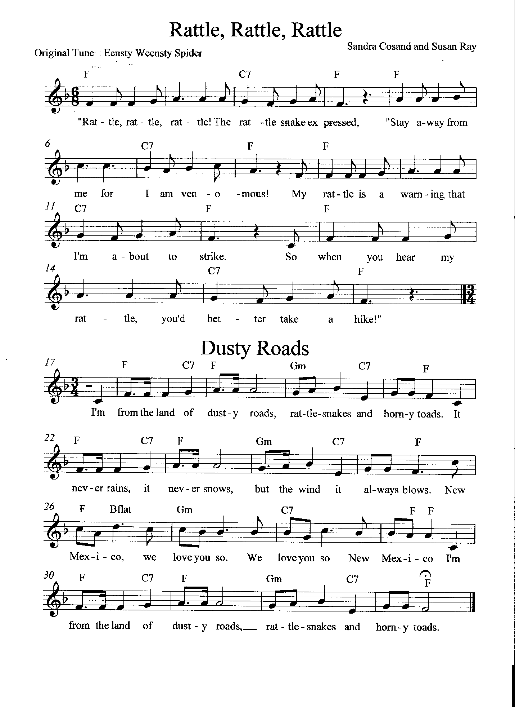

Page 25
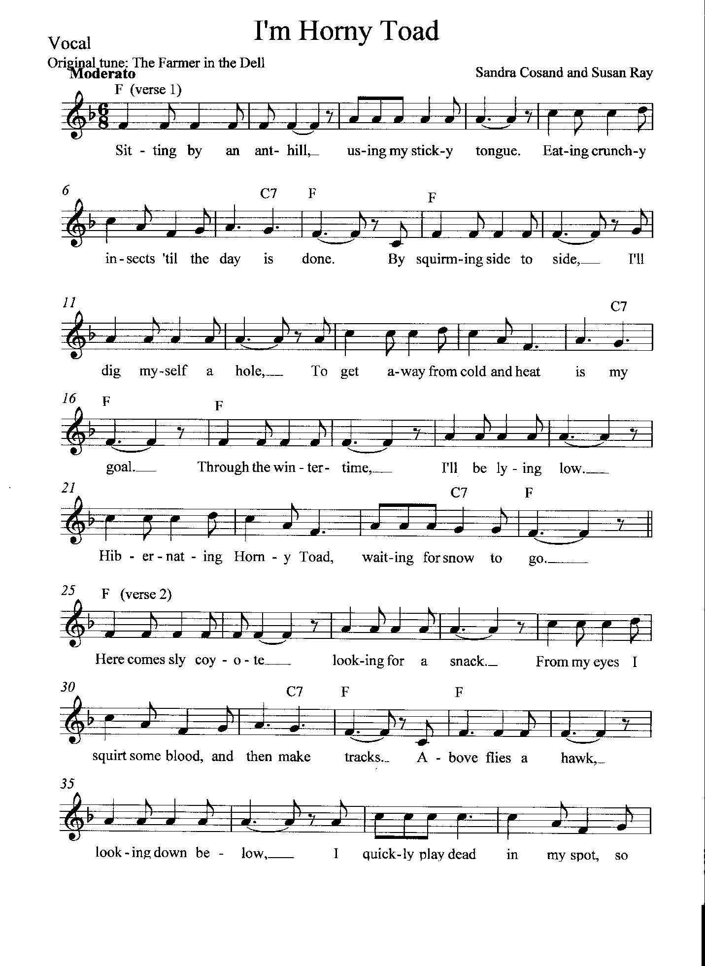

Page 26

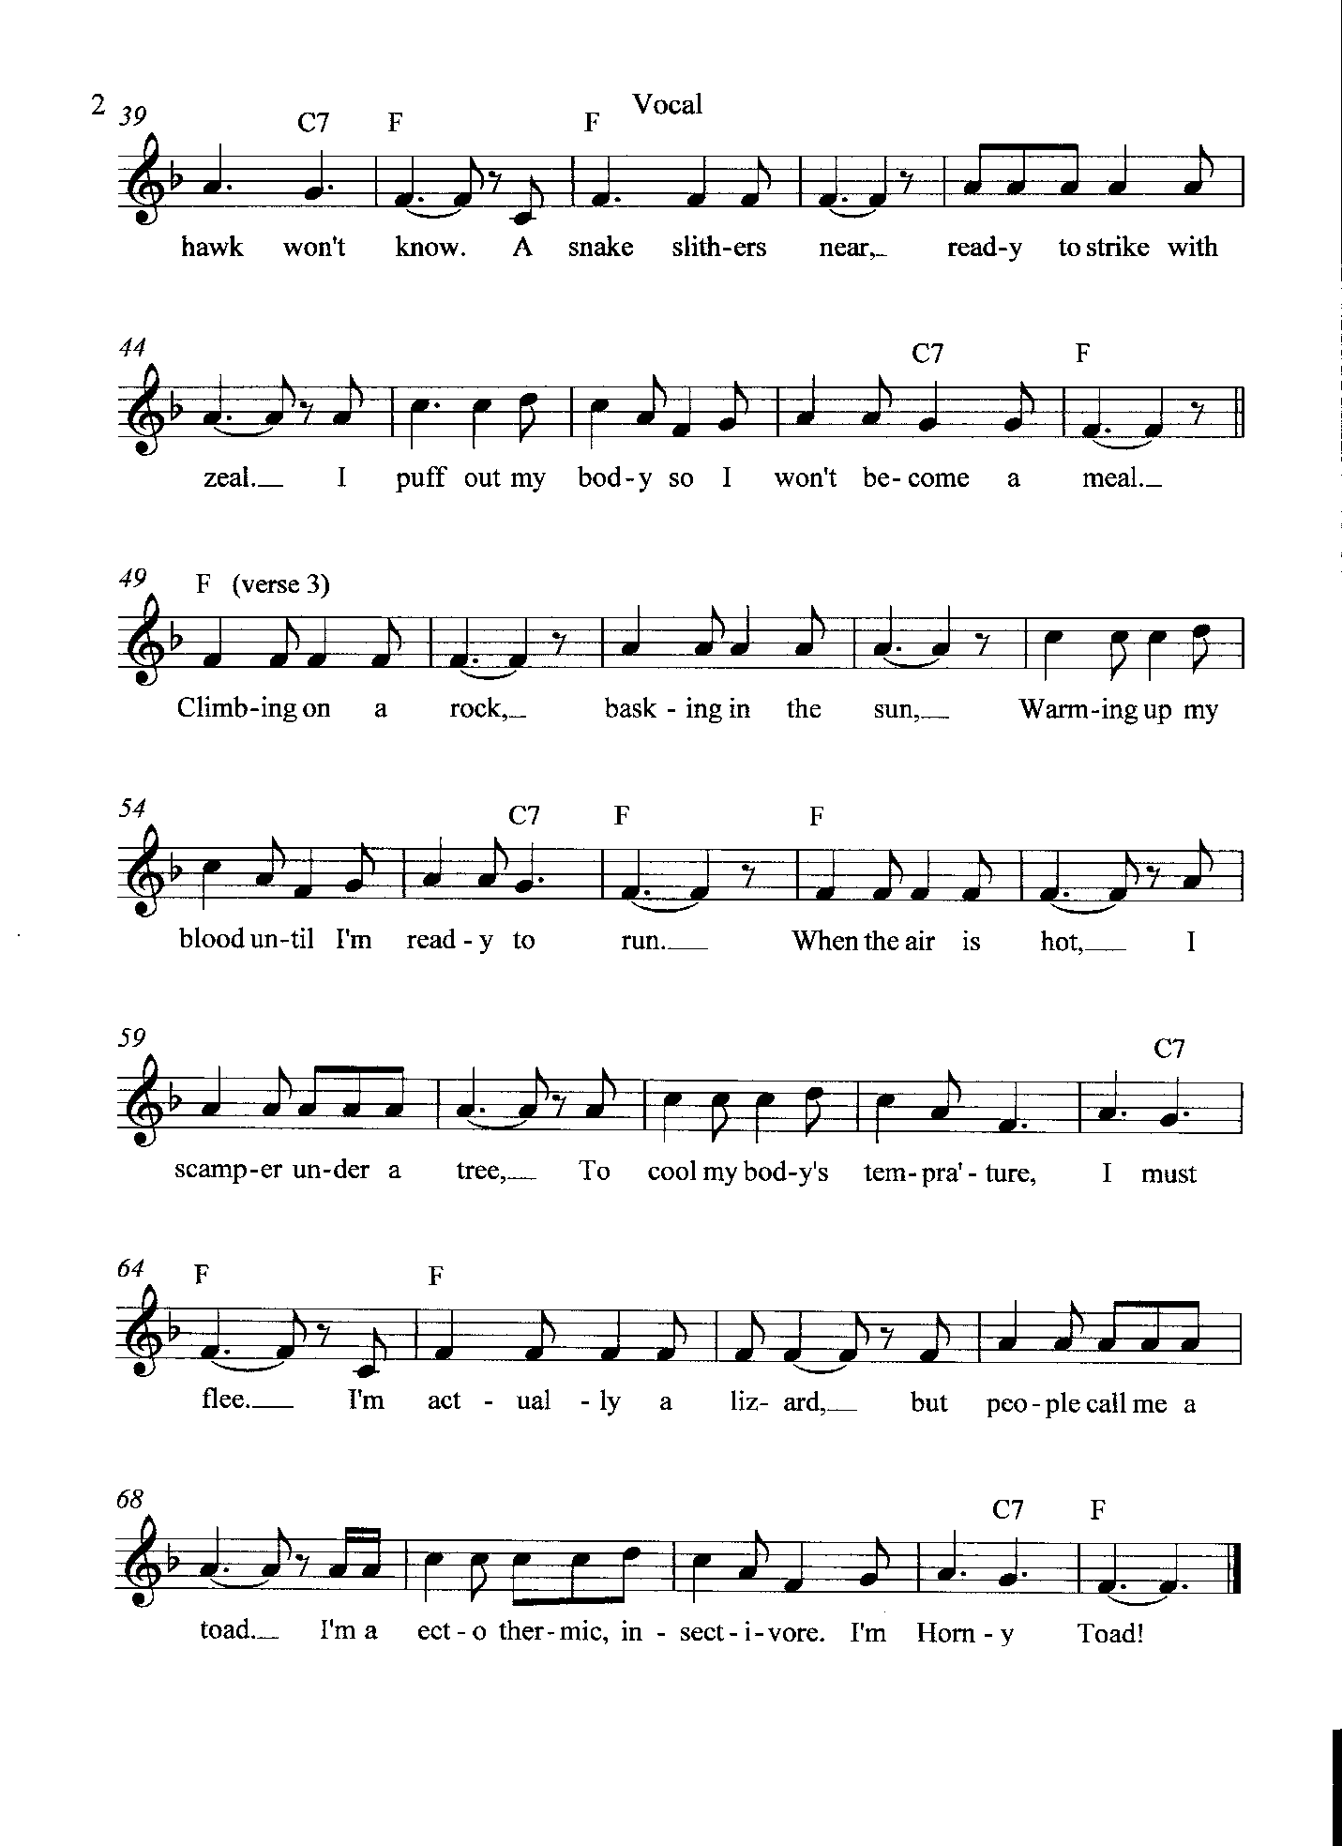

Page 27

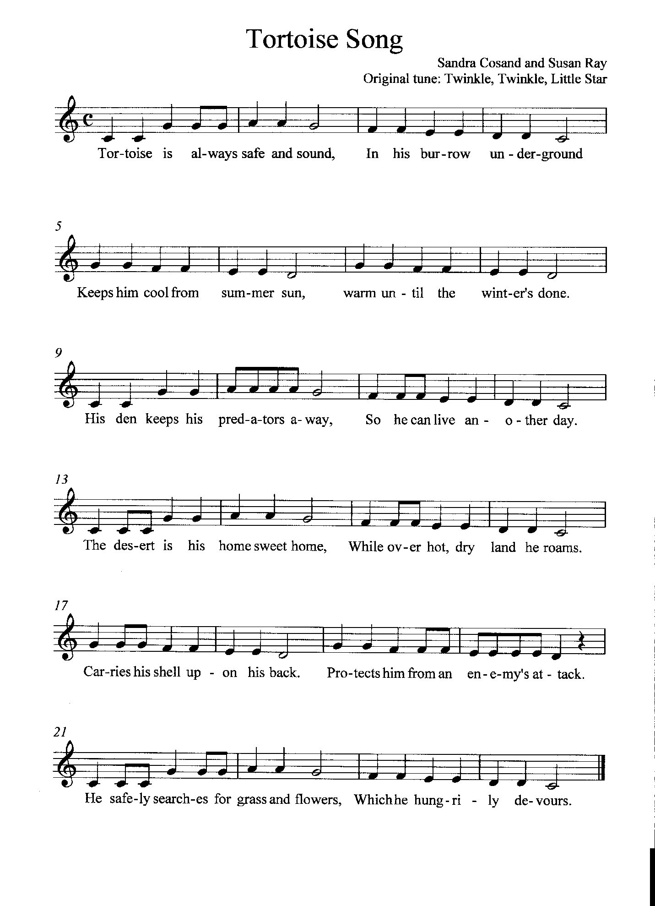

Page 28
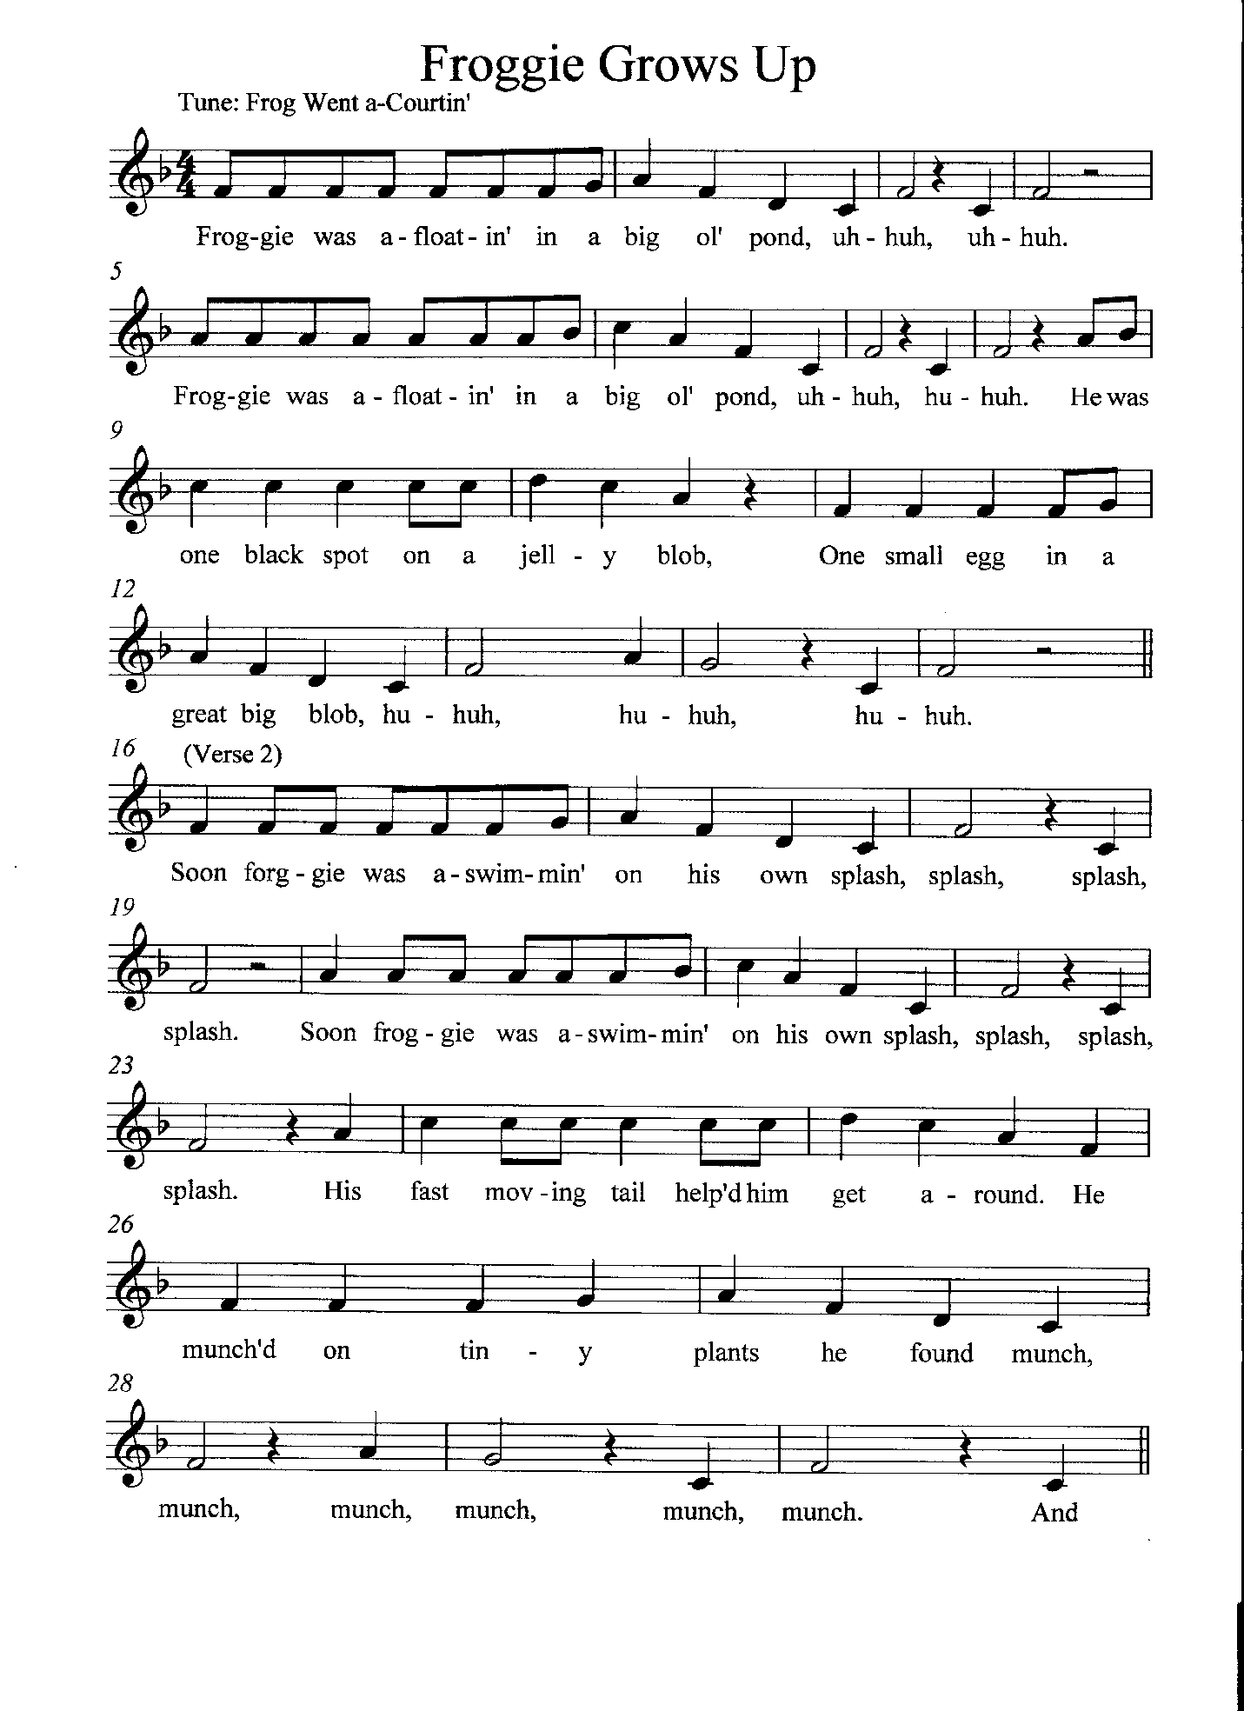

Page 29

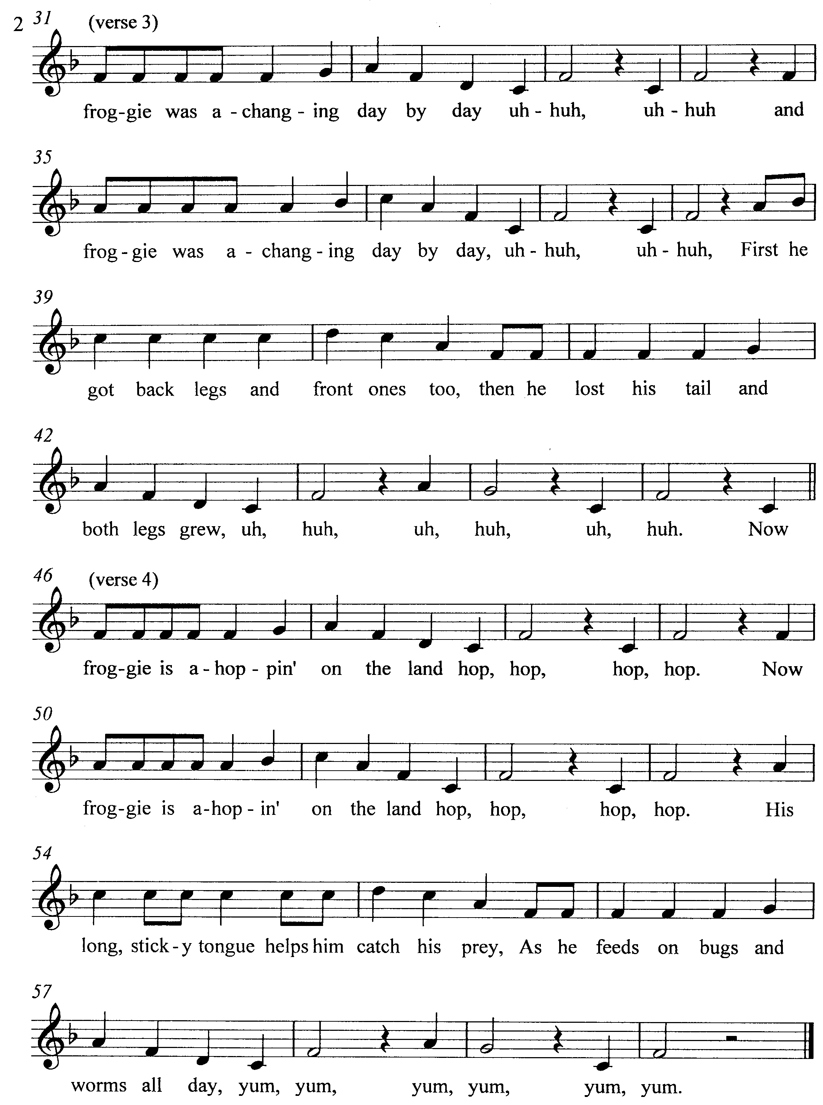

3rd Grade Lessons Unit 2: Bird Beak Adaptations Page 30

Science Activity 1: Bird Beaks- Adaptations: A Living Desert Zoo and Gardens State Park Docent Classroom Visit Activity

Strand II: Content of Science
Standard II (Life Science): Understand the properties, structures, and processes of living things and
the interdependence of living things and their environments.
K-4 Benchmark I: Know that living things have diverse forms, structures, functions, and habits.
Performance Standards
- Know that an adaptation in physical structure or behavior can improve an organism’s chance for survival.
- Observe that plants and animals have structures that serve different functions.

Objective: The students will determine the species and diet of Chihuahuan Desert birds by examining the function and shapes of “human” tools that replicate birds’ beaks and comparing them to pictures of birds.

A docent from the Living Desert Zoo and Gardens State Park presents this activity. This is an enjoyable activity that lets students examine human tools (straws, pliers, etc.) to determine which bird beak it most resembles and what type of food it would eat. The activity takes about 50 to 60 minutes. All the materials are supplied except water. It takes about 15 minutes for the docent to set up the seven stations, and flat working surfaces are needed. You will not have to teach anything before the docent comes. If you wish to have a docent bring this activity to your classroom, please call the park at (575) 887-5516.

